

Black & McDonald Limited’s Response

To

**Ministry of Transportation**

**DESIGN-BUILD**

**REQUEST FOR PROPOSALS**

For

Design, Construction, Operation and Maintenance of the **Travel Time System**

**DB Contract Number: 2021-2025**

Proposal Submission Date: March 2, 2022

**Black & McDonald Limited**

31 Pullman Court,

Scarborough, ON M1X 1E4

**TABLE OF CONTENTS**

1.15.2.1 TRANSMITTAL LETTER 1

1.15.2.2 CONFLICT OF INTEREST CONFIRMATIONS 3

1.15.2.3 FORM OF OFFER 5

1.15.3 RATED REQUIREMENTS 9

1.15.3.1 PROPONENT DESCRIPTION, RELEVANT EXPERIENCE, QUALIFICATIONS AND EXPERTISE 9

1.15.3.1.1 Proponent Profile 9

1.15.3.1.2 Relevant Qualifications and Experience 11

1.15.3.2 UNDERSTANDING OF SCOPE OF WORK 14

1.15.3.2.1 Understanding Contract Requirements 14

1.15.3.2.2 Work Plan and Schedule 16

1.15.3.2.3 Innovative Approach 17

1.15.3.3 PROJECT MANAGEMENT PLAN 19

1.15.3.3.1 Project Team And Qualifications 19

1.15.3.3.2 Management Plan 24

1.15.3.4 SYSTEM COMPONENTS, PRODUCT AND SYSTEM CONCEPT 29

1.15.3.4.1 System Concept 29

1.15.3.4.2 Infrastructure Components and Product Cut Sheets 32

1.15.3.5 COMPLIANCE WITH SYSTEM SPECIFICATIONS 38

1.15.3.6 OPERATIONS, WARRANTY AND MAINTENANCE PLAN 122

1.15.3.6.1 Operations And Maintenance Plan 122

1.15.3.6.2 System Redundancy Procedure 132

APPENDIX a GANTT CHART …………………………………………………………… 136

APPENDIX b ORGANIZATIONAL CHART ……………………………………………..141

APPENDIX c CUT SHEETS ……………………………………………………………….142

APPENDIX d ITS CENTRAL HIGH AVAILABILITY ……………………………………152

APPENDIX e RESUMES …………………………………………………………………..153

# 1.15.2.1 TRANSMITTAL LETTER

Black & McDonald Limited

31 Pullman Court,

Scarborough, Ontario

M1X 1E4

Date: March 2, 2022

The Ontario Ministry of Transportation

Central Region

159 Sir William Hearst Ave

Toronto, ON

M3M 3G8

**Subject: RFP for Design, Construction, Operation and Maintenance of the Travel Time System: DB Contract Number is: 2021-2025**

Black & McDonald Limited (B&M) is pleased to provide the enclosed package in response to the above mentioned Request for Proposal.

B&M is committed to implementing innovative and cost-effective solutions to its customers’ requirements on time, on budget, and with safety foremost in mind. Black & McDonald is a reliable and flexible contractor operating with integrity and loyalty to employees, customers, suppliers, and the communities we serve.

With B&M as your prime contractor, you will gain the following:

* **Queue and Stopped Vehicle Contract Experience:** The proposed project team for the Travel Time System is identical to the team which successfully implemented the Queued and Stopped Vehicle Advisory System (QSVAS) along Highway 405. This has provided our team with unique experience in deploying, configuring and testing intelligent transportation systems under Ministry’s Design Build (DB) arrangement. This knowledge will aid our team in delivering a fully functional system on time and on budget.
* **Highly Skilled/trained workforce:** B&M will provide a labour force whose selection is based on the required skills and level of expertise. This ensures that best practices and leading edge methodologies are implemented for every contract with which we work. Our staff members continuously train and update their skills, providing our clients with expertise and knowledge in all areas of operation, maintenance, health and safety. The result is a workforce with unparalleled knowledge and understanding of our clients’ requirements.
* **Proven operations and maintenance programs:** B&M offers the benefit of more than ninety years’ experience as an electrical contractor and over forty years’ experience in the Utility Sector and Maintenance contracts.
* **Reduction of owning and operating costs:** B&M ensures that equipment and systems operate at maximum efficiency.
* **Single-source accountability:** A single call to B&M ensures that all services assigned are provided in a prompt and effective manner.
* **Accountability of task**: B&M will work with Ministry to establish and implement standard operating policies and procedures.
* **Client satisfaction:** We are recognized for providing service excellence and are firmly committed to your satisfaction as a client. We go the extra mile to ensure that our service goes beyond your expectations
* **Purchasing Power:** Currently B&M is one of the largest utility contractors in Canada and because of our sales volume and financial stability we garner preferential pricing for our projects. We are able to combine our efforts when negotiating with suppliers and as a result we negotiate pricing that is unmatched in our industry. This purchasing power provides our customers with significant cost savings
* **Continuity of service:** B&M operates under union agreements that include “no strike/no lockout” clauses; as a result we do not foresee any labour disruptions that would interfere with our ability to provide services to our customers.
* **Commitment to Health, Safety and the Environment:** B&M is committed to protecting their people, their property and the environment and will take all necessary steps to provide and maintain a safe and healthy work environment. Refer to the enclosed details on our Health and Safety Program.

With a track record of success spanning over ten decades, B&M has built a solid reputation based on our company’s mission of providing our customers with quality and service that is second to none. This means we do the job right the first time, on time, on budget, and with the highest standards of safety and quality in the industry.

If you require additional information, please do not hesitate to contact me at (647) 749-0818.

Yours Truly,

Black & McDonald Limited



Charles Mossman

Vice President

# 1.15.2.2 CONFLICT OF INTEREST CONFIRMATIONS

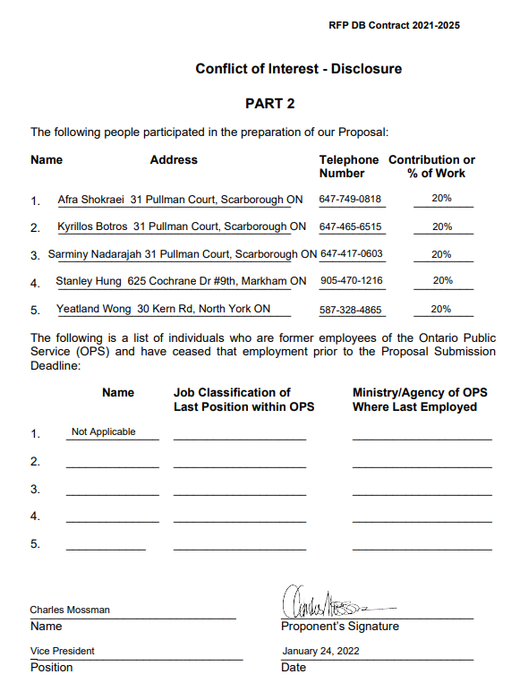

# 1.15.2.3 FORM OF OFFER



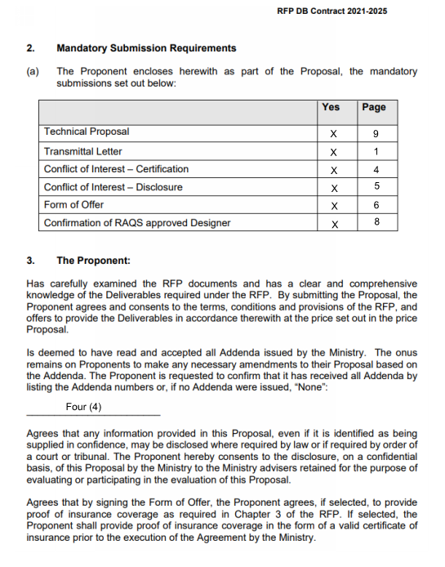

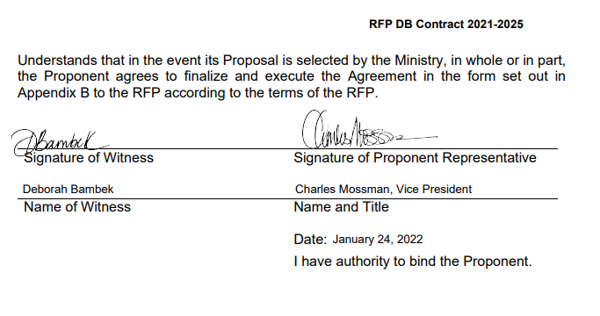

**Confirmation of RAQS Approved Designer**

# 1.15.3 RATED REQUIREMENTS

# 1.15.3.1 PROPONENT DESCRIPTION, RELEVANT EXPERIENCE, QUALIFICATIONS AND EXPERTISE

## 1.15.3.1.1 Proponent Profile

The Project Team (the “Team”) is composed of a strong suite of companies namely B&M, Transnomis, LEA, and Stinson ITS. B&M is an experienced ITS contractor. B&M, serving as the prime proponent, providing project management, construction, routine maintenance and emergency services for the Project.

B&M is an integrated, multi-trade prime contractor founded in 1921 serving government, institutions, industry and commerce. With over 30 offices, a team of over 5,000 staff and access to over 500 vehicles in our fleet, B&M lives and breathes the ultimate in safety, quality and high performance along with engineering excellence, best in class fabrication and unprecedented customer service.

Our utility personnel are highly experienced in addressing the challenges of working in both urban and remote areas. They are exceptionally well- trained and skilled to deal with the issues of traffic congestion and pedestrian safety, minimizing disruptions along roadways and ensuring that the safety of all concerned remains top-of-mind.

Services:

* Automated queue and stopped vehicle advisory systems
* Supply, installation and configuration of intrusive and non-intrusive detection systems including incident detection systems; adaptive traffic control systems and loop detectors
* Installation, and maintenance of ITS field components (Bluetooth readers, wireless communications, UPS systems, non-intrusive traffic sensors, CCTV analog and IP cameras, fixed and portable variable message signs;
* Installation and maintenance of intelligent transportation system (ITS), traffic signal, advanced traffic management system (ATMS), high mast & streetlight;
* Decorative lighting fixture installation;
* Airfield lighting, navigation and landing aids;
* Emergency services, storm recovery response teams.

B&M is a member of The Electrical Utilities Safety Association of Ontario, International Brotherhood of Electrical Workers, Electrical Contractors Association Ontario, IAPA, Greater Toronto Electrical Contractor Association, Electrical Safety Authority and Infrastructure Health & Safety Association.

**LEA Consulting Ltd.**

The detailed design of the TT systems, equipment, and provisions will be undertaken by LEA Consulting Ltd (LEA). The design team will report to B&M.

LEA is a privately-held, Canadian consulting firm providing planning, engineering design, and construction administration services for urban infrastructure projects. LEA’s clients and partners include public sector agencies at all three levels of governments across Canada, major developers, architects, contractors, and law firms.

LEA has offices in Markham, Stratford, Timmins, and Toronto, Ontario, and currently employs over 180 professionals. LEA is an active and influential member of key engineering, transportation and planning associations, including Professional Engineers Ontario (CofA #10903658), the Association of Consulting Engineering Companies | Ontario and Canada, the Canadian Security Association (CANASA), and the Transportation Association of Canada.

**Stinson ITS**

Stinson ITS is a Manufacturer, Distributor and System Integrator of Intelligent Transportation Systems (ITS) with a focus on providing Turn-Key Solutions. With a diverse and talented team, we have the expertise to assist with every aspect of a project, from early design consultations to implementation to long term operation and maintenance. This model involves the inclusion of minimum service levels and long-term maintenance warranties into contracts to ensure that systems are designed to work as intended and to last for many years to come.

Stinson Equipment Ltd O/A Stinson Owl-Lite is an Ontario corporation that was established in 1960. It currently employs 85 employees in two locations in the Region of York, and locations in the provinces of Alberta, British Columbia and Quebec. Stinson ITS Inc is a Canadian owned and operated company with now 14 employees. As a subsidiary of Stinson Owl-lite we still utilize their accounting, admin, and HR staff so these 14 employees are solely: technical salespersons, solution engineers, project managers and technical support staff.

Stinson ITS Inc., formerly a division of Stinson Owl-Lite, was founded in 2020 after 5 years of continued success and growth including numerous large ITS projects primarily in Ontario and Alberta. For over 55 years Stinson Owl-Lite has been committed to being on the leading edge of providing solutions for the traffic control and infrastructure industry. Stinson’s core business has traditionally been traffic control signage and safety equipment. The tremendous growth in our ITS department spurred the founding of Stinson ITS Inc.

**Transnomis Solutions Inc.**

Transnomis is an Ontario based technology company that specializes in road information management and communications solutions, for agencies with road information, and all that need it. MTO has certified Transnomis as an approved vendor for providing ATMS and Firmware for field hardware in its Registry, Appraisal and Qualification System (RAQS). Since 2007, Transnomis has been building a comprehensive Intelligent Transportation System (ITS) called ITS Central to provide specialized ATMS Control for ITS.

Transnomis packaged service offerings includes 1) ITS Central – a map-centric Advanced Traffic Management System (ATMS) central software, 2) VMS Central - cloud-hosted solution available to work zone traffic safety companies, allowing them to configure and create their own “Smart Work Zones.”, 3) Municipal 511 - cloud-hosted and shared platform available to municipalities of all sizes to communicate and manage their road events and emergency responses, 4) Permit Central - a web application that provides a user interface for the public to create a permit application online and for staff to manage the approval process.

Transnomis has 14 years of experience building user friendly and custom software control systems for road information management and ITS device. Transnomis has integrated traffic data sensors, traffic signal systems, video analytics systems, work management systems, video management systems, geographic information systems (GIS), automatic vehicle locators (AVL), and road weather information systems (RWIS).

## 1.15.3.1.2 Relevant Qualifications and Experience

The table below provides a selection of relevant projects and experience for the team’s companies:

| **Company Involved** | **Project Name** | **Project Description/Scope** | **COMP Date** | **Client References** |
| --- | --- | --- | --- | --- |
| B&M | City of Toronto 3202-14-5072 | Contract to supply, installation and maintenance of ITS components. | 2017 | Jason Pires  Project Manager  [jpires@toronto.ca](mailto:jpires@toronto.ca)  416-398-3942 |
| B&M | MTO: Link427 Extension ATMS & Electrical | Supply & install of electrical and civil works including CCTV cameras, cameras, VMS, poles, ITS equipment, ATMS loops, sensors, Traffic Counting Stations, and ATMS | 2021 | Jorge Cadete  Construction Manager [jorge.c@link427cjv.com](mailto:jorge.c@link427cjv.com)  416-678-7124 |
| B&M | VIVA Next Yonge St. Rapid Way | Supply and installation of cable trenching and joint use duct banks | 2021 | Jeff Fellman  Dufferin Construction  [jeff.fellman@ca.crh.com](mailto:jeff.fellman@ca.crh.com) 416-297-2600 |
| B&M  Transnomis  LEA Consulting | MTO Hwy 405 QSVAS | Scope included design, construction and operation and maintenance of a new Queue & Stopped Vehicle Advisory System (QSVAS) on Highway 405 Eastbound; includes full automation using sensors, DMS signs, and machine edge software control. | 2021 | Lija Whittaker  Operations and Deployment Head  [Lija.Whittaker@ontario.ca](mailto:Lija.Whittaker@ontario.ca) 416-235-3541 |
| B&M | MTO 2017-2022 ATMS – VMS Upgrade & Extension, | Electrical and civil works including supply & installation of cables, ground wires, UPS, spare components for ATMS work, System Integration Testing, 17 VMS’s /w poles, and Power Supply Cabinets. | 2019 | Felix Tam  Senior Project Engineer  [felix.tam@ontario.ca](mailto:felix.tam@ontario.ca)  416-235-4400 |
| B&M | 407 ETR: VMS Signs | Complete electrical and civil works including supply & installation of (4) VMS, ATMS Equipment Cabinet, electrical hand holes and other equipment. | 2017 | Jeff Booker  407ETR  [jbooker@407etr.com](mailto:jbooker@407etr.com)  905-265-4070 |
| Stinson ITS | Region of Durham, Travel time sensors | Supply 60x Stinson AIS - Bluetooth & WiFi travel time sensors, to provide travel time data on regional arterial roads. Devices installed in traffic cabinets. | 2020 | Dave Dankmeyer  Project Manager, Traffic Management & ITS, [dave.dankmeyer@durham.ca](mailto:dave.dankmeyer@durham.ca), 1-866-786-8116 |
| Stinson ITS | 407ETR,  Miovision Smart Intersections | Project involves the deployment of Miovision SmartLink to all 407ETR off-ramp intersections (74 intersections) for Stop bar detection, remote comms, signal monitoring and traffic signal timing plan control | 2021 | Craig White  VP Highway and Tolling Operations [cwhite@407etr.com](mailto:cwhite@407etr.com) 416-989-3182 |
| Stinson ITS | MTO 2015-2348 Queue Warning System Design Deployment | Design, Supply, Deploy and Maintain Queue-End safety warning systems for MTO capital contracts;  15+ system deployments ranging in length and complexity from 2-24 weeks and from 8-24 sensors per system. | 2018 | Dennis Tessarello  Senior ITS Specialist  [Dennis.Tessarolo@ontario.ca](mailto:Dennis.Tessarolo@ontario.ca)  416-235-4834 |
| Stinson ITS  Transnomis | Finch LRT (Mosaic Transit), Smart Work Zone System | BT travel time system with PVMS operated by ITS Central. 9 CCTV cameras, /w 720p HD streaming footage via wide wireless network. Managed and monitored using Genetec Security Centre, hosted by Stinson. Supply, install and maintain all equipment. | 2019 - 2024 | Kamran Shah,  Traffic & Transit Manager  [kshah@mosaictransit.com](mailto:kshah@mosaictransit.com) 416-689-9214 |
| Stinson ITS  Transnomis | Eglinton Crosstown & Crosslinx LRT Smart Work Zone | Stinson deployed & operated smart work zone including travel time system & portable CCTV trailers for remote monitoring. ITS Central used to provide travel time messaging, based on Stinson AIS Bluetooth sensor data as well as real-time bus GPS data. | 2014- Ongoing | Neil Blake  Project Manager  [nblake@aecon.com](mailto:nblake@aecon.com)  647-382-8847 |
| Transnomis | Durham Region Travel Time System | Transnomis implemented its ITS Central Bluetooth Travel Time add-on to the Region’s existing Roadway Event Management System (REMS). | 2020 | Dave Dankmeyer  Project Manager, Traffic Management & ITS, [dave.dankmeyer@durham.ca](mailto:dave.dankmeyer@durham.ca), 1-866-786-8116 |
| Transnomis | City of Edmonton - ATMS | ATMS Software to manage and operate existing Vehicle Detection Stations, 134 permanent and portable VMS; RWIS, Data collection, calculate travel times. | 2019 | Michael Vaudan  Senior Operations Engineer [michael.vaudan@edmonton.ca](mailto:michael.vaudan@edmonton.ca), 780-496-6207 |
| Transnomis | California SR-101 Smart Work Zone System | Cloud hosted software solution for California Department of Transportation to enable the Smart Work Zone software functions needed for Caltran’s SM 101 Express Lanes Project. | 2020-Ongoing | Joe Jeffrey  Road-Tech Safety Services, Inc.  [joe@road-tech.com](mailto:joe@road-tech.com)  530-672-0222 |
| Transnomis | Oklahoma Smart Work Zone System for various construction projects | Smart Work Zone SaaS, for Action Safety Supply (a local work zone traffic control contractor) and Oklahoma DOT. Real time slow / queued traffic warnings as travel time information to motorists on OK’s Interstate highways, 24/7. | 2016- Ongoing | Jerry Hietpas  Action Safety Supply Co  [Jerry@actionsafetysupply.com](mailto:Jerry@actionsafetysupply.com) |
| LEA Consulting | Rt. Hon. Herb Gray Parkway; Ministry of Transportation Ontario | The project included a full ATMS design including CCTV, VDS, QWS, VMS, communications, and power subsystems. LEA continues to provide engineering support for the maintenance and expansion of the ITS systems. | 2010 - Ongoing | David Wang, P.Eng.  Deputy Operations Director WEMG  [dwang@wemg.ca](mailto:dwang@wemg.ca), 519-946-3771 |
| LEA Consulting | MTO Central Region, Highway 404 Resurfacing and Structural Rehabilitation; | Includes ATMS design, communications, and power, VDS via loops and NITS and CCTV camera replacement. The ATMS work included protection / relocation of existing ATMS. Upgraded all CCTV cameras, including HOV tunnel cameras, to meet the MTO’s latest specification. | 2021 | Robert Chan, P.Eng.  Supervising Engineer  ITS Program Section  [Robert.Chan@ontario.ca](mailto:Robert.Chan@ontario.ca)  416-709-4501 |
| LEA Consulting | New Bridge over the Saint-Lawrence | Includes new Champlain Bridge spanning 3.4km across the St. Lawrence River, a new 470m bridge for île des Soeurs, and widening of the federal portion of HWY 15. Detailed design includes CCTVs, Vehicle Detection Systems, Lane Control Systems, VMS, Weigh-In-Motion Systems, RWIS Emergency Call Boxes, Lane Access Gates, and ITS comms backbone. | 2021 | Luis Sanchez  Project Manager  SICE Canada  [lsanchez@sice.com](mailto:lsanchez@sice.com)  647-483-4026 Ext. 212 |

# 1.15.3.2 UNDERSTANDING OF SCOPE OF WORK

## 1.15.3.2.1 UNDERSTANDING CONTRACT REQUIREMENTS

**Contract Requirements:** The project involves the design, construction, operation and maintenance of a new Travel Time (TT) System by replacing the existing TT system on multiple highway corridors in MTO Central Region, Ontario. The travel time information will be displayed on MTO owned VMS to assist the public to find out the travel time along alternate routes and plan their route selections accordingly as well as reducing congestion in work zones and around incidents.

B&M understands that at the end of Operation, Maintenance and Support Phase, MTO may exercise the optional extension of the TT Service for two (2) additional years. B&M understands that once awarded B&M shall coordinate the work with other Contractors within and/or adjacent to the contract limits to ensure that we do not perform work in the same area at the same time, or adversely affect each other’s work. B&M understands that Travel time data sharing agreements with additional partner agencies may be reached during the Term of Agreement, in which case B&M shall collaborate with the partner agency’s travel time service provider to receive and generate the travel time information for new TT destinations.

B&M understands that MTO is responsible for displaying travel time information on the VMS as well as that the existing TT System must remain in operation until the new system is ready to Go-Live. B&M understands that due to COVID-19 pandemic, B&M shall comply with local public health guidelines and recommendations that are in effect at the time. B&M understands that other ongoing capital contracts may take precedence over the work required under this contract as determined by the MTO RWSCU.

**Scope of Work:** This RFP seeks to develop and implement a TT system that helps the public make informed route selection decisions, take advantage of faster alternate routes, and reduce congestion along congested roads. The TT Service consists of the following components:

1. Bluetooth (BT) Readers that includes all their mounting, power and communications infrastructure and services required for operation of the BT units and as described in the RFP document;

2. TT System Solution that will process the real-time detection data and field equipment status and generate travel times for the specified road segments; and

3. Internet service that allows the MTO central system to retrieve TT data for VMS publication.

B&M installed server will receive the raw data collected from the BT and will be responsible to transform it into TT information, data storage and hosting. B&M server will format the processed TT information into three (3) data feeds, in accordance with MTO data specifications:

* Link-based TT – TT between two adjacent BT;
* Route-based TT – TT between VMS and the displayed destination;
* Sign-based TT message – for each destination defined for VMS

MTO's Central Region's COMPASS System/Software shall be able to receive these data feeds through a secure channel, representing the demarcation point between the B&M’s system and MTO's system. These mentioned data feeds will also be made available with MTO’s other travel time servers and partner agencies. Travel time information for Central Region’s VMS that display TT for destinations outside of Central Region, is subscribed to the server from select partner agencies. Data dictionary of the partner agencies TT systems will be adjusted to match the data dictionary required by this contract.

**Services to be delivered:** B&M is responsible to provide, host, and manage a TT System Graphical User Interface (GUI) for MTO users to access.B&M will be responsible for developing a Test Plan including Pre-Installation Testing (PIT), Proof of Performance (POP), System Integration Testing (SIT), Pilot Demonstration Testing (PDT) and System Acceptance Testing (SAT). B&M Team will supply with all required equipment, housing, power provisions, mounting hardware and infrastructure, and the digital cellular data services for the duration of the TT Service Contract

Once awarded, B&M will supply an external power disconnect to enable isolation of the Bluetooth equipment without access to the cabinet. B&M will select the size, electrical design and environmental enclosure to meet the equipment needs and the requirements of current edition of Canadian Electrical Code CSA C22.1 and will supply liquid tight flexible conduit and fittings to enclose all external wiring. B&M Team will design the solar power supplies to meet the operation requirements of the Bluetooth Reader and the cellular communication device. B&M will conform to OPSS 609 and all standards referenced in RFP for installation of electrical grounding equipment. At locations where, external cable access enclosure is not present, B&M shall supply and install the new enclosure according to the requirements. The Bluetooth Readers and all associated components will be securely mounted to the poles or unistrut to withstand its own load, winter ice and wind loading in the installation area. The existing Bluetooth equipment and all associated infrastructure components as listed in Appendix C will be removed, except the support structures being used for the new deployment, specifically the wooden posts at existing controller cabinets. B&M Team will host a Network Time Protocol (NTP) solution to accurately synchronize time between the MTO systems, the TT System, and the BT Readers.

**Important Issues, Risks and Challenges:**

|  |  |
| --- | --- |
| **RISKS** | **MITIGATION STRATEGIES** |
| Schedule | B&M will develop and maintain a critical path schedule throughout the contract period. Schedule updates will be provided to MTO as per the requirements |
| Material Lead Time | B&M will establish an equipment and material management plan where no latency will occur on providing any required material. Material and equipment management is of critical importance to maintain prompt response and efficient repair times. |
| Manpower | B&M provides highest quality personnel who keeps their knowledge up to date on the latest industry technologies and training. |
| Pandemic | B&M complies with local health guidelines as safety is the most important aspect during the construction work. |

## 1.15.3.2.2 Work Plan and Schedule

|  |  |
| --- | --- |
| Task 1  Work Management | * Initial Contract Meeting and kick off meetings * Schedule monthly construction progress meetings * Monthly construction progress meeting scheduled * Internal bi-weekly meetings scheduled |
| Task 2 Documentation Submission | |  |  | | --- | --- | | * Submit updated PMP | * Submit Project Safety and EMP | | * Submit Project Schedule | * Submit Test Plans for approval | | * Submit Quality Management Plan for approval | * Submit Training Plan for approval | |
| Task 3  System Design | |  | | --- | | * Equipment List | | * Equipment Configuration * Environmental Submissions | * Maintenance and Operations Plan * Equipment Removal Plan | | * Implementation Plan | * New Pole Site Drawings | |
| Task 4  Pilot Deployment | |  |  | | --- | --- | | * Provide Pre-Installation Testing | * Provide Staff Training | | * Conduct Proof of Performance Testing | * Conduct Pilot Demonstration Testing including accuracy testing | | * Conduct System Integration Testing |  | |
| Task 5  Full Deployment | * Conduct Proof of Performance Testing * Conducting System Integration Test * Provide Staff Training * Conduct System Acceptance Test with report to submit to the MTO for approval including accuracy testing |
| Task 6  System Acceptance Test | |  |  | | --- | --- | | * Address Deficiencies (if any) | * System Document Submission | | * Substantial Completion | * New Pole Site Record Drawings | | Removal of existing MTO BT system until B&M’s TT system has passed all testing phases and has been approved for Go-Live operation. |  | |
| Task 7  Ongoing Technical Support & Maintenance | |  |  | | --- | --- | | * Submit mobilization plan upon award of the contract | * Coordinate with the MTO for traffic management requests | | * Provide routine maintenance and non-routine maintenance plans | * Provide maintenance services * Obtain all permits prior to mobilization | | * Submit maintenance reports | * Submit after hours dispatch info | | * Contact the MTO upon arrival and departure of site | * Complete log book entry, dismantle traffic control, clean site | |
| Task 8  DECOM | * Removal of TT system * Removal of all assets and BT readers are to be salvaged and delivered to MTO Belfield Yard location. |

**LTE Service**

Cellular service will be provided by Telus. A public static IP will be provided for each site. MicroHard modems will be configured with firewall and other security settings to prevent unauthorized network access.

## 1.15.3.2.3 Innovative Approach

Our Project Team’s proposal and fees includes the following innovative approaches, above the provided specifications.

Included within the price and proposal, are the following innovative approaches:

**Open Protocol Sensor**

The Stinson AIS sensor uses a published and open protocol which allows any third-party software provider to integrate the raw sensor data output. As such, end users are not locked into a single software vendor. If MTO chooses, they could opt to use an alternative software platform in the future for travel time calculations. For instance, Genetec - MTO’s video management system - is already integrated with Stinson AIS.

**Improved Detection Functionality**

Additional detection: Beyond basic Bluetooth detection, the proposed solution will allow for higher detection and data through additional detection of;

* Bluetooth Low Energy (BLE) Devices: our field testing indicates that BLE offers 20x the number of detections compared to Bluetooth alone
* Wi-Fi device detection: Our field testing indicates that Wi-Fi device detection offers 5x more detections than Bluetooth alone.

In additional to the increased data and device detection capability, having both Wi-Fi and Bluetooth sensors allows for built in redundancy; if the Bluetooth module fails, then the Wi-Fi sensor will continue to function, and vice versa.

This functionality is included within the proposed bid price and proposal

**Innovative Software Interface**

Some additional functionality of the software, above the stated specifications, include

* Full web-based sensor management interface, allowing for an operator to easily maintain, troubleshoot, and reconfigure the sensor
* Full VMS Management Interface; ITS Central will allow for pixel-by-pixel preview of the messages, to illustrate exactly how the sign message will be posted. This is superior to a text-only display
* Quick and easy creation of virtual VMS’s to evaluate and envision travel time message displays at new VMS locations
* Integration with existing Ontario 511 data (cameras, road conditions, constructions and incidents) into the same map interface for full situational awareness of what is happening on the roads. It put the current travel time data in context.
* Integration with Environment Canada precipitation (rain/snow) and radar imagery as an overlay for additional situational awareness.

**PROJECT COST CONTROL**

B&M utilizes a well-defined and monitored job cost control system using Oracle’s JD Edwards (JDE) which acts as an early warning system to enable the Project Manager to review live project financials at any given moment, unlike some elaborate systems which provide little more than historical data long after opportunities for value engineering have passed. B&M objectives of job cost control for tracking and maintaining project budgets include:

* To monitor planned, incurred and anticipated project expenditures;
* To control the cost of construction;
* To provide ongoing forecasts of the project’s financial outcome; and
* To maintain effective records which provide the results of good and bad estimates so that adjustments can be made in labour productivity factors, and project methodology

To accomplish the objectives, specific job control steps are undertaken within our accounting software to measure actual performance versus planned performance, and to identify variances in time needed to make appropriate corrections. Criteria include Labour hours, Materials, Equipment or (Major Material), Consumables, Direct Job expenses, Subcontracts, Rentals, and Cash Allowances.

**Productivity Strategy**

Manpower productivity is managed using JD Edward’s (JDE) and MS Project scheduling software. Once an estimate is finalized and all associated scope of work is captured, our accounting team uploads the estimated costs for all the labour, equipment and materials into our JDE software. As scope of work in the field is executed, the quantities are captured on a daily basis and compared with schedule requirements and productivity estimates. B&M analyzes this data and determines next steps. B&M will continuously strive for increased productivity to ensure milestone and end dates are achieved or improved from planned turn over.

**Change Management**

B&M uses JDE to track and manage the change management process for all projects. Change Requests contain important information regarding a potential customer Change Order including; brief description, reference numbers, associated dates and all required adjustments to estimated man-hours, cost and revenue which impact the overall budget of a job. Change Orders should always be entered into JD Edwards at a “submitted” status before the quote letter is submitted to the customer. This ensures that quoted Change Order amounts are visible on the Job Status Inquiry and on certain Job Reports. Once approval or a “proceed” notice is received from the customer it is critical that the required status updates are completed in JD Edwards to ensure that correct job forecasting of cost and revenue is maintained. It is important to follow this process to ensure all changes in the Contract are budgeted, costed, forecast and billed.

# 1.15.3.3 PROJECT MANAGEMENT PLAN

## 1.15.3.3.1 PROJECT TEAM AND QUALIFICATIONS

**ORGANIZATIONAL CHART**

Black & McDonald will lead the Project and the key personnel will report to the Project Manager. Our site safety will be taken care of by the B&M Safety Advisor. The design team will be led by Stanley Hung from LEA Consulting Ltd. Stinson ITS will supply the primary field devices, and provide technical expertise. Transnomis Solutions will the supply, testing, and development of the central software. B&M will be the coordination contact with MTO throughout the project timeline.

B&M Project Manager will be responsible for communication with stakeholders and maintaining relationships. B&M understands that effective stakeholder management is a key skill for our Project Managers who are accountable for end-to-end project management and execution. B&M creates a stakeholder plan that identifies the stakeholders, discusses goals, determines work methods and identifies project/work scope risks. Key stakeholders are invited to participate in steering committees, focus groups, gate reviews, or other project meetings or milestones. B&M project manager will arrange a weekly call with project partners including engineering firms, product venders and software designer to address project needs, scope, deadlines and any technical questions. B&M will implement a reporting structure starting from the Project Manager going down to the Project Foreman and will be expand to include other project parties. We manage our project schedule through Microsoft Project and assign a single Project Scheduler to manage the float in schedule. B&M maintains a flow of project documents through SharePoint website as an official repository for soft documents, reports, and files. B&M also uses Citrix ShareFile to securely share documents with clients if required.

B&M utilizes a well-defined and monitored job cost control system using JD Edward’s (JDE) to justify mid-course corrections necessary for bringing the job on time and within budget. It enables the Project Manager to review live project financials at any given moment. B&M monitors all change requests by the client or subcontractors through JDE. B&M field crews are available on call for any emergencies on site or after hours through B&M existing bi-lingual 24 hr/7 Day/365 Call Centre telephone answering service. Once the project is awarded, the call centre service is utilized to contact a key individual at any time of day or night.

Please find Organizational Chart in **Appendix B**.

**PROJECT MANAGER PROFILE**

**Alicia Turner:** Alicia Turner is a knowledgeable industry professional with over 10 years of experience in construction and utilities. She is working within the MTO/Municipal division in Black & McDonald under Utilities Region. She started in Black & McDonald as Project Coordinator and Estimator and later moved on to work as a Project Manager. Her roles and responsibilities include approving deliverables, acting as first response to all disputes, maintain project schedule, progress billing, maintain relationship with client, vendors and design team, ensure all work/design changes are approved by the Contract Administrator, oversees the system installation, integration and commissioning, OPT, training, and final documentations. She has worked on several significant projects such as

Alicia worked on **MTO 2020-2014 Hwy.405 Queue & Stopped Vehicles Project** and managed material & equipment, created and updated schedule, and tracked changed orders, cost and productivity. She was the main contact for the owner.

**MTO 2019-2119 QEW/Glendale Ave. Interchange Reconstruction Project** scope included supply and installation of LED Roadway Lighting Luminaries, LED Highmast & Underpass Luminaries, Highway Type Signal Heads, Pedestrian Type Signal Heads, Loops, Traffic Signal Systems, Pushbuttons, and ATMS.

During 2017-2018 she worked on **Yonge Street Rapidway, Yonge St. Widening, Viva Bus Rapidway Lanes down the Centre of Yonge Street in Richmond Hill and Newmarket Project** scope included supply & installation of 30 Temporary & Permanent Intersections, Traffic Signal Controller Cabinets, APS, Pre-emption Detectors, and Maintenance & Conflict Monitor Checks. 10km of Temporary & Permanent Roadway Lighting, 10km of Fibre Optic Cable, Joint Use Trench,750 Decorative & Custom Lighting Poles and Luminaires. Construction of 20 VivaNext Bus Station Platforms, complete with Electrical & ITS Systems, Bell & Rogers Manholes and GLB adjustments within project limits as an Approved Contractor.

She also worked on **VivaNext H2 VMC, Highway 7 Widening of 4.2km’s along Hwy.7, between Hwy.400 and the GO Bradford/Barrie Railway**. Scope included supply & installation permanent & temporary intersections, traffic signals, Audible Pedestrian Signals, street lighting, Pre-Emption Detectors, decorative & platform lighting, rigid PVC Conduit, and underground duct bank.

**BIOGRAPHY AND RESUMES (SEE APPENDIX E)**

**BLACK & MCDONALD LIMITED**

**Afra Shokraei, P,Eng, PMP – Project Sponsor | 15+ years | P3 | ITS Technology |**

Afra Shokraei is the ITS/Traffic Division Manager at Black & McDonald, and will serve as the Project Sponsor for the duration of this project. Afra has a keen understanding of construction management, project management, and the business development of ITS projects. Afra has had significant involvement in P3 and major projects incorporating new ITS technologies and systems, including incident detection, speed enforcement systems, central and ATMS systems, toll systems, dynamic message signs, intersection management and adaptive traffic control systems.

**Jason Calleja – Construction Manager | 20+ years |**

Jason will handle supervisory responsibilities for managing all aspects of the construction, installation, maintenance, and repair of electrical systems, fixtures, apparatus, and appliances. Jason will report to the Project Manager on this project. Roles and Responsibilities: Jason will be the point of contact during construction and maintenance phase to address any system outages or malfunctioning.

**Michael Clark – Superintendent | 20+ years**

He will be responsible for manpower scheduling, supervision, material ordering, cost control, fleet management, forecasting, estimating, inspecting the work of trade staff, planning and coordination of day to day operations in conjunction with the Operations and Division Manager.

**Colin Young – Maintenance Foreman | 20+ years**

Colin will handle supervisory responsibilities for managing all aspects of the construction, installation, maintenance, and repair of electrical systems, fixtures, apparatus, and appliances. He is responsible for inspecting the work of electricians and trades helpers on this project.

**Ben Char – Quality Assurance | 10+ years**

Ben will be the Quality Control Specialist/Team Leader on this project. He will be responsible for maintaining of QC records and submissions, ensures projects are in compliance with the Company’s Quality Program, NCR activities related to the projects, and mentoring. It will be Ben and the project team’s responsibility to ensure that proper quality management and control plans are being carried out and updated regularly for the duration of this contract. Ben will be reporting to Contract Project Manager, Alicia. Ben will be responsible for developing and fully integrating Quality Management System (QMS) plans.

**Jim McNeil – Safety Advisor**

Jim McNeil has been designated as the Environment/Health and Safety Inspector for this contract. Jim will report to Alicia (Project Manager) for the duration of this contract. Jim McNeil’ roles and responsibilities on this project include to oversee site safety, train on site employees, coordinate safety meetings, and ensure incidents are recognized, investigated, analyzed and reported in a timely/valued manner.

**Heather Graham – Cost Control | 19+ years**

Heather’s responsibilities will be to maintain project budgets, analyze budget variances and prepare estimates of costs to complete, and accounting.

~~~~**TRANSNOMIS**

**Simon Foo, Ph.D., P.Eng. – Software Solution Lead**

Simon is the owner, founder, and CEO of Transnomis Solutions. He has degrees in Computer, Electrical, and Civil Engineering, and solid experience in TMC operations, and ITS device integration. Simon personally architected and developed the ITS Central Software Solution, proposed for this project. Simon will lead the Travel Time Software Technical Solution and oversee the architecture and design. Simon will be the primary contact for Transnomis.

**Yeatland Wong, P.Eng. – Software Project Delivery Lead**

Yeatland will lead the delivery of the software product on behalf Transnomis Solution, working closely to support Simon Foo. He will also ensure the software is delivered according to schedule, and will lead software requirements and planning. Yeatland will also oversee the staff responsible for software testing, automation testing, documentation, and operational tech support. He has 20+ years of experience in project management, planning, implementation, testing and operation of ITS and TMC systems.

**Roy Li, B.A.Sc. – Software Development Lead**

Roy is the senior developer at Transnomis Solutions. Roy has implemented a large number of new features for Transnomis, including a fully end-user customizable dashboard, new variable message sign (VMS) work flow, handling of custom fields and forms, permit application integration, and custom reports. His role will be to oversee the Transnomis team of software developers, and work daily with the software development team to implement the required features.

**LEA CONSULTING**

**Stanley Hung, P.Eng. – Design Team Project Manager / ATMS Lead Engineer**

Stanley will be a Design Team Project Manager/ATMS Lead Engineer for this project and will be responsible for the management and coordination of design work and project team members for work assignments. Stanley has over 19 years of direct ITS project design and management experience. He is a RAQS-approved key person for Electronic Subsystem Design, Construction Contract Administration, and Specialized Inspection Services, as well as for ATMS Product, Process and Strategic Development. Stanley is the Project Manager/Design Lead on the MTO’s Queue and Stopped Vehicle Advisory System on Highway 405; design includes fibre optic communications, ATMS power, NITS, QWS and pole mounted VMS.

**Yogesh Alwani, EIT – ATMS Designer**

Yogesh is an Intelligent Transportation Systems (ITS) professional with over 5 years of transportation engineering, design, and research experience. He has managed, designed, and consulted on several transit ITS projects, as well as on traffic management systems, traffic signal coordination and supporting data communication systems over his career. These ITS systems encompass various subsystems including Ultrasonic Sensors, Heat detection sensors, onboard vehicle systems, vehicle detectors, Advanced Traffic Management System, Sustainability Engineering, Fleet Management System, Infrastructure Management and Project Management. Yogesh has been involved in the ATMS/ITS design work for the Credit River Bridge, MTO Highway 401 Widening Project, London to Tilbury, and the new Champlain Bridge in Montreal. He has undertaken designs for VDS, RMS, CCTV, VMS, communications, and power subsystems.

**Jiamin Liu – ATMS Designer**

Jiamin is an ITS Designer at LEA, she graduated with a specialization in Transportation Engineering. While working as a Quality Coordinator, Jiamin helped develop, implement, and maintain new quality control processes using the most current design standards and specifications. Through her internship working under the ITS department at the Ministry of Transportation, Jiamin also gained experience and knowledge of several ITS projects and subsystem.

**Bradley Dufour, M.Sc., CISEC, CPESC – Environmental Lead | 14+ years**

Bradley has experience in the planning, design of execution of MTO Class EA studies across the province and has extensive experience in coordinating and managing a team of environmental specialists for these projects. He is a Certified Inspector of Sediment and Erosion Control (CAN-CISEC) and Certified Professional in Erosion and Sediment Control (CPESC).

**Alexa Disher, B.Es., CAN-CISEC-IT rcji – Terrestrial Ecologist**

Alexa will serve as Terrestrial Ecologist for this project. Alexa has over 2 years of relevant experience as a Terrestrial Ecologist and has completed a variety of biological surveys to characterize existing conditions of the terrestrial ecosystem. She will assist in the characterization and documentation of terrestrial and aquatic ecosystem existing conditions, including the evaluation of habitat potential for Species at Risk.

**Gavin Maybury, B.Sc., CAN-CISEC, rcji – Environmental Biologist**

Gavin will serve as Environmental Biologist for this project. He has over 10 years of relevant experience and has completed a variety of biological surveys to characterize existing conditions. Gavin has completed MTO/DFO/MNRF Fisheries Specialist training and is approved for the RAQS Fisheries Assessment, Natural Sciences, and Environmental Inspection During Construction specialties. He will assist in the characterization and documentation of terrestrial and aquatic ecosystem existing conditions, including the evaluation of habitat potential for Species at Risk.

**STINSON ITS**

**Michael McGuire – Senior Project Advisor**

Michael is the Vice President & General Manager of Stinson ITS. Michael has a diverse technology background with experience across many disciplines including networking, automated control systems, wireless communications and Intelligent Transportation Systems. During his 7 years at Stinson, he has managed several high profile MTO contracts as well as overseen the design and launch of multiple product lines, including the Stinson AIS, our TC31A Warning System, and Stinson’s Centralized School Zone Flasher Control system. For this project: Michael will provide high level oversight the entire project, assisting where needed. He will be particularly involved in the design, testing and engineering aspects of the project.

**Matt McDermott – Project Manager**

Matt is a dedicated project management resource at Stinson ITS and has extensive experience managing the deployment and ongoing maintenance of many ITS projects. He has been with Stinson for nearly 5 years and will be the lead project manager for Stinson. For this project: Matt will be responsible for day-to-day project management including task scheduling, resource, quality and cost management, contract management, site supervision and maintenance. As well as coordinating service and support. He will work closely with the team of companies to ensure a successful project delivery.

**Ronak Patel – ITS Engineering Technologist**

Ronak is an electronics engineering technologist who’s been with Stinson for over 5 years. He is our lead technician on staff and works closely with our service team and project managers to ensure timely resolution of service issues. He is skilled in both electronics design, fabrication and troubleshooting. At his time with Stinson, he has spent a great deal of time designing and building electronic & mechanical assemblies. These include the Stinson AIS, solar power systems, customized electrical enclosures and large mechanical mounting structures for ITS sensor systems. For this project: Ronak will be the lead Technical Support resource for the Stinson AIS and all other field devices/equipment. He will work closely with Transnomis and B&M staff to ensure successful deployment and operation of the travel time system.

**Harrison McDonald – Technical Project Coordinator**

Harrison is an IMSA Level 2 Certified Field/Bench technician and Electrical Engineer in Training. Harrison has over 6 years’ experience in the Intelligent Transportation Systems field and has worked on numerous ITS applications for the Ministry involving doppler radar. This includes the Queued and Stopped Vehicle Advisory System (QSVAS) along Highway 405. Harrison is a Technical Account Manager at Stinson ITS. For this project: He will be responsible for assisting with many of the technical aspects of the project including validation testing documentation, deployment planning and coordination between the various teams. He will also assist Matt with project management.

## 1.15.3.3.2 Management Plan

**Commitment to Meeting the Project Timelines**

B&M prioritises on-time and on-budget project completion and uses Microsoft Project to achieve this goal. It enables all of the associated requirements, milestones, and ultimate completion dates involved in the completion of the project delivered through an integrated team method to be mutually established and easily updated. Every project is assigned to a dedicated Project Scheduler who is primarily responsible for assisting the Project Manager in scheduling activities such as creating baseline schedules, updating schedules weekly or biweekly to integrate change orders, defining and monitoring the Critical Path of the project, and rising any anticipated delays issues to the Project Manager.

|  |  |
| --- | --- |
| **IDENTIFIED RISK** | **MITIGATION STRATEGY** |
| Completion of tasks is falling behind schedule | Project Manager will identify causes of delay and add resources as required. |
| Long lead times of product supply | If material with long lead times are not ordered within an acceptable time frame, it will threaten to undermine the project schedule. To rectify this, procurement of all products with long lead delivery commence immediately after the design approval. |
| Client Communication Issues | Many channels of communication can duplicate efforts and cause project delivery to become disorganized. To rectify this, the project manager will serve as the single point of contact for the contract. Bi-weekly internal meetings will be scheduled such that the project manager may disseminate information gathered from the client to the project team and vice versa. |

**Commitment to Quality of Services to be Delivered**

B&M has a Quality Assurance / Quality Control Policy and Program in place that will comply with our client's Quality Management needs' principles and objectives. Our Program was established to fulfill, and then surpass, our client's quality assurance standards through continual evaluation and improvement. The goal of B&M's Program is to increase efficiency and lower project costs while maintaining the highest level of quality in every performed work Through training sessions, seminars, access to educational resources, and IMSA certification courses, B&M promotes quality work by developing and maintaining our workforce knowledge. The B&M management team and field crews assigned to this contract have extensive expertise of ITS infrastructure as well as MTO infrastructure and procedures. We have demonstrated the efficiency of our services on past projects/maintenance contracts, and our services does not include any back charges.

| **IDENTIFIED RISK** | **MITIGATION STRATEGY** |
| --- | --- |
| Installation of new infrastructure is not according to OPSS/OPSD | All the documents and constructions tasks will be reviewed by designer and project quality controller coordinator to ensure there is no deviation from OPSS and OPSD |
| Wrong material been selected | All material shop drawing will be submitted to the designer for their review and approval prior to place orders to supplier. The material selection document will be submitted to the Ministry as part of the project design package |
| Installed ITS equipment is non-functional upon installation | All ITS equipment including BT readers and communication infrastructure will be thoroughly tested prior to installation. |

**Sensor System Quality Control**

Manufacturing & FAT

The Stinson AIS sensor is designed and manufactured by Stinson ITS Inc. in its Woodbridge, ON facility. Each device goes through a series of Factory Acceptance Tests (FAT) which includes manual testing and verification of each subsystem component is functioning properly. These include verifying core device functions such as Bluetooth detection, WiFi detection, onboard Web Server operation, NTP sync, Factory reset and firmware update are operating correctly. After initial testing each device also goes through a 7 day burn in period. Devices are tested again upon completion of the burn in.

System Device Testing

In accordance with the project requirements, we will prepare test plans for Pre-Installation Testing (PIT), Proof of Performance (POP) testing and System Integration Testing (SIT) for each sensor that is to be supplied. The equipment will be tested according to the provided test plan to ensure compliance with all technical requirements. OE and MTO representatives shall be invited to be present at all testing and shall witness the tests being performed.

Pre-Installation Testing (PIT) will be performed at Stinson’s Woodbridge, ON facility after initial quality control tests are completed. POP tests shall be performed in the field once devices are installed, likely in batches or as is reasonable for the OE and MTO to accommodate. SIT testing shall be performed once the entire system is deployed and end to end testing of all system functionality is possible.

Software System Quality Control

Software system quality control will follow quality control methodologies to ensure that the software is error free, and that operational errors are detected and rectified quickly

| **IDENTIFIED RISK** | **MITIGATION STRATEGY** |
| --- | --- |
| Revision Control Issues | The revision control system and revision control history ensures a capability to quickly revert faulty changes of a new deployment that has proven to be problematic. This is done using the system’s “diff” feature. Transnomis utilizes the industry-standard tool “GIT”. |
| Critical System Code Issues | Critical system functions (such as security functions, control logic functions, and interlock safety functions) are all reviewed twice – once by a senior developer and once by the software manager. This is to ensure correct, logical, and error-free implementation. System functions that are less critical are reviewed by either a senior developer or a peer developer. |
| Code Integration Issues | The Transnomis technical team practices Continuous Integration (CI). Developers merge their code into a shared repository (trunk) several times a day and the code in each merge is tested using automated testing. The CI process is supported by the use of popular tools like Jenkins, MS Test, Selenium, Nunit and Zalenium.  Once the preliminary stage of build and unit testing is completed, Jenkins then triggers automated test cases where Component Testing, Smoke Testing, Integration Testing, and Regression Testing are performed. |
| Device Integration issues | A test server is set up with a modest set of data, integrated devices, and an integration of a subset of open data sources at a significantly lower polling frequency. Test servers help detect software integration issues prior to deployment into any production environment. These servers not only allow for manual testing of various web pages requiring user inputs, they also provide a platform for any new developments and full integration testing for gateway processes. |
| Modular and GUI Integration Issues | A staging server is set up with clients’ sample datasets and configurations. A staging server will be set up to test all relevant software modules and graphical user interfaces before deployment to production. |
| Module Failure | All Transnomis software modules are covered by automated software issue logging and alerts. Should a module fail and/or crash, the software will automatically log it as an issue into the database and will send out a notification email to Transnomis Solutions staff. Issues are often resolved even before the end-user notices them.  Actions taken to resolve the software issue are tracked and logged. |

System Testing

Comprehensive System Testing will also mitigate risks of software errors and issues. The project will undergo comprehensive testing, in adherence with standard MTO processes. A formal Test plan will be prepared and submitted for review and approval that will document the tests to be performed and the expected results. The OE and MTO will be invited to all testing as witnesses, and test results will be documented and submitted at the completion of all tests.

* PIT and POP Testing: Pre-Installation Testing (PIT) will include all PIT tests required in the Special Provision for each ATMS element, and will be conducted prior to the installation of the components. After installation, Proof of Performance (POP) testing will test each component and subsystem individually, confirming that the unit meets the performance standards. Central Software will be tested for central software functionality only, without connecting to field devices. These tests will specifically address the special provision paragraphs requiring POP testing as listed in the quality control section for each item.
* System Integration Testing (SIT): When all POP testing is completed, and every element of the system is operational, the system can undergo System Integration Testing (SIT) to ensure that the entire system operates correctly when it is fully online. This testing will verify the operation of the communication subsystem as a standalone subsystem, and then independently verify the Traffic Sensor Solution subsystem and VMS subsystems operating over the communication subsystem. When all subsystems are confirmed, the next stage of testing will confirm the operation of all equipment operating at the same time. Finally, fail safe testing will test the operation of redundant communication systems (fiber rings and backup LTE modem connections) to ensure that the operation continues seamlessly during a simulated failure. Central Software will be used to control and check the statuses of the field hardware. The field hardware devices will then be tested to ensure they perform the physical actions as expected (e.g., activation of VMS messages, etc.).
* Pre-OPT Calibration Period: Pre-OPT calibration period will allow for iterative optimization of the overall automation and look for opportunities to adjust device firmware settings and improve algorithms /parameters with the goal of reducing false positive and false negatives.
* End to End Test (E2E): This End to End Test will test that the field conditions trigger the correct messaging on the field devices. Where practical and safe, field conditions will be recreated.

Commitment to Traffic Control

The main purpose of modal transportation networks is to guarantee a safe and efficient traffic movement for public on highways and roadways. B&M has in place a Public Protection & Traffic Management Planning tenet to make sure B&M authorized employees comprehend the necessities for and to:

* Provide protection for workers and the public by regulating traffic flow and implementing efficient traffic control plans.
* Effectively warn the public at all time prior to entering the work zone.
* Pause traffic whenever needed by the construction work progress. Otherwise to keep traffic moving at reduced speeds to avoid tie-ups and delays.
* Allow the work to proceed safely and efficiently.
* Ensure that public traffic has priority over construction equipment.
* Facilitate the safe movement of vehicles and equipment within the designated safe work zone.
* Improving fuel efficiency by controlling traffic that helps reduce vehicles time on the road which will lead to minimize carbon-emissions produced by vehicles.

B&M can provide Public Protection & Traffic Management Planning, Road Plates Guideline, and Traffic Protection Utility Plan upon request. Field crews will minimize disruptions to daily public life by working within the required time frames designated by the contract, ensuring all signage and traffic control equipment is staged as per MTO Book 7 procedures and completing work in a timely fashion.

Commitment to Occupational Health and Safety

B&M believes that the measures we take will help drive B&M closer to our vision of a workplace where “Nobody Gets Hurt Today or Tomorrow”. Our management team is committed to putting our people first in meeting our customer’s challenges in the most critical environments. B&M believes the most effective way to avoid any potential risks to people and the environment and to meet our HSE commitment is through a competent, committed workforce and practices designed to ensure the resultant risk is effectively managed proactively. We accomplish this by effective implementation of our Hazard Identification Elimination Risk Assessment & Control (HIERAC) processes and B&M HSE Manual. B&M owners and senior management demonstrate strong leadership and commitment to health and safety programs.

Due to the nature of work, driver safety will be considered and monitored at all times to ensure that there is zero risk for accidents occurring. Once arriving on site, B&M will conduct a tailboard safety briefing prior to work commencement. All lane closures and traffic control will be according to Book 7; if paid duty officers are required, the correct arrangements will be made.

|  |  |
| --- | --- |
| **IDENTIFIED RISK** | **MITIGATION STRATEGY** |
| Risk to workers and public safety when working along different highways | Working on the highways presents many risks to field crew and public safety. Highway workers may face many risks such as constant moving vehicles and limited work space. It is our top priority to ensure the safety of all project team members and the travelling public when working on this contract. All field crew members will have mandatory safety training refresher courses delivered. No crew member will be permitted to work on the contract without providing proof of training. Daily tailboard safety meetings will be conducted at the yard prior to arrival on-site. Daily meetings will review the work to be conducted, the traffic control plan staging, safety protocols and coordination with vendors or technical support. Crew members will sign the safety plan. Crew members not present for safety briefing will not be permitted to work for that day. Highway construction projects are typically more remote than other types of worksites. As a result, it may be more challenging to gauge incoming changes in the weather. In the event extreme weather is forecast for that day, the project team will inform the MTO that crews will be not conduct any work along the subjected highway due to the environmental risk. |

# 1.15.3.4 SYSTEM COMPONENTS, PRODUCT AND SYSTEM CONCEPT

### **1.15.3.4.1 System Concept**

This Travel Time system will gather data from Bluetooth and Wifi detectors. The data will be transmitted to ITS Central control software, and be used to estimate travel times along roadways within the scope area, between detectors, and between specified origin destination pairs. Additional travel time data will be received from interjurisdictional partners, and processed by ITS Central. The link based data and route based data will be transmitted in a VPS feed, along with sign based message data, to MTO.

## General System Architecture

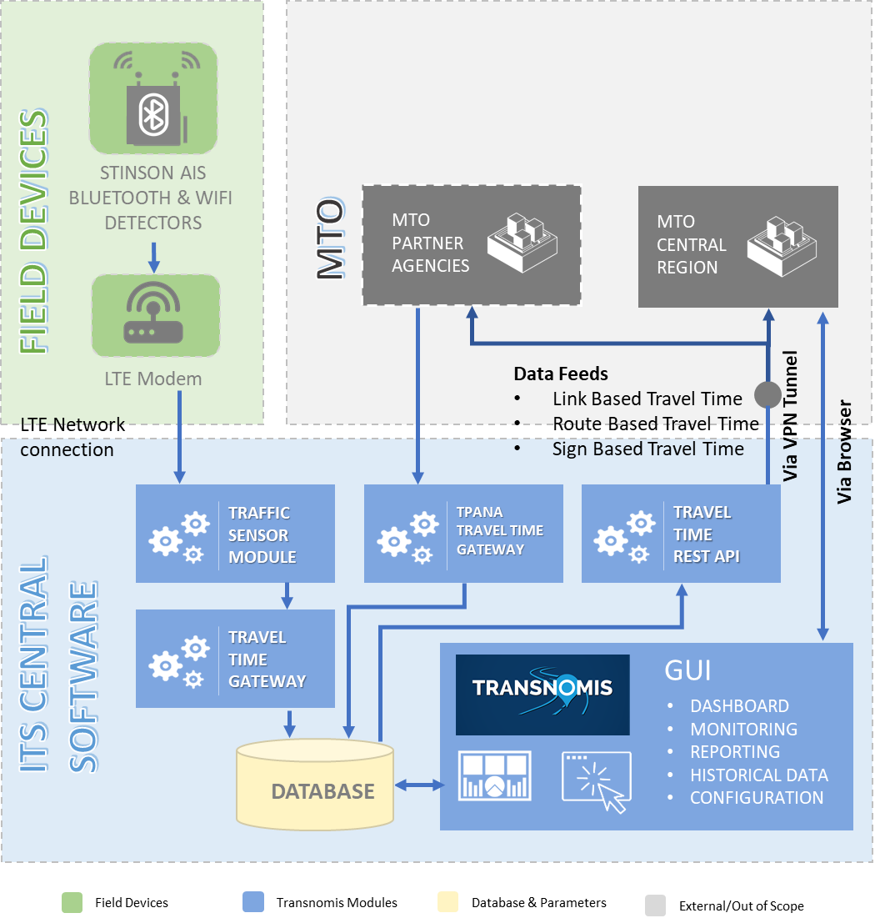

Above is an overview diagram depicting our proposed vision of the general system architecture.

Stinson AIS Bluetooth and WiFi Detectors will collect data from the field, and transmit that data to the ITS Central software, via an LTE network connection.

The entirety of the ITS Central software is proposed to be hosted by a third-party hosting service, OVH, providing triple redundant servers and failover. The third-party hosting will be provided for within the scope of this proposal, and managed by Transnomis.

The field data (hashed MAC addresses) will be received by the ITS Central’s Traffic Sensor Module, processed by the Travel Time Gateway module into travel time information and relevant statistics, and stored in the ITS Central database. Travel time information from the interjurisdictional partner agencies, will be received and processed through ITS Central’s TPANA Travel Time Gateway, for links and routes that cross MTO Central Region boundaries.

Transnomis will work with MTO and its Owners Engineer to create a secure VPN data feed for the transfer of the travel time information to the MTO’s Central Region COMPASS system and software, and to other MTO partner agencies. The processed data will meet the MTO data specifications and the data dictionary provided. The three data feeds will from ITS Central’s Travel Time REST API, and will comprise of:

* Link based Travel Times, on routes between adjacent sensors
* Route based Travel Times, between VMS and the specified destination(s)
* Sign based Travel Times messages – for each destination defined for VMS

The ITS Central GUI will allow for MTO’s system users and system administrators to interact with the system, via a web browser. The ITS Central GUI includes, but is not limited to, the following functionality:

* A configurable dashboard
* Monitoring of the field devices
* Reporting on current data and travel times
* Retrieval of historical data
* Configuration of device parameters, notification contacts, and system parameters

Using the information provided in the RFP, Transnomis has already configured all of the Bluetooth sensor locations and meta-data, as well as VMS locations:

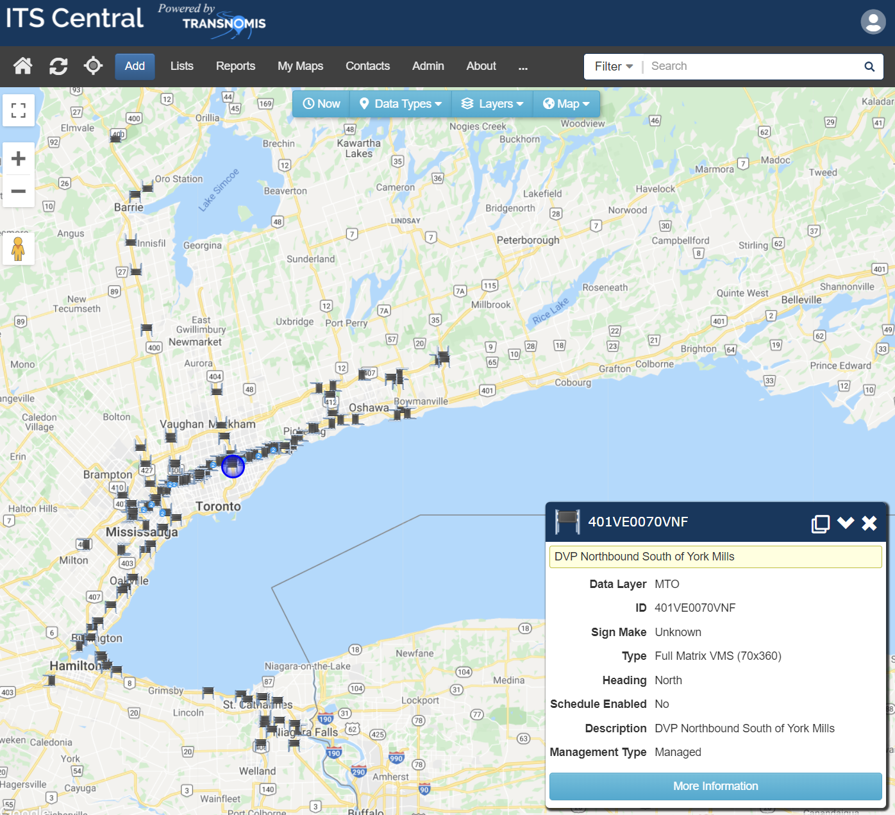

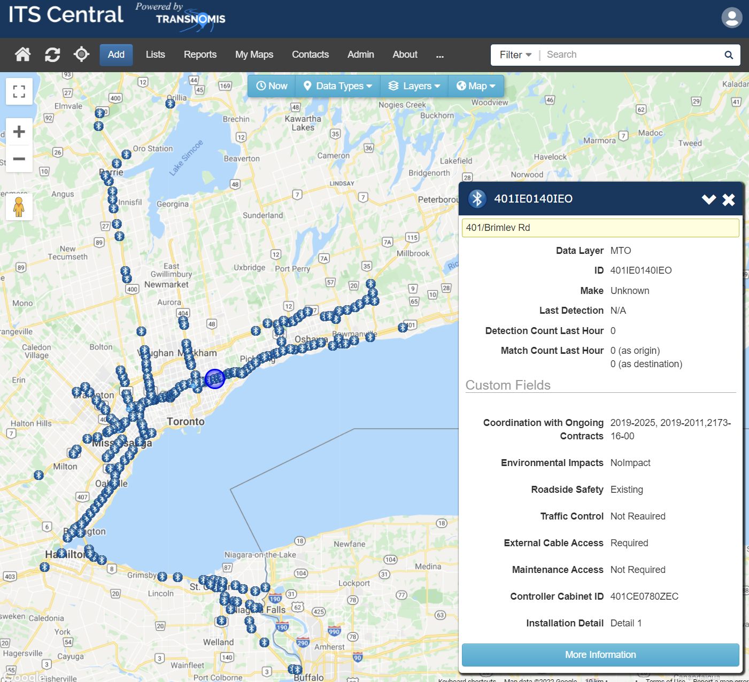

MTO will receive the data feeds, and can use the data to display travel time information on VMS. Future data sharing agreements may be reached during the Term of Agreement, per Article 3.

### **Concept** **of Operations**

The following provides a synopsis of the concept of operations

* The sensors will read the MAC addresses of detected devices (Bluetooth & Wi-Fi) as they pass through the sensor’s detection radius (minimum 100m).
* Device MAC addresses are hashed and encrypted and sent to ITS Central software instance via local LTE modem connection
* ITS Central receives hashed MAC addresses continuously from all sensors and processes the data into matches in order to calculate link travel time data (Link Data: Matches between two adjacent sensors).
* ITS Central received travel time link data from the partner agencies.
* Link data is combined to calculate the configured route times (a route is a combination of adjacent segments) as required for the three types of travel times (link-based, route based, and sign based).
* Travel time data is stored and the three types of travel times are provided to the MTO via the XML feed API interface through a secured VPN tunnel.
* MTO receives the data feeds, and uses the data for VMS displays. MTO also is able to access further data and configure/monitor devices via the web browser GUI.

## 1.15.3.4.2 Infrastructure Components and Product Cut Sheets

### **Functional Specifications of TT System Related Infrastructure Components & Cut Sheets**

**Integrated All-In-One Bluetooth Reader: Stinson AIS – Bluetooth, Bluetooth Low Energy & Wi-Fi Detection Sensor**

These devices are integrated into a non-metallic enclosure to provide the integrated all-in-one solution The Ministry has requested.

They will utilize external weatherproof omni directional antennas for long range and robust detection for highway environments. Each transceiver will have a dedicated antenna (1 for Bluetooth, 1 for Wi-Fi) in order to maximize detection quality.

While our standard aluminum enclosure is shown below for the purposes of this tender the device components will be housed in a non-metallic enclosure as has been requested.

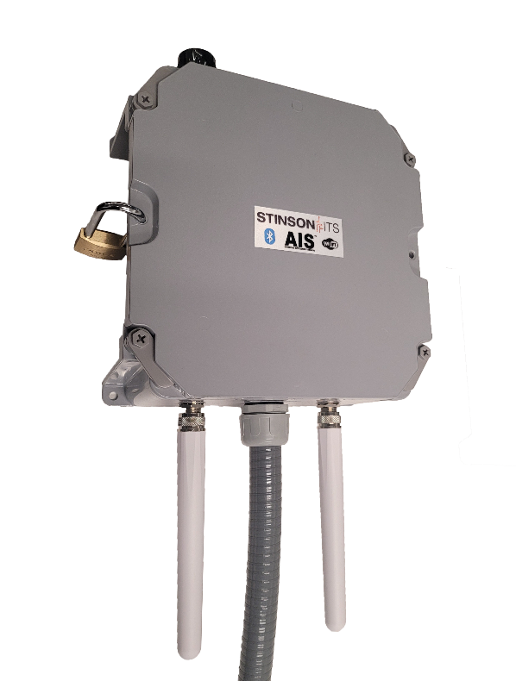The Stinson AIS is a versatile sensor which supports Bluetooth, Bluetooth Low Energy and WiFi detection.  While detection rates from a single transceiver are fairly uniform across vendors the Stinson AIS outperforms them by incorporating multiple transceivers in a single unit; our standard configuration is 1x Bluetooth transceiver and 1x WiFi transceiver.  This allows for scanning multiple frequency channels at the same time and communicating with multiple devices simultaneously.  With the addition of WiFi detection the Ministry will be able to capture 2-3 times as many devices as “Bluetooth only” devices.

Bluetooth sensors are traditionally similar in their feature sets and performance characteristics and what differentiates them is their ease of installation in various environments as well as the simplicity of configuration.  Below are some of the key attributes which set our sensor apart:

**Key Features:**

* Supports three antenna types: Low powered Omni (100m range), high powered Omni (200m range), and Directional antenna (300m range)
* Diverse Power Supply options.  Can be powered by a standard 120V AC outlet, any 9-36V DC power source, or via Power-Over-Ethernet.
* On-board SD card for data redundancy and backup. Data self-heals upon reconnect.
* NTP Time sync support
* Open-Protocol – Sensor utilizes an open-protocol firmware such that any ATMS/CMS system can integrate its protocol and receive raw detection data directly. The Ministry will not be locked into a single software vendor for travel time processing, the Stinson AIS has been integrated into a number of ATMS systems including: (1) Transnomis ITS Central and (2) Genetec Travel Time Engine

**Compact Shelf Mount Unit:**

Stinson’s shelf mount unit combines all of our hardware features into a compact enclosure.  This unit integrates an onboard wide input power supply (9-36VDC) as well as passive Power over Ethernet support.  PoE support means only a single cable is required to connect the unit, making install easier.  Its small form factor makes it ideal for traffic cabinet & PVMS mounting.  Units can be ordered with an AC or DC PoE injector.

**Technical Specifications:**

|  |  |
| --- | --- |
| **Processor** | 1.2GHz 64-Bit Quad Core |
| **Memory** | 1GB DDR-RAM |
| **I/O** | 10/100 Ethernet Port |
| **Dimensions** | 6” x 3” x 6” (L x W x H) |
| **Weight** | 3lbs |
| **Power Consumption** | 3W Nominal |
| **Power Supply** | 120VAC or 9-36VDC |
| **Antenna** | Omni Directional or Directional |
| **Detection Range** | 100m – 200m max |
| **Operating Temperature** | -40°C to +75°C |

**MTO Third-Party Tested:**

The Stinson AIS participated in an MTO project in 2016 to test a variety of alternative Bluetooth detection devices to determine their accuracy and penetration rates. This testing was performed on Hwy 26 near Wasaga Beach and involved three vendor devices: Iteris Vantage, ISS Deep Blue, and the Stinson AIS. WSP performed the testing and evaluation which focused on the Accuracy and Penetration rate of each sensor to determine if they met industry standards. The results of the testing confirmed that the Stinson AIS met industry standards for both metrics and as such were well suited for travel time applications on roadways.

**Ease of Installation:**

When designing the Stinson AIS, ease of installation and configuration were two key factors we focused on throughout the process.  With this in mind, we developed two sensor variants for installation in any environment:

* a compact shelf mount unit when cabinet space is critical
  + a standalone weatherproof pole mount unit when no cabinet or infrastructure is available (Not included)

To further ease the simplicity of installation we have designed a flexible power supply system which makes it possible to install this device nearly anywhere.  While hardwiring is possible most of our sensors are powered using Power Over Ethernet (POE), this means the power and data comes over a single Ethernet cable into the unit. This simplifies installation as there are only two cables to plug in; the Ethernet cable and the antenna cable.  Our POE system can get power from:

* 120VAC Outlet/supply
* DC supply of 9 to 36V
* Standard 802.3at/af POE network switch or midspan (adapter required, not included)

**Ease of Configuration:**

The Stinson AIS is very easy to configure, all configurations are done through a very user-friendly web interface (Screenshot below).  For normal operation the only setting that needs to be configured is the **IP Address & NTP server**.  Our unit supports DHCP as well as Static IP addressing.  Using the default IP address, it is very easy to access the web interface using any web browser.  From there you can enter the device IP and the configuration is complete.

Additional settings that can be changed in the unit are related to MAC address encryption, Network time sync and firmware upgrades.  You can also remotely reset the unit from this interface.

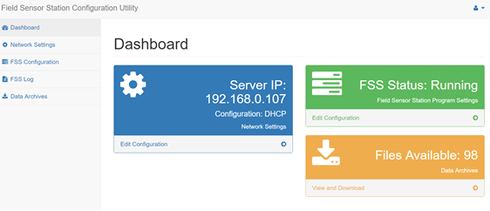

**Cellular Modem: MicroHard BulletLTE NA2**

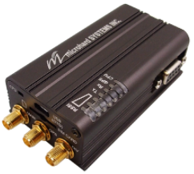MicroHard modems will be configured with a firewall and other security settings to prevent unauthorized network access. The devices will also be monitored by ITS Central to ensure normal operation and alerts will be triggered if the modem goes offline or becomes non-responsive for any reason. We employ IP whitelisting, firewall port rules, ping blocking and limiting of some network diagnostic requests to secure the device. This helps prevent DDOS attacks and other types of nuisance traffic & intrusion attempts.

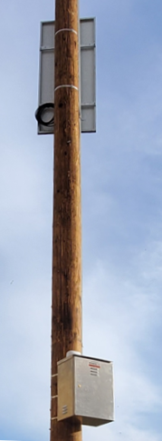**Stinson ITS Solar System**

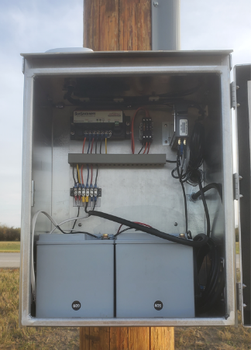Stinson will be supplying solar systems for all of the standalone sites that are called for in this project. Stinson has been designing and manufacturing solar systems for over 7 years and has extensive experience. The systems supplied shall be intentionally over-sized in order to provide exceptional performance and near zero regular maintenance. The system will provide 12 days of autonomy and will utilize a solar panel twice as large as is needed such that it can fully charge even in cloudy conditions or when the panel is partially covered in snow. The system utilizes an MPPT solar controller which allows for charging during the above-mentioned challenging conditions when solar voltage is not optimal. The solar panel will also be mounted at a very steep angle (75-90 degrees) in order to ensure rapid shedding of any snow accumulation. The system includes separate fuses for the batteries, load and solar panel allowing for easy de-energization for service and maintenance.

**Product Cutsheets**

**Stinson ITS – AIS Sensor**

Datasheet: Please refer to Appendix X Stinson AIS Travel Time Sensor

**MicroHard BulletLTE NA2 – Cellular Modem**

Datasheet: Please refer to Appendix X MicroHard BulletLTE NA2 Cellular Modem

**Scepter JBOX - Weatherproof Enclosure**

Datasheet: Please refer to Appendix X Scepter JBOX Weatherproof Enclosure

**HESPV – Solar Panel**

Datasheet: Please refer to Appendix X HESPV-160-36PV Solar Panel

**Morningstar Professional Series – Solar Controller**

Datasheet: Please refer to Appendix X Morningstar Professional Series Sunsaver MPPT Solar Controller

**DEKA – Valve-Regulated Absorbed Glass Matt (AGM) Batteries**

Datasheet: Please refer to Appendix X DEKA AGM Solar Photovoltaic Batteries

**Server Hosting**

For hosting, we propose the services of OVH (<https://www.ovh.com/>). It is one of the largest internet hosting companies in the world, with 400,000 servers, 33 data centers in 4 continents and 1.6 million customers. It is fully certified:

* PCI DSS
* ISO/IEC 27001, 27017, 27018, 27701, 50001
* SOC 1, SOC 2 and SOC 3
* Cloud Security Alliance STAR certified

OVH.com has a data center in Beauharnois, QC. Its facility is highly secure with access only by authorized employees. It has technician and security on-site 24/7. It has systematic double power supply, 250 kVA UPS and generators with an initial autonomy of 48 hours. It has a minimum of 2 network connections and two network rooms within each of its data centers. For more information, please see <https://www.ovh.com/ca/en/about-us/datacenters.xml>

As part of the contract, Transnomis Solutions will procure three dedicated servers with OVH data center in Beauharnois, QC. One server will be the primary server hosting the ITS Central application. The second (fail-over) server will be used for live streaming replication, which will be ready to take over immediately should the primary server fails. The third server will also have live streaming replication serving as hot spare.

Although hosting is provided by reliable third party, Transnomis Solutions is fully responsible for the availability of its software service. The Ministry will never have to deal with the hosting company. Transnomis Solutions will be the single point of contact for all issues related to services provided for this contract, including server availability issues.

# 1.15.3.5 COMPLIANCE WITH SYSTEM SPECIFICATIONS

**1.15.3.5.1 SOFTWARE COMPLIANCE MATRIX**

|  |  |  |  |
| --- | --- | --- | --- |
| **2.6.5.1 General System Overview** | |  |  |
| **Item No.** | **Requirement** | **Currently Compliant** | **Additional Details** |
| **(Yes/No)** |
| **1.1** | The Solution shall receive raw data from Bluetooth Readers deployed in the field. | Yes | See section titled “Detailed Software Compliance”. |
| **1.2** | The Solution shall process the raw data into travel time information as per the MTO defined formats. | Yes | See section titled “Detailed Software Compliance”. |
| **1.3** | The Solution shall publish the travel time information as secured data feeds. | Yes | See section titled “Detailed Software Compliance”. |
| **1.4** | The data feeds shall be made accessible to MTO through a secure data transmission channel. | Yes | See section titled “Detailed Software Compliance”. |
| **1.5** | The Solution shall publish the travel time information as a secured public API for future system integration and data sharing within MTO and with other jurisdictions specified by MTO. | Yes | See section titled “Detailed Software Compliance”. |

|  |  |  |  |
| --- | --- | --- | --- |
| **2.6.5.2 System Configuration and Operations** | | | |
| **Item No.** | **Requirement** | **Currently Compliant** | **Additional Details** |
| **(Yes/No)** |
| **2.1** | The Solution shall be configured to operate using the metric system of measurement. | Yes | See section titled “Detailed Software Compliance”. |
| **2.2** | The Solution shall be scalable to accommodate the future expansion of the TT System, including geographic expansion, and the addition of Readers, routes, and VMSs, by continuing to provide the same level of service. Details of future hardware expansions are described in Section 8. | Yes | See section titled “Detailed Software Compliance”. |
| **2.3** | The Solution shall operate and publish real-time travel time data feeds continuously (i.e. 24/7, 365 days). | Yes | See section titled “Detailed Software Compliance”. |
| **2.4** | The Solution shall have a continuous monthly uptime of at minimum 99% outside of any scheduled and routine maintenance. | Yes | See section titled “Detailed Software Compliance”. |
| **2.5** | The Solution shall have backup or redundancy procedures in place in order to resume normal operations upon system failure. | Yes | See section titled “Detailed Software Compliance”. |
| **2.6** | The Proponent shall provide remote access to the TT System Graphical User Interface (GUI) to authorized MTO users in a secured manner. | Yes | See section titled “Detailed Software Compliance”. |
| **2.7** | The GUI shall be compatible with Microsoft Edge Version 88 or later, and Google Chrome Version 79 or later. | Yes | See section titled “Detailed Software Compliance”. |
| **2.8** | At minimum, the GUI shall consist of the following four (4) modules: - Travel Time Dashboard (see Section 2.6.5.6); - Historical Data Portal (see Section 2.6.5.5.5); - Reporting System (see Section 2.6.5.7); and - System Parameter Configuration (see Section 2.6.5.10). | Yes | See section titled “Detailed Software Compliance”. |
| **2.9** | The GUI shall be able to accommodate simultaneous operations by at least ten (10) concurrent users, with no adverse effects. | Yes | See section titled “Detailed Software Compliance”. |
| **2.10** | The GUI shall comply with the Accessibility for Ontarians with Disabilities Act (AODA). | Yes | See section titled “Detailed Software Compliance”. |
| **2.11** | The GUI shall comply with the Web Content Accessibility Guidelines (WCAG) 2.1. | Yes | See section titled “Detailed Software Compliance”. |

|  |  |  |  |
| --- | --- | --- | --- |
| **2.6.5.3 User Access, Security and Privacy** | |  |  |
| **Item No.** | **Requirement** | **Currently Compliant** | **Additional Details** |
| **(Yes/No)** |
| **3.1** | All end-to-end services of the TT System shall comply with the latest Government of Ontario Information Technology Standards (GO ITS) security requirements. | Yes | See section titled “Detailed Software Compliance”. |
| **3.2** | All end-to-end services of the system shall comply with the guidelines described in the Freedom of Information and Protection of Privacy Manual published by the Government of Ontario. | Yes | See section titled “Detailed Software Compliance”. |
| **3.3** | The Proponent shall limit all accesses to the Solution to authorized individuals identified by MTO during the Term of Agreement. | Yes | See section titled “Detailed Software Compliance”. |
| **3.4** | User access privileges shall be definable on a functional level. This shall allow for different levels and roles of users to access system features and functions. | Yes | See section titled “Detailed Software Compliance”. |
| **3.5** | User access privileges shall be definable by MTO and managed by the Proponent during the Term of Agreement. | Yes | See section titled “Detailed Software Compliance”. |
| **3.6** | The user access privileges shall be categorized, as a minimum, as: - System Administrators (Service Provider) – shall have full access to the system as well as the capability for maintaining user account passwords and privilege levels; - System Administrators (Client) – shall have access for monitoring real-time and historical travel time information, reporting, and system parameter configuration as well as the capability for maintaining user account privilege levels; - System Operators – System access for monitoring real-time, historical travel time information, and reporting. Access can be limited to a geographic area, with Report Only privileges on the remaining network;  - System Report Only – Capable of viewing the system and viewing/printing reports. | Yes | See section titled “Detailed Software Compliance”. |
| **3.7** | The Proponent shall collaborate with MTO to establish a site-to-site IPSec VPN tunnel between the system and MTO firewall. | Yes | See section titled “Detailed Software Compliance”. |
| **3.8** | The VPN tunnel shall use secure channels to transmit data feeds, including but not limited to:  - Hypertext transfer protocol secure (HTTPS); and - Secure file transfer protocol (SFTP). | Yes | See section titled “Detailed Software Compliance”. |

|  |  |  |  |
| --- | --- | --- | --- |
| **2.6.5.4 Device Integration** | |  |  |
| **Item No.** | **Requirement** | **Currently Compliant** | **Additional Details** |
| **(Yes/No)** |
| **4.1** | Each Bluetooth reader shall be assigned a unique ID value for identification purposes by the Solution, which shall match the Bluetooth reader’s ID assigned by MTO (see Appendix C). | Yes | See section titled “Detailed Software Compliance”. |
| **4.2** | Each VMS shall be assigned a unique ID value for identification purposes by the Solution, which shall match the VMS’s ID assigned by MTO (see Appendix C). | Yes | See section titled “Detailed Software Compliance”. |
| **4.3** | Bluetooth reader operational failures and losses of communication with the Solution shall be automatically logged for reporting and auditing purposes. | Yes | See section titled “Detailed Software Compliance”. |
| **4.4** | Data stored internally on a Bluetooth reader collected in the event of an interruption of communications with the Solution (see Section 2.6.2), shall be automatically transferred and loaded into the Solution once communications are restored. | Yes | See section titled “Detailed Software Compliance”. |
| **4.5** | The Solution shall be capable of configuring Bluetooth reader settings, including: - Bluetooth reader ID as assigned by MTO; - System-related functions, including data storage, and user authentication; - Network-related parameters, including IP address, netmask, and gateway; - Time synchronization between the travel time server and Bluetooth Readers; and - Other features required to make the Proponent’s Bluetooth Readers operational. | Yes | See section titled “Detailed Software Compliance”. |
| **4.6** | The Bluetooth Readers shall be configured such that the Vendor receives a notification immediately upon Bluetooth device failure. | Yes | See section titled “Detailed Software Compliance”. |
| **4.7** | The Solution shall record details of any Bluetooth device configuration changes. | Yes | See section titled “Detailed Software Compliance”. |
| **4.8** | The Media Access Control (MAC) IDs of all captured Bluetooth-enabled devices shall be encrypted automatically based on industry standard encryption and privacy requirements. | Yes | See section titled “Detailed Software Compliance”. |

|  |  |  |  |
| --- | --- | --- | --- |
| **2.6.5.5 Data Requirements** | |  |  |
| **2.6.5.5.1 Data Collection** | |  |  |
| **Item No.** | **Requirement** | **Currently Compliant** | **Additional Details** |
| **(Yes/No)** |
| **5.1.1** | The Solution shall be configured to collect and process data from all Bluetooth Readers deployed by the Proponent under this Contract. | Yes | See section titled “Detailed Software Compliance”. |
| **5.1.2** | The data processing time between receiving raw data into the Solution and processing travel time information shall not be greater than one (1) second. | Yes | See section titled “Detailed Software Compliance”. |

|  |  |  |  |
| --- | --- | --- | --- |
| **2.6.5.5.2 Data Processing** | |  |  |
| **Item No.** | **Requirement** | **Currently Compliant** | **Additional Details** |
| **(Yes/No)** |
| **5.2.1** | The Solution shall support all data processing procedures required for the development of travel time information. | Yes | See section titled “Detailed Software Compliance”. |
| **5.2.2** | The travel time for a route shall be calculated using the travel times of the links that make up the route. | Yes | See section titled “Detailed Software Compliance”. |
| **5.2.3** | The Proponent shall automatically infill route travel time information in the event of an origin Bluetooth reader failure. | Yes | See section titled “Detailed Software Compliance”. |
| **5.2.4** | The Proponent shall automatically infill route travel time information in the event of an intermediate Bluetooth reader failure. | Yes | See section titled “Detailed Software Compliance”. |
| **5.2.5** | The Proponent shall automatically infill route travel time information in the event of a destination Bluetooth reader failure. | Yes | See section titled “Detailed Software Compliance”. |
| **5.2.6** | The Solution shall be capable of filtering data to remove anomalies, outliers, and encrypted MAC IDs unmatched to a destination using robust statistical methods. | Yes | See section titled “Detailed Software Compliance”. |
| **5.2.7** | Processing statuses and conditions, including recalculation, anomalies, and unmatched encrypted MAC IDs, shall be recorded with the processed data to support post-mortem analysis. | Yes | See section titled “Detailed Software Compliance”. |

|  |  |  |  |
| --- | --- | --- | --- |
| **2.6.5.5.3 Data Feed Configuration** | |  |  |
| **Item No.** | **Requirement** | **Currently Compliant** | **Additional Details** |
| **(Yes/No)** |
| **5.3.1** | The Solution shall generate three (3) real-time secured data feeds:  • Link-based TT – TT between two adjacent BT;  • Route-based TT – TT between VMS and the displayed destination; and • Sign-based TT message – for each destination defined for VMS. | Yes | See section titled “Detailed Software Compliance”. |
| **5.3.2** | The Proponent shall construct these data feeds in compliance with MTO data specifications provided in Appendix C. | Yes | See section titled “Detailed Software Compliance”. |
| **5.3.3** | The link-based travel time data feed shall be in XML format. | Yes | See section titled “Detailed Software Compliance”. |
| **5.3.4** | The link-based travel time data feed shall be encoded in UTF-8 format. | Yes | See section titled “Detailed Software Compliance”. |
| **5.3.5** | The route-based travel time data feed shall be in XML format. | Yes | See section titled “Detailed Software Compliance”. |
| **5.3.6** | The route-based travel time data feed shall be encoded in UTF-8 format. | Yes | See section titled “Detailed Software Compliance”. |
| **5.3.7** | The sign-based travel time message data feed shall be in XML format. | Yes | See section titled “Detailed Software Compliance”. |
| **5.3.8** | The sign-based travel time message data feed shall be encoded in UTF-8 format. | Yes | See section titled “Detailed Software Compliance”. |
| **5.3.9** | The Proponent shall define data timeout limits signifying whether a travel time measurement is recent and representative of real-time conditions. | Yes | See section titled “Detailed Software Compliance”. |
| **5.3.10** | Multiple data timeout limits shall be configurable to support differences in traffic patterns between rural and urban areas. | Yes | See section titled “Detailed Software Compliance”. |
| **5.3.11** | The default user-specified data timeout limit shall be two (2) minutes. | Yes | See section titled “Detailed Software Compliance”. |
| **5.3.12** | The Solution shall automatically determine whether a VMS message is “valid” for a given time period. A message is “invalid” if one of the following occurs:  - Route travel time information is unavailable (including but not limited to loss of communication, or no device matches); or - If the timestamp of the route travel time information provided exceeds the user-specified data timeout limit. | Yes | See section titled “Detailed Software Compliance”. |
| **5.3.13** | The Solution shall allow MTO to define a configurable, pre-specified time period, during which MTO will publish route travel time messages on VMSs. The initial default time period shall be: - Weekdays (Monday to Friday) – 6:00am to 10:00am, 3:00pm to 8:00pm; and - Weekends (Saturday and Sunday) and statutory holidays – 9:00am to 12:00pm, 5:00pm to 9:00pm. | Yes | See section titled “Detailed Software Compliance”. |
| **5.3.14** | The Solution shall have the ability to identify real-time route travel time as slow traffic condition as per MTO definition. | Yes | See section titled “Detailed Software Compliance”. |
| **5.3.15** | The slow traffic condition shall be configurable in the Solution. | Yes | See section titled “Detailed Software Compliance”. |
| **5.3.16** | As a default, slow traffic shall be defined as two (2) times the free-flow travel time (i.e. travel speed is half of the speed limit). | Yes | See section titled “Detailed Software Compliance”. |
| **5.3.17** | The refresh rate of the secured link-based travel time data feed shall be no longer than one (1) minute. | Yes | See section titled “Detailed Software Compliance”. |
| **5.3.18** | The refresh rate of the secured route-based travel time data feed shall be no longer than one (1) minute. | Yes | See section titled “Detailed Software Compliance”. |
| **5.3.19** | The refresh rate of the secured sign-based travel time message data feed shall be no longer than one (1) minute. | Yes | See section titled “Detailed Software Compliance”. |
| **2.6.5.5.4 Data Storage and Archiving** | |  |  |
| **Item No.** | **Requirement** | **Currently Compliant** | **Additional Details** |
| **(Yes/No)** |
| **5.4.1** | Data shall be hosted and stored by the Proponent within Canada utilizing cloud-based solution, outside of MTO premises. | Yes | See section titled “Detailed Software Compliance”. |
| **5.4.2** | Historical aggregated travel time information shall be stored and accessible to users for the duration of the Contract. | Yes | See section titled “Detailed Software Compliance”. |
| **5.4.3** | The aggregation period of historical aggregated travel time information shall be at least every five (5) minutes. | Yes | See section titled “Detailed Software Compliance”. |
| **5.4.4** | Stored aggregated travel time information shall include at minimum: - Link; - Route; - Travel time; - VMS ID;  - Number of encrypted MAC ID matches; and - VMS messages from the generated sign-based TT message XML feed. | Yes | See section titled “Detailed Software Compliance”. |
| **5.4.5** | VMS message archives in the stored aggregated travel time information shall include information traceable to the underlying VMS ID, defined routes on a specific VMS, assigned links, and Bluetooth reader’s aggregated recorded data for future analysis, as well as retroactive diagnostic capabilities. | Yes | See section titled “Detailed Software Compliance”. |
| **5.4.6** | The Proponent shall store a minimum of six (6) months of historical raw data for auditing purposes, including individual timestamped encrypted MAC ID records with their associated Bluetooth Readers. | Yes | See section titled “Detailed Software Compliance”. |

|  |  |  |  |
| --- | --- | --- | --- |
| **2.6.5.5.5 Historical Data Access** | |  |  |
| **Item No.** | **Requirement** | **Currently Compliant** | **Additional Details** |
| **(Yes/No)** |
| **5.5.1** | All historical data access and querying by users, or by user request to the Proponent, shall be done through use of the GUI historical data portal module. | Yes | See section titled “Detailed Software Compliance”. |
| **5.5.2** | The data portal screen shall provide, at minimum, the following selection criteria for data querying: - Time period type (single, continuous or recurring); - Time period (time of day, day of week, time of year); - Location (All locations, a specific region or zoomed area, selected routes); and - Field hardware (selected VMSs and Bluetooth Readers). | Yes | See section titled “Detailed Software Compliance”. |
| **5.5.3** | The historical data portal shall be accessible remotely by MTO users. | Yes | See section titled “Detailed Software Compliance”. |
| **5.5.4** | Historical data shall be readily accessible to MTO users within five (5) minutes of travel time information publishing. | Yes | See section titled “Detailed Software Compliance”. |
| **5.5.5** | VMS messages shall be included in queries of field hardware and location for auditing and accuracy checking purposes. | Yes | See section titled “Detailed Software Compliance”. |
| **5.5.6** | Users shall be able to query travel times of routes over a specified time period. | Yes | See section titled “Detailed Software Compliance”. |
| **5.5.7** | Users shall be able to query travel times of routes by recurring time periods, including but not limited to specific days of the week over a specified number of weeks. | Yes | See section titled “Detailed Software Compliance”. |
| **5.5.8** | Each link travel time query shall include individual check-in and check-out timestamps of the Bluetooth pair forming the link, and the calculated travel time for each encrypted MAC ID. | Yes | See section titled “Detailed Software Compliance”. |
| **5.5.9** | Each route and link travel time query shall include the travel time average, maximum, and minimum values over the records in the query. | Yes | See section titled “Detailed Software Compliance”. |
| **5.5.10** | Each route and link travel time query shall show the number of matched and unmatched records in that time period. | Yes | See section titled “Detailed Software Compliance”. |
| **5.5.11** | Each route and link travel time query shall display the MTO-assigned IDs of the origin and destination Readers. | Yes | See section titled “Detailed Software Compliance”. |
| **5.5.12** | Each route and link travel time query shall include the MTO-assigned ID of the query’s selected routes and links. | Yes | See section titled “Detailed Software Compliance”. |
| **5.5.13** | Each route and link travel time query shall include the MTO-assigned VMS ID of any sign that displays information for the route. | Yes | See section titled “Detailed Software Compliance”. |
| **5.5.14** | The data portal shall be able to query historical data for any Bluetooth reader or VMS, based on its unique MTO-assigned Bluetooth or VMS ID. | Yes | See section titled “Detailed Software Compliance”. |
| **5.5.15** | Queries of Bluetooth Readers shall include individual encrypted MAC ID records with check-in and check-out timestamps for the Bluetooth pairs. | Yes | See section titled “Detailed Software Compliance”. |

|  |  |  |  |
| --- | --- | --- | --- |
| **2.6.5.5.6 Data Ownership** | |  |  |
| **Item No.** | **Requirement** | **Currently Compliant** | **Additional Details** |
| **(Yes/No)** |
| **5.6.1** | MTO shall own all data, including aggregated and archived data. | Yes | See section titled “Detailed Software Compliance”. |
| **5.6.2** | The Proponent shall perform a regular data dump to MTO. MTO to provide the Proponent with details on frequency of these data dumps and which data to include. Data to include at minimum processed travel time data for all links and routes in Central Region. | Yes | See section titled “Detailed Software Compliance”. |
| **2.6.5.6 Travel Time Dashboard** | |  |  |
| **Item No.** | **Requirement** | **Currently Compliant** | **Additional Details** |
| **(Yes/No)** |
| **6.1** | The GUI shall provide a dashboard for MTO to access real-time travel time and hardware (Bluetooth reader, VMS) information. | Yes | See section titled “Detailed Software Compliance”. |
| **6.2** | The dashboard shall include a map view. | Yes | See section titled “Detailed Software Compliance”. |
| **6.3** | The dashboard shall include a map view. | Yes | See section titled “Detailed Software Compliance”. |
| **6.4** | The dashboard shall provide information on travel time index (TTI) for links and routes. TTI = TT (real-time) / TT (free-flow) | Yes | See section titled “Detailed Software Compliance”. |
| **6.5** | The dashboard shall provide information on buffer time index (BTI) for links and routes. BTI = (TT (95th percentile) – TT (real-time)) / TT (real-time) | Yes | See section titled “Detailed Software Compliance”. |
| **6.6** | The dashboard shall provide information regarding the number of matched encrypted MAC ID records for a specified link, route, and time period.) | Yes | See section titled “Detailed Software Compliance”. |
| **6.7** | The dashboard table/graphical view shall default to displaying VMSs and their associated route destinations and their most recent travel time information and the associated date/time stamp information for each VMS TT message. | Yes | See section titled “Detailed Software Compliance”. |
| **6.8** | The dashboard table/graphical view shall have the capability of listing historical route travel times and messages. | Yes | See section titled “Detailed Software Compliance”. |
| **6.9** | The dashboard table/graphical view shall have the option to tabulate travel time routes, displaying their associated Bluetooth Readers, travel times, and historical travel times. | Yes | See section titled “Detailed Software Compliance”. |
| **6.10** | The dashboard table/graphical view shall have the option to tabulate Bluetooth Readers, and display the associated routes, real-time travel times, and historical travel times. | Yes | See section titled “Detailed Software Compliance”. |
| **6.11** | The dashboard base map shall be up-to-date, and shall be based on Google Maps, Bing Maps, or equivalent. | Yes | See section titled “Detailed Software Compliance”. |
| **6.12** | The base map shall be updated annually, and/or when a new section of highway is open within MTO jurisdiction. | Yes | See section titled “Detailed Software Compliance”. |
| **6.13** | The Proponent shall be responsible for obtaining and renewing the map license. | Yes | See section titled “Detailed Software Compliance”. |
| **6.14** | The dashboard map shall be used to display travel times as coloured lines overlain on roadways. | Yes | See section titled “Detailed Software Compliance”. |
| **6.15** | The dashboard map view shall default to displaying MTO Central Region. The map view shall include functionality to configure zoom and focus to suit display size. | Yes | See section titled “Detailed Software Compliance”. |
| **6.16** | All MTO roadways included in the TT System shall be labelled by default. | Yes | See section titled “Detailed Software Compliance”. |
| **6.17** | The dashboard map shall include an option to display a map of individual municipalities within Ontario. | Yes | See section titled “Detailed Software Compliance”. |
| **6.18** | The dashboard map shall include an option to display a map of other MTO Regions and the full province of Ontario. | Yes | See section titled “Detailed Software Compliance”. |
| **6.19** | The dashboard map shall include a zoom feature to display a selected area of the province of Ontario. | Yes | See section titled “Detailed Software Compliance”. |
| **6.20** | The dashboard map shall be able to display the locations of TT System components, including Bluetooth Readers, VMSs, and routes. | Yes | See section titled “Detailed Software Compliance”. |
| **6.21** | The dashboard map shall default to showing real-time travel time information on its routes. Data shall be refreshed every one (1) minute. | Yes | See section titled “Detailed Software Compliance”. |
| **6.22** | The dashboard map shall be able to display historical travel time if desired by the user. | Yes | See section titled “Detailed Software Compliance”. |

|  |  |  |  |  |
| --- | --- | --- | --- | --- |
| **2.6.5.7 Reporting System** | |  |  | |
| **Item No.** | **Requirement** | **Currently Compliant** | | **Additional Details** | |
| **(Yes/No)** | |
| **7.1** | The GUI shall consist of a user-accessible reporting system. | Yes | | See section titled “Detailed Software Compliance”. | |
| **7.2** | The GUI shall consist of a user-accessible reporting system. Reads (number of Bluetooth-enabled devices detected at each Bluetooth reader): - Matches (number of matched encrypted MAC IDs for any pair of Bluetooth Readers); - Instances of “slow traffic” in the sign-based TT message XML feed (see Item 5.3.14 in Section 2.6.5.5.3); - Validity of VMS messages in the sign-based TT message XML feed (see Item 5.3.12 in Section 2.6.5.5.3); - Bluetooth reader health and a log of trouble tickets; - Bluetooth reader communications disruptions; - Travel Time (for any route configured in the system); and - Origin-Destination patterns. | Yes | | See section titled “Detailed Software Compliance”. | |
| **7.3** | The reporting system shall be able to report on any user-specified historical time period and location. | Yes | | See section titled “Detailed Software Compliance”. | |
| **7.4** | The reporting system shall allow users to generate and display, as a minimum, the following comparisons of travel time information in graph and chart form:  - Comparison of raw data reads from two or more Bluetooth Readers for a specific time period; - Comparison of travel time between two or more specified time periods for a specific link or route; and - Comparison of travel time between two or more routes for a specific time period. Output shall be customizable. | Yes | | See section titled “Detailed Software Compliance”. | |
| **7.5** | The reporting system shall be able to present data distributions of travel times for a specified time period and location. | Yes | | See section titled “Detailed Software Compliance”. | |
| **7.6** | The reporting system shall have the ability to generate reports based on ad-hoc queries, including but not limited to:  - Selection of any Bluetooth reader to generate reports of detected Bluetooth-enabled device counts (reads) at any date; and - Selection of any two routes to generate and display differences in the number of matches and travel time for a selected time interval. | Yes | | See section titled “Detailed Software Compliance”. | |
| **7.7** | The reports from the reporting system shall be generated in a printer-friendly and clearly organized format. | Yes | | See section titled “Detailed Software Compliance”. | |
| **7.8** | The reports shall be exportable in CSV file format. | Yes | | See section titled “Detailed Software Compliance”. | |
| **7.9** | The reports shall be exportable in XML file format. | Yes | | See section titled “Detailed Software Compliance”. | |
| **7.10** | The reports shall be exportable in PDF file format. | Yes | | See section titled “Detailed Software Compliance”. | |
| **7.11** | The reporting system shall automatically generate the following reports on a daily, weekly, and monthly basis, and archive these reports: - Ranking of routes by average speed; and - Ranking of routes by average travel time per kilometre. | Yes | | See section titled “Detailed Software Compliance”. | |
| **7.12** | Reports generated shall be automatically forwarded by email to a pre-set list of users compiled by the System Administrator. | Yes | | See section titled “Detailed Software Compliance”. | |

**2.6.5.8 Partner Data Sharing**

|  |  |  |  |
| --- | --- | --- | --- |
| **Item No.** | **Requirement** | **Currently Compliant** | **Additional Details** |
| **(Yes/No)** |
| **8.1** | Data feeds generated by the solution shall be sharable with partners as defined by MTO. | Yes | See section titled “Detailed Software Compliance”. |
| **8.2** | The Solution shall share the data feeds with MTO West Region and East Region for its links which cross into Central Region jurisdiction. These data feeds shall match the format presented in Appendix C.  MTO to provide a list of these locations following Contract award. | Yes | See section titled “Detailed Software Compliance”. |
| **8.3** | The Solution shall integrate with MTO West Region’s and East Region’s TT System in order to receive relevant shared data feeds.  MTO to provide a list of these locations following Contract award.  West Region’s and East Region’s data feeds follow the data dictionaries outlined in Appendix C. | Yes | See section titled “Detailed Software Compliance”. |
| **8.4** | The Solution shall operate with other link-based TT for route-based and sign-based TT measurement and shall be able to add TT from data feeds received from other jurisdictions (MTO West Region and East Region) to TT generated by the Solution’s central software to complete TT routes which span the two jurisdictions. | Yes | See section titled “Detailed Software Compliance”. |

|  |  |  |  |
| --- | --- | --- | --- |
| **2.6.5.9 System Maintenance** | |  |  |
| **Item No.** | **Requirement** | **Currently Compliant** | **Additional Details** |
| **(Yes/No)** |
| **9.1** | The Proponent shall be responsible for all maintenance of the Solution during the Term of Agreement. | Yes | See section titled “Detailed Software Compliance”. |
| **9.2** | All scheduled and routine maintenance performed by the Proponent must be done outside the pre-specified time period for VMS message publication, as specified in Item 5.3.13 in Section 2.6.5.5.3. | Yes | See section titled “Detailed Software Compliance”. |
| **9.3** | In the event the Proponent makes any changes to its processes or methodologies during the Term of Agreement, including but not limited to data collection, processing methodology, storage, hosting, or cybersecurity, the Proponent shall inform MTO in detail of these changes in advance. Prior to these changes, the Proponent shall provide documentation to demonstrate that these changes comply with the specifications of this Agreement. MTO to test and approve these changes at their discretion. | Yes | See section titled “Detailed Software Compliance”. |
| **9.4** | The Proponent shall keep the Solution up to date with the latest available software updates for the duration of the Term of Agreement. | Yes | See section titled “Detailed Software Compliance”. |
| **9.5** | The Proponent shall provide all bug patches to the Solution upon development. | Yes | See section titled “Detailed Software Compliance”. |
| **9.6** | The Proponent shall refer to the SLA for operational procedures to process maintenance requests by MTO. | Yes | See section titled “Detailed Software Compliance”. |

**2.6.5.10 System Parameter Configuration**

|  |  |  |  |
| --- | --- | --- | --- |
| **Item No.** | **Requirement** | **Currently Compliant** | **Additional Details** |
| **(Yes/No)** |
| **10.1** | All system parameter configuration by users, or by user request to the Proponent, shall be done through use of the GUI system configuration module. | Yes | See section titled “Detailed Software Compliance”. |
| **10.2** | The system configuration module shall be able to perform device configuration changes described in Section 2.6.5.4. | Yes | See section titled “Detailed Software Compliance”. |
| **10.3** | The system configuration module shall be able to add, modify, and delete Bluetooth Readers. | Yes | See section titled “Detailed Software Compliance”. |
| **10.4** | The system configuration module shall be able to define and configure routes by combining multiple links together and pairing Bluetooth Readers to VMSs. | Yes | See section titled “Detailed Software Compliance”. |
| **10.5** | The system configuration module shall be able to configure the data feed refresh rate. | Yes | See section titled “Detailed Software Compliance”. |
| **10.6** | The system configuration module shall be able to configure the outlier filtering algorithm. | Yes | See section titled “Detailed Software Compliance”. |
| **10.7** | The system configuration module shall be able to configure the pre-specified time period for VMS message publication. | Yes | See section titled “Detailed Software Compliance”. |
| **10.8** | The system configuration module shall be able to configure the slow traffic condition. | Yes | See section titled “Detailed Software Compliance”. |
| **10.9** | The system configuration module shall be able to configure the data timeout duration. | Yes | See section titled “Detailed Software Compliance”. |
| **10.10** | The system configuration module shall be able to configure the map display, including placing Bluetooth Readers on the map, drawing routes, and defining travel time thresholds to change route colours. | Yes | See section titled “Detailed Software Compliance”. |
| **10.11** | For auditing purposes, the Solution shall record details of any changes to the above parameters. | Yes | See section titled “Detailed Software Compliance”. |
| **10.12** | The Proponent shall refer to the SLA for operational procedures to process requests by MTO to make changes to the service configurations listed above. | Yes | See section titled “Detailed Software Compliance”. |
| **10.13** | The Proponent shall back-up the parameters of the existing TT System configuration, including but not limited to properties and locations of all BT Readers, routes, links, and VMS messages. Parameter configuration back-ups shall be saved in an accessible file. | Yes | See section titled “Detailed Software Compliance”. |
| **10.14** | The Solution shall automatically send the configuration file (listed in Item 10.13) detailing the current system configuration to MTO on the last business day of every month. | Yes | See section titled “Detailed Software Compliance”. |
| **10.15** | The Solution shall automatically send the configuration file (listed in Item 10.13) detailing the current system configuration to MTO on the last day of the Term of Agreement. | Yes | See section titled “Detailed Software Compliance”. |

|  |  |  |  |
| --- | --- | --- | --- |
| **2.6.5.11 System Performance and Diagnostics** | |  |  |
| **Item No.** | **Requirement** | **Additional Details** | **Additional Details** |
|  |
| **11.1** | The Solution shall be capable of sending email alert notifications to pre-configured recipients in the event that the system availability has dropped below a threshold in a given day or week. | Yes | See section titled “Detailed Software Compliance”. |  |
| **11.2** | The Solution shall generate daily, weekly, and monthly reports on the status of the Readers, including field hardware health and communications status. | Yes | See section titled “Detailed Software Compliance”. |  |
| **11.3** | The Solution shall monitor the status of the Bluetooth Readers in real-time. | Yes | See section titled “Detailed Software Compliance”. |  |
| **11.4** | The Solution shall display information regarding the status of Bluetooth Readers on a dedicated screen accessible from the GUI containing, at minimum, the MTO-assigned ID of the reader, IP address of the reader, and the last time data was received from the reader. | Yes | See section titled “Detailed Software Compliance”. |  |
| **11.5** | The Solution shall be capable of sending email alert notifications to pre-configured recipients in the event that a reader loses communication with the Solution. | Yes | See section titled “Detailed Software Compliance”. |  |
| **11.6** | The Solution shall be capable of sending email alert notifications to pre-configured recipients in the event that configured link or route speed thresholds are exceeded. | Yes | See section titled “Detailed Software Compliance”. |  |

**Detailed Software Compliance**

**General System Overview (2.6.5.1)**

*1.1. The Solution shall receive raw data from Bluetooth Readers deployed in the field.*

Transnomis’ ITS Central software is currently installed as the Advanced Traffic Management System in the City of Edmonton, Region of York, Region of Durham, MTO East Region, and BC Ferries. In addition, ITS Central is the control software being used for MTO’s Queue and Stopped Vehicle Advisory System (QSVAS) on Highway 405, which is currently in the Operational Performance Test (OPT) period. ITS Central specializes in retrieving data and device status information from the field devices it’s integrated with, including the Stinson AIS Bluetooth/WiFi sensor, cellular modems, CCTV cameras, variable message signs, vehicle detectors, traffic signals, and various weather detection equipment (e.g., atmospheric sensors, wind meters, pavement sensors, etc.).

*1.2. The Solution shall process the raw data into travel time information as per the MTO defined formats.*

ITS Central is able to process the raw data (MAC addresses retrieved from the sensors) into travel time information, per the MTO defined formats.

*1.3. The Solution shall publish the travel time information as secured data feeds.*

ITS Central publishes processed data to an XML file using HTTPS secured data feeds. See Requirement 5.3.1 for examples of the XML feed output.

*1.4. The data feeds shall be made accessible to MTO through a secure data transmission channel.*

ITS Central publishes data feeds to an XML file using HTTPS and access may be restricted to those with a valid login to the system.  Transnomis will also work with MTO to establish a secured VPN Tunnel for the data feeds, allowing for an additional layer of security.

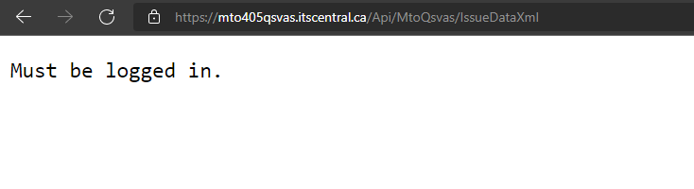

*1.5. The Solution shall publish the travel time information as a secured public API for future system integration and data sharing within MTO and with other jurisdictions specified by MTO.*

Per above, ITS Central publishes processed data to an XML file using HTTPS secured data feeds, allowing for a secured public API for future system integration and data sharing within MTO and with other jurisdictions.  Permissions may be granted by the system administrator for access to the secured data feeds.

**System Configuration and Operations (2.6.5.2)**

*2.1. The Solution shall be configured to operate using the metric system of measurement.*

ITS Central will be configured for metric by default. ITS Central supports both metric and imperial units as user preference.

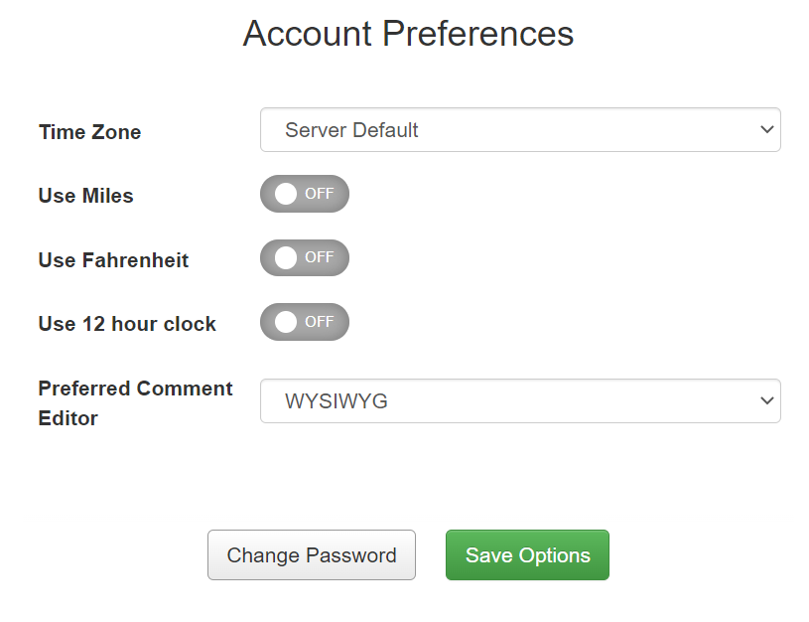

*2.2. The Solution shall be scalable to accommodate the future expansion of the TT System, including geographic expansion, and the addition of Readers, routes, and VMSs, by continuing to provide the same level of service. Details of future hardware expansions are described in Section 8.*

ITS Central is designed to be fully scalable, to include future geographic expansion and inclusion of additional routes.  In addition, adding additional Bluetooth readers and VMS’s is a common request by our previous clients, and can be easily accommodated.

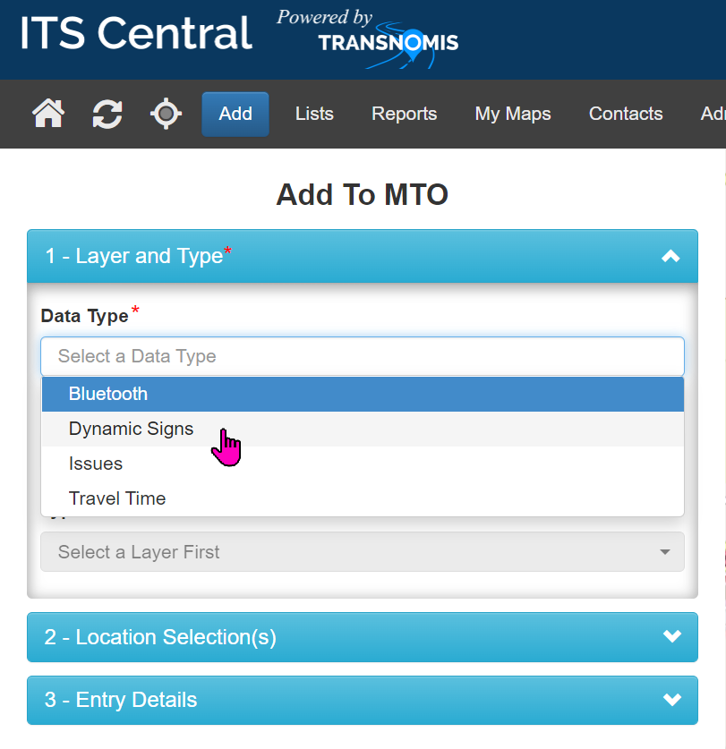

*2.3. The Solution shall operate and publish real-time travel time data feeds continuously (i.e. 24/7, 365 days).*

Our ITS Central software is designed to operate continuously, 24/7/365.  Our ITS Central Advanced Traffic Management Systems in the City of Edmonton, Region of York, Region of Durham, MTO East Region, and BC Ferries operate continuously (24/7/365). MTO’s QSVAS is also designed for continuous operations.  Our systems in Toronto, Oklahoma, and California are also running 24/7/365.

High availability features, and redundancy are designed within our proposed system, including triple servers, failover, device monitoring.

*2.4. The Solution shall have a continuous monthly uptime of at minimum 99% outside of any scheduled and routine maintenance.*

Professional third-party hosting, and triple servers are proposed to achieve 99% uptime, with an expected uptime of better than 99.99% excluding scheduled maintenance. A total of 3 servers, hosted professionally by OVH within Canada, will be utilized in this project to achieve full system triple redundancy and fail-over. OVH has technician and security on-site 24/7. It has systematic double power supply, 250 kVA UPS and generators with an initial autonomy of 48 hours. It has a minimum of 2 network connections and two network rooms within each of its data centers.

System uptime will also be monitored by a third-party service “UptimeRobot”. It provides notification to Transnomis should the system to be detected as offline. See below uptime monitoring of MTO East Visibility Warning System, showing 100% uptime over last 30 days.

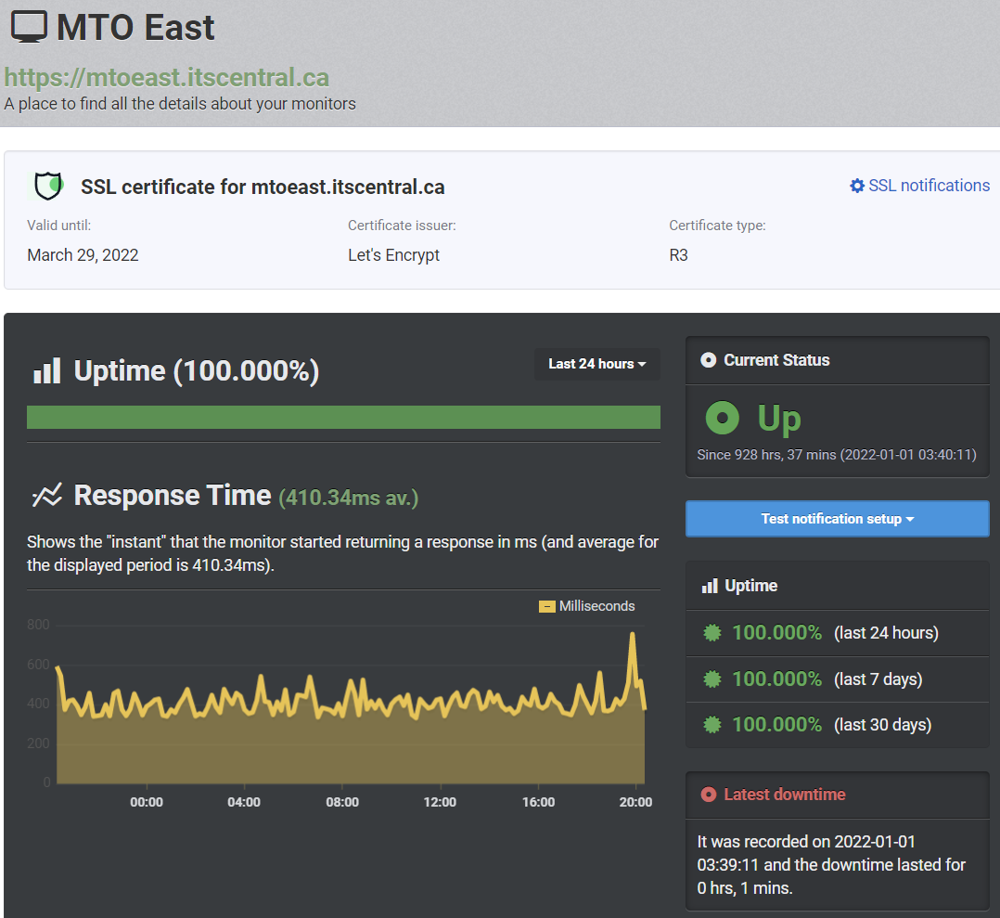

*2.5. The Solution shall have backup or redundancy procedures in place in order to resume normal operations upon system failure.*

A total of 3 servers, hosted professionally by OVH within Canada, will be utilized in this project to achieve full system triple redundancy and fail-over.  Servers will be monitored, and notifications sent to Transnomis upon failure.   Field devices will be monitored, and notifications sent to B&M upon device failure.  Crashes are monitored and logged in the system.  Transnomis will review all errors logged into the system to ensure good system performance.

ITS Central provides an interface for system administrators to create and download backups. This can easily be performed prior to any software updates.

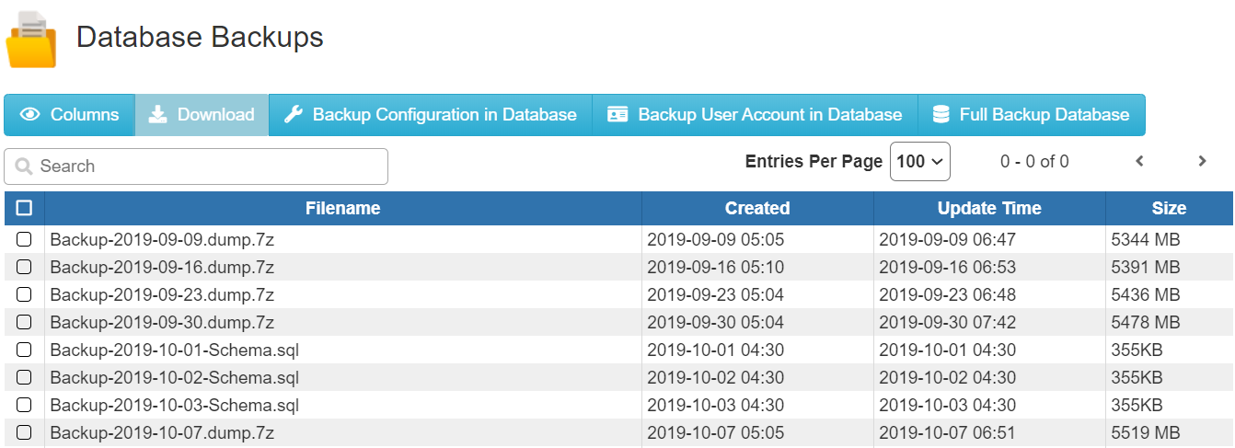

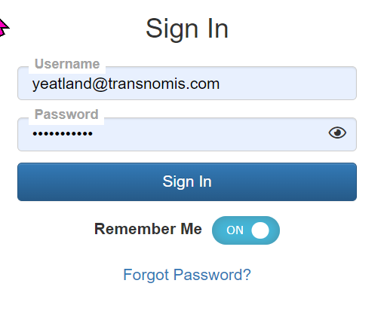*2.6. The Proponent shall provide remote access to the TT System Graphical User Interface (GUI) to authorized MTO users in a secured manner.*

Transnomis’ ITS Central software allows for browser- based access, secured by HTTPS, password- based login, and user group permissions.

User rights are managed by user groups, and users are assigned to one or more user groups. The permissions the user has is the aggregation of all of the permissions of the groups the user belongs to.

*2.7. The GUI shall be compatible with Microsoft Edge Version 88 or later, and Google Chrome Version 79 or later.*

ITS Central is compatible with all current browsers including Microsoft Edge Version 88 or later, Google Chrome Version 79 or later.  ITS Central is also compatible with Firefox, Opera and Safari.

*2.8. At minimum, the GUI shall consist of the following four (4) modules: • Travel Time Dashboard (see Section 2.6.5.6); • Historical Data Portal (see Section 2.6.5.5.5); • Reporting System (see Section 2.6.5.7); and • System Parameter Configuration (see Section 2.6.5.10).*

Among other modules, a Travel Time Dashboard, Historical Data Portal, Reporting System, and System Parameter Configuration modules are included within ITS Central.

See requirement sections

* 2.6.5.6
* 2.6.5.5.5
* 2.6.5.7
* 2.6.5.10

*2.9. The GUI shall be able to accommodate simultaneous operations by at least ten (10) concurrent users, with no adverse effects.*

ITS Central has been used by over a hundred users concurrently (e.g., Municipal511 is used by over 200 Ontario municipalities) with hundreds of gigabytes of data, with no adverse effects.

*2.10. The GUI shall comply with the Accessibility for Ontarians with Disabilities Act (AODA).*

ITS Central complies with AODA

*2.11. The GUI shall comply with the Web Content Accessibility Guidelines (WCAG) 2.1.*

ITS Central complies with WCAG 2.1

**User Access, Security and Privacy (2.6.5.3)**

*3.1. All end-to-end services of the TT System shall comply with the latest Government of Ontario Information Technology Standards (GO ITS) security requirements.*

ITS Central complies with all Government of Ontario Information Technology Standards security requirements.

*3.2. All end-to-end services of the system shall comply with the guidelines described in the Freedom of Information and Protection of Privacy Manual published by the Government of Ontario.*

All end-to-end services of this system comply with the guidelines in the Freedom of Information and Protection of Privacy Manual published by the Government of Ontario.

*3.3. The Proponent shall limit all accesses to the Solution to authorized individuals identified by MTO during the Term of Agreement.*

The access to the system will be restricted to authorized individuals identified by the MTO.  The user account list in ITS Central will allow for control of authorized access.

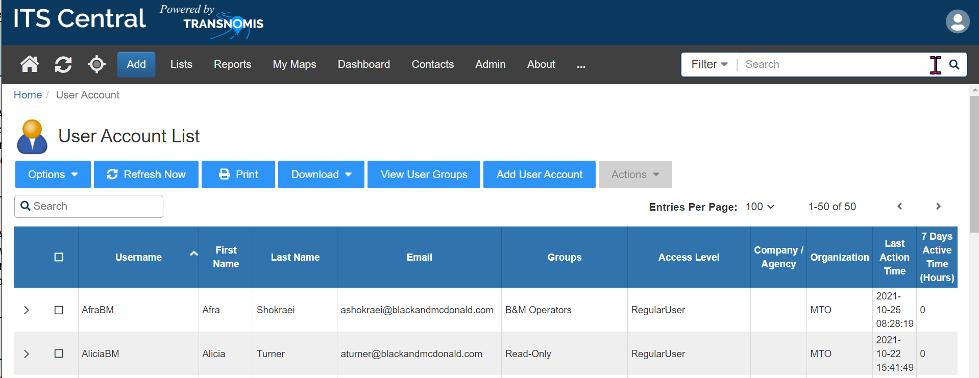

*3.4. User access privileges shall be definable on a functional level. This shall allow for different levels and roles of users to access system features and functions.*

User privileges are definable on a functional level.  User rights are managed by user groups, and users are assigned to one or more user groups. The permissions the user has is the aggregation of all of the permissions of the groups the user belongs to.  The screenshot below illustrates the ability to define functional levels for a user group.

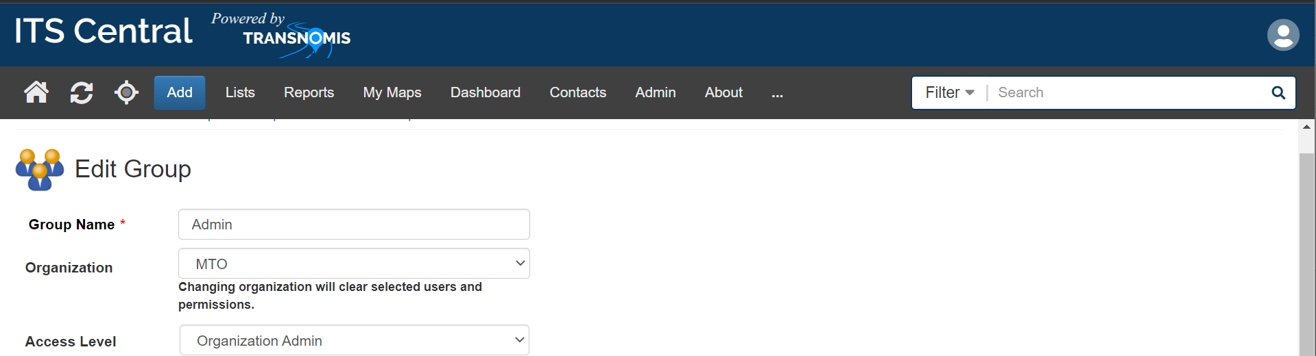

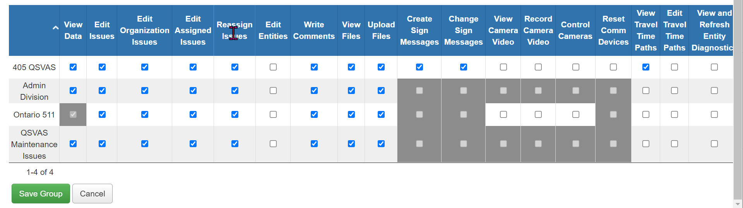

*3.5. User access privileges shall be definable by MTO and managed by the Proponent during the Term of Agreement.*

The vendor team will manage user access privileges as defined by MTO.  ITS Central allows for easy user access permission management.



*3.6. The user access privileges shall be categorized, as a minimum, as: System Administrators (Service Provider) – shall have full access to the system as well as the capability for maintaining user account passwords and privilege levels; System Administrators (Client) – shall have access for monitoring real-time and historical travel time information, reporting, and system parameter configuration as well as the capability for maintaining user account privilege levels; System Operators – System access for monitoring real-time, historical travel time information, and reporting. Access can be limited to a geographic area, with Report Only privileges on the remaining network; System Report Only – Capable of viewing the system and viewing/printing reports.*

User Access groups are easy to define and can be created as desired.

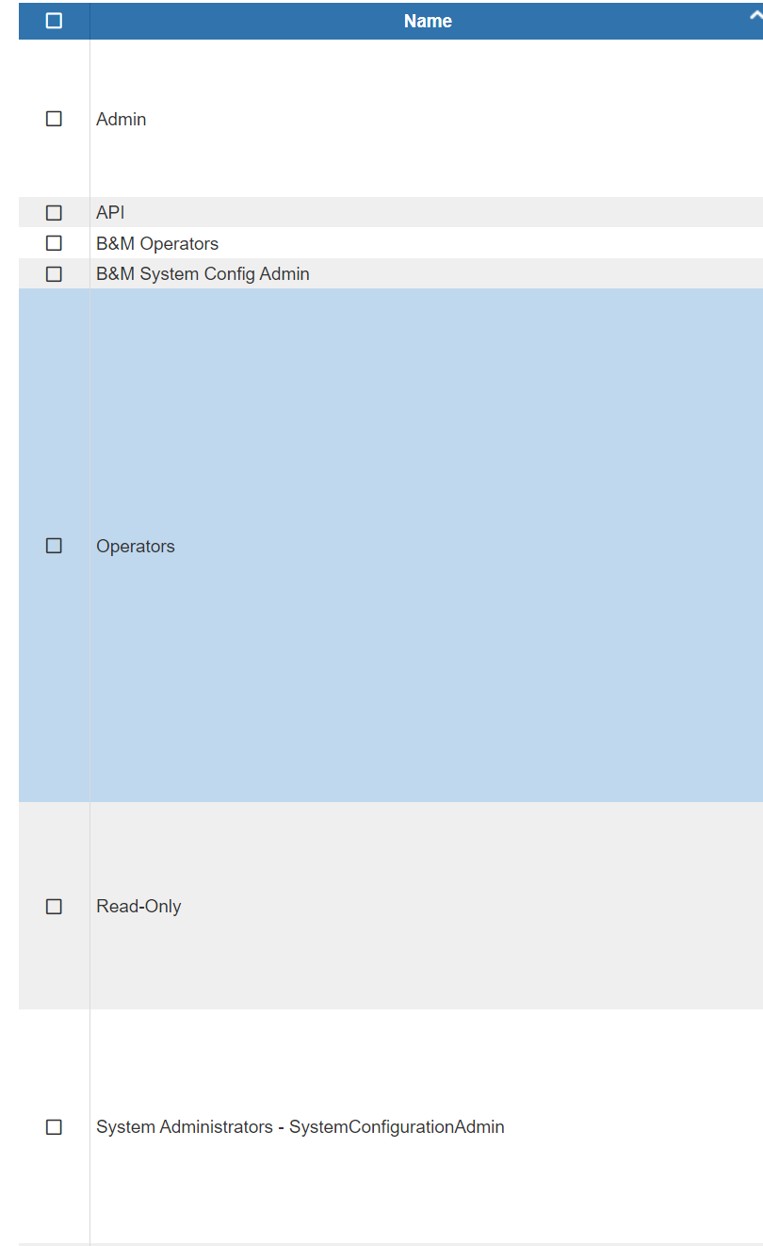

*3.7. The Proponent shall collaborate with MTO to establish a site-to-site IPSec VPN tunnel between the system and MTO firewall.*

The project team will collaborate with MTO to establish a site-to-site IPSec VPN tunnel between the ITS Central server and MTO firewall.

*3.8. The VPN tunnel shall use secure channels to transmit data feeds, including but not limited to: Hypertext transfer protocol secure (HTTPS); and Secure file transfer protocol (SFTP).*

The VPN tunnel will use secure channels to transmit data feeds, including but not limited to Hypertext transfer protocol secure (HTTPS); and Secure file transfer protocol (SFTP).

**Device Integration (2.6.5.4)**

*4.1 Each Bluetooth reader shall be assigned a unique ID value for identification purposes by the Solution, which shall match the Bluetooth reader’s ID assigned by MTO (see Appendix C).*

Each Bluetooth Reader will be assigned a unique ID which will match the Bluetooth reader’s ID assigned by the client.

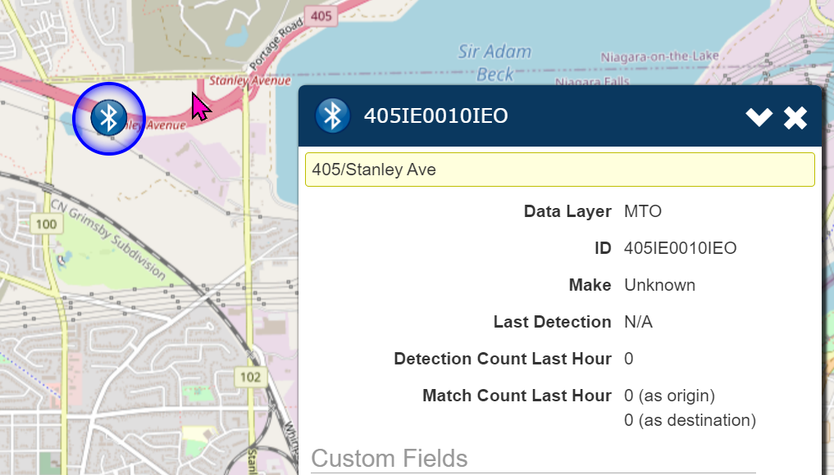

*4.2 Each VMS shall be assigned a unique ID value for identification purposes by the Solution, which shall match the VMS’s ID assigned by MTO (see Appendix C).*

Each VMS will be assigned a unique ID value for identification purposes by the Solution, which shall match the VMS’s ID assigned by MTO

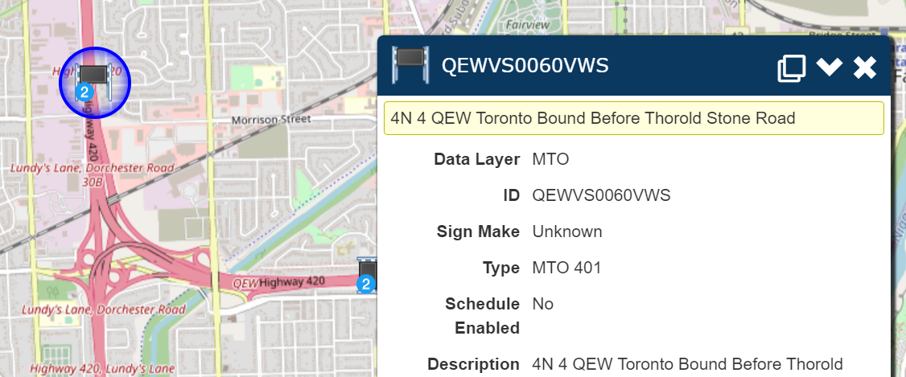

*4.3 Bluetooth reader operational failures and losses of communication with the Solution shall be automatically logged for reporting and auditing purposes.*

The operational failures and losses of communication will be logged for each Bluetooth reader.   All field devices that are monitored retain a log that can be accessed through ITS Central’s Issues tab.

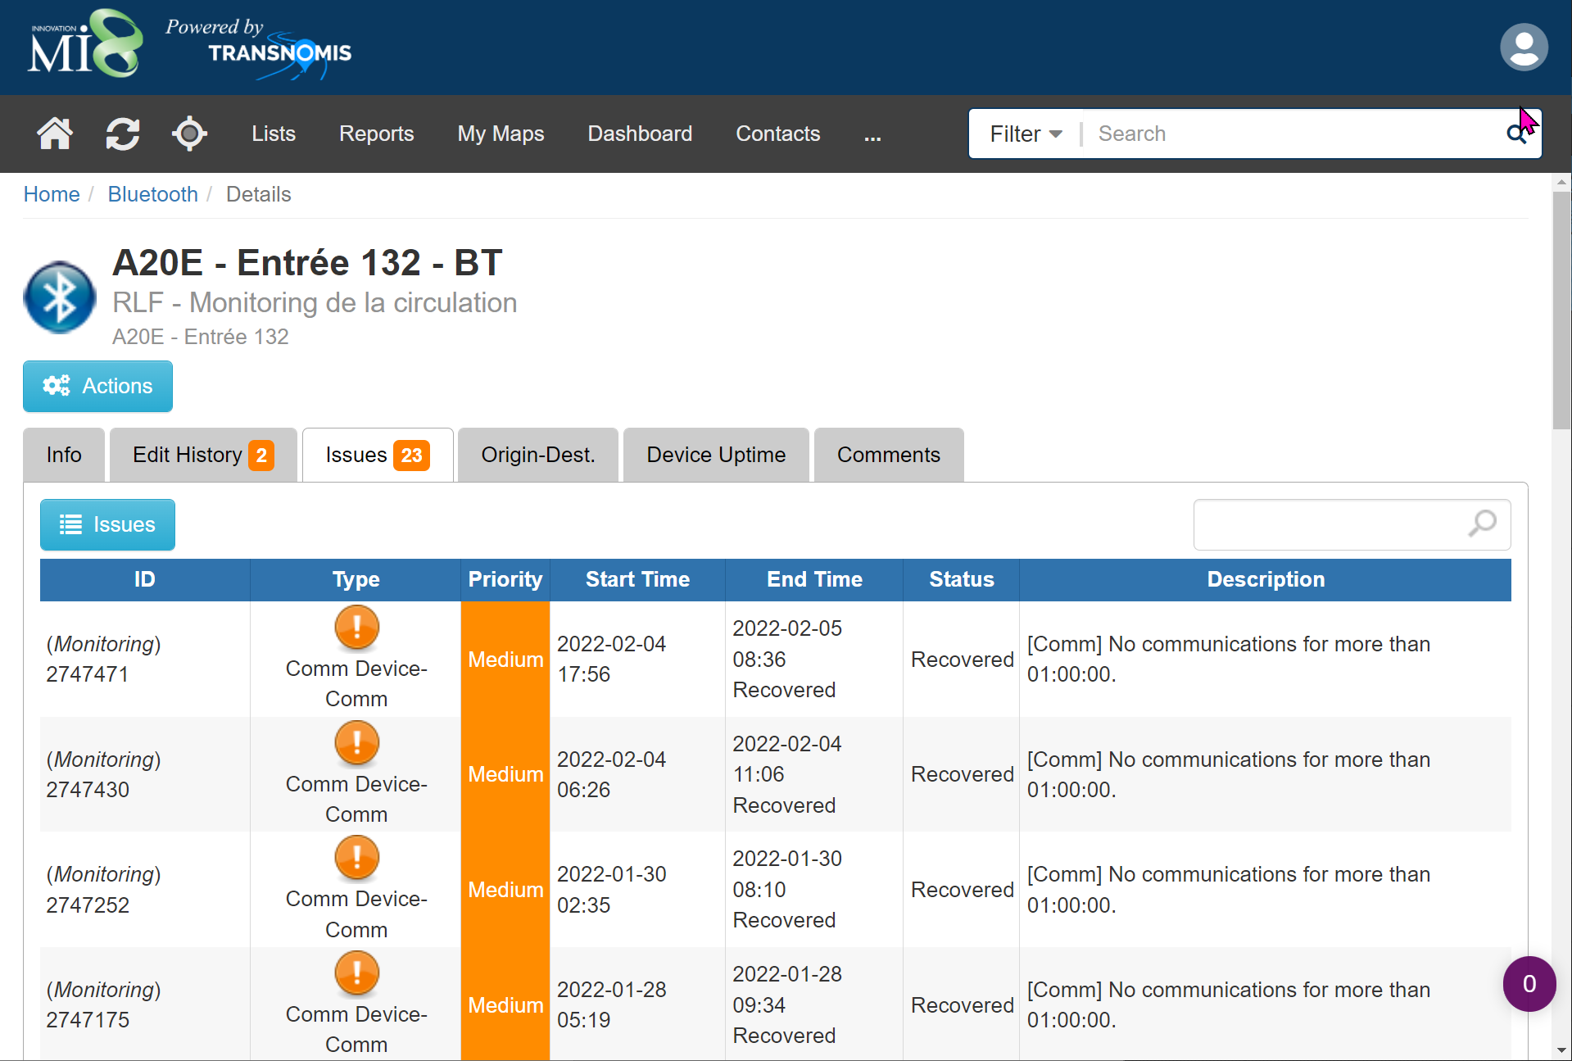

*4.4 Data stored internally on a Bluetooth reader collected in the event of an interruption of communications with the Solution (see Section 2.6.2), shall be automatically transferred and loaded into the Solution once communications are restored.*

Regardless of communication, data is stored continuously within the Stinson AIS Bluetooth and Wi-Fi sensor, encrypted on an onboard SD card. Data may be retrieved via the sensor’s web-based GUI:

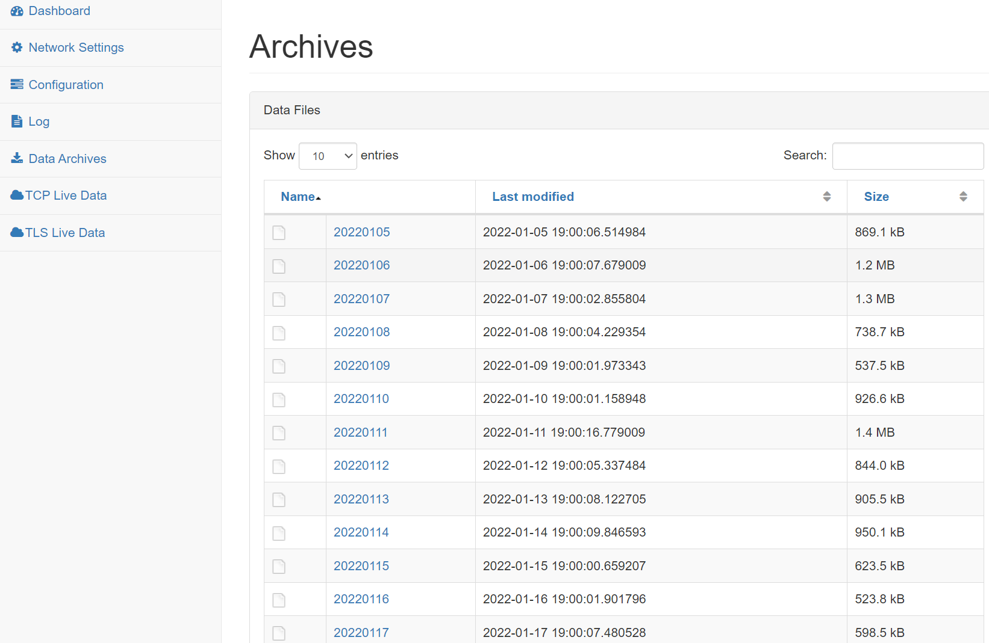

When ITS Central detects the restoration of communication to the sensor, it automatically downloads the archived data files needed from the sensor, and re-process the Bluetooth/WiFi data by matching with data from other sensors, and re-computing the travel time data.

*4.5 The Solution shall be capable of configuring Bluetooth reader settings, including: Bluetooth reader ID as assigned by MTO; System-related functions, including data storage, and user authentication; Network-related parameters, including IP address, netmask, and gateway; Time synchronization between the travel time server and Bluetooth Readers; and other features required to make the Proponent’s Bluetooth Readers operational.*

ITS Central and the sensor’s web-based GUI allows for configuration of the Bluetooth reader settings, including assignment of the ID, system related functions, data storage, user authentication, network parameters, time synchronization, and other factory features.

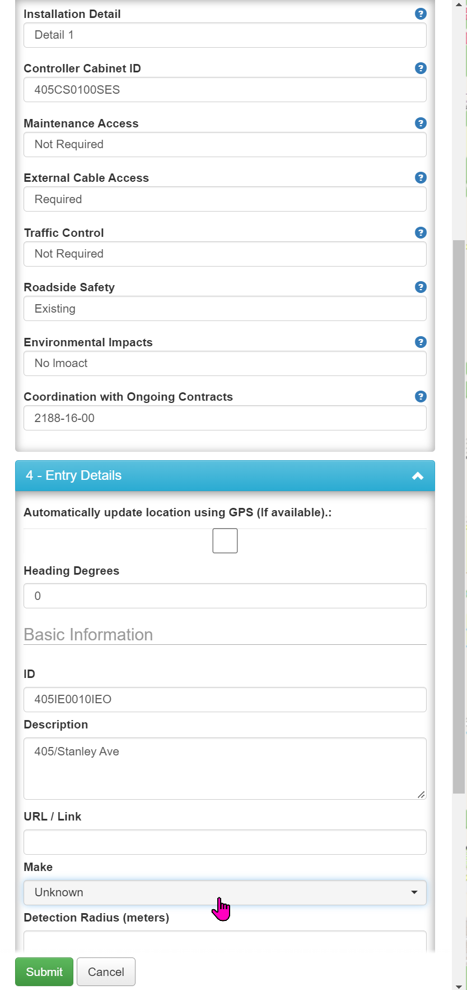

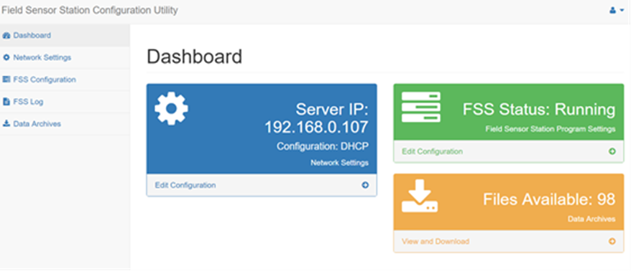

*4.6 The Bluetooth Readers shall be configured such that the Vendor receives a notification immediately upon Bluetooth device failure.*

Field devices are monitored by ITS Central, and email notifications are sent immediately to B&M’s team – as well as any other persons included in the notification list - immediately upon Bluetooth device failure.

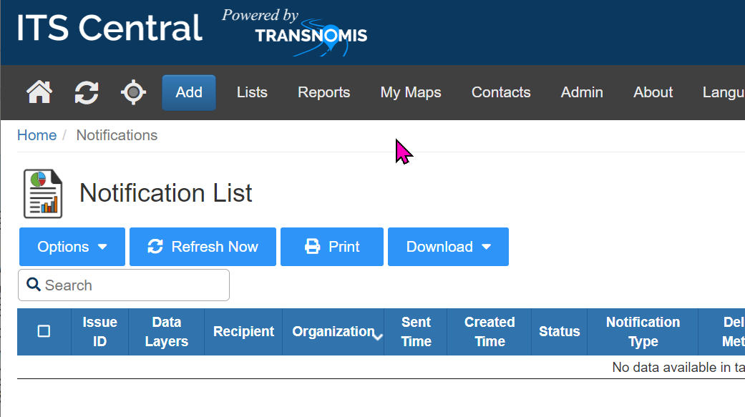

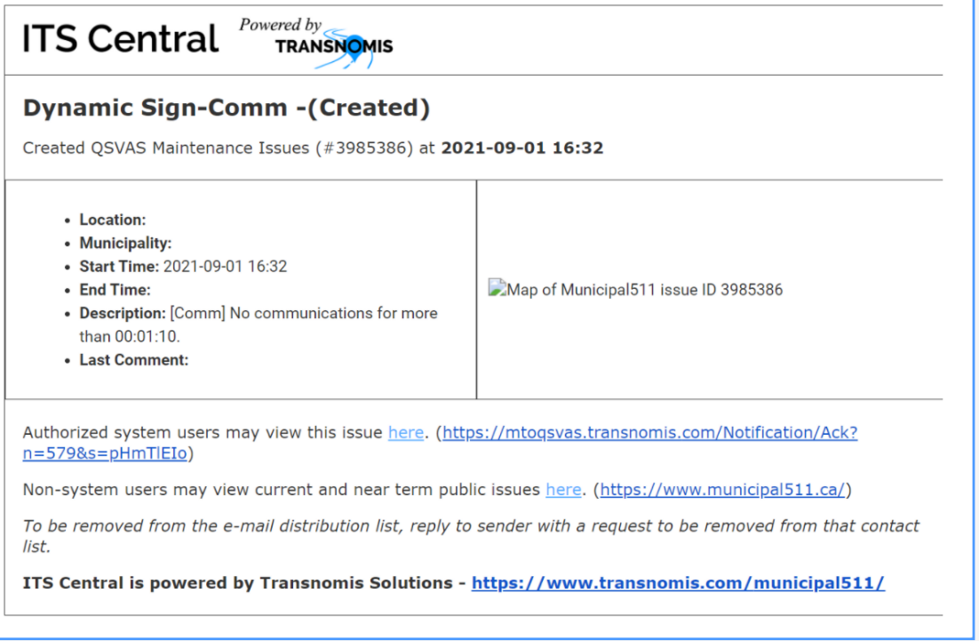

*4.7 The Solution shall record details of any Bluetooth device configuration changes.*

All device configuration changes are recorded, including the username of the person who made the change, type of change, and the time, under the “Edit History” tab of the device details page, available for all devices.

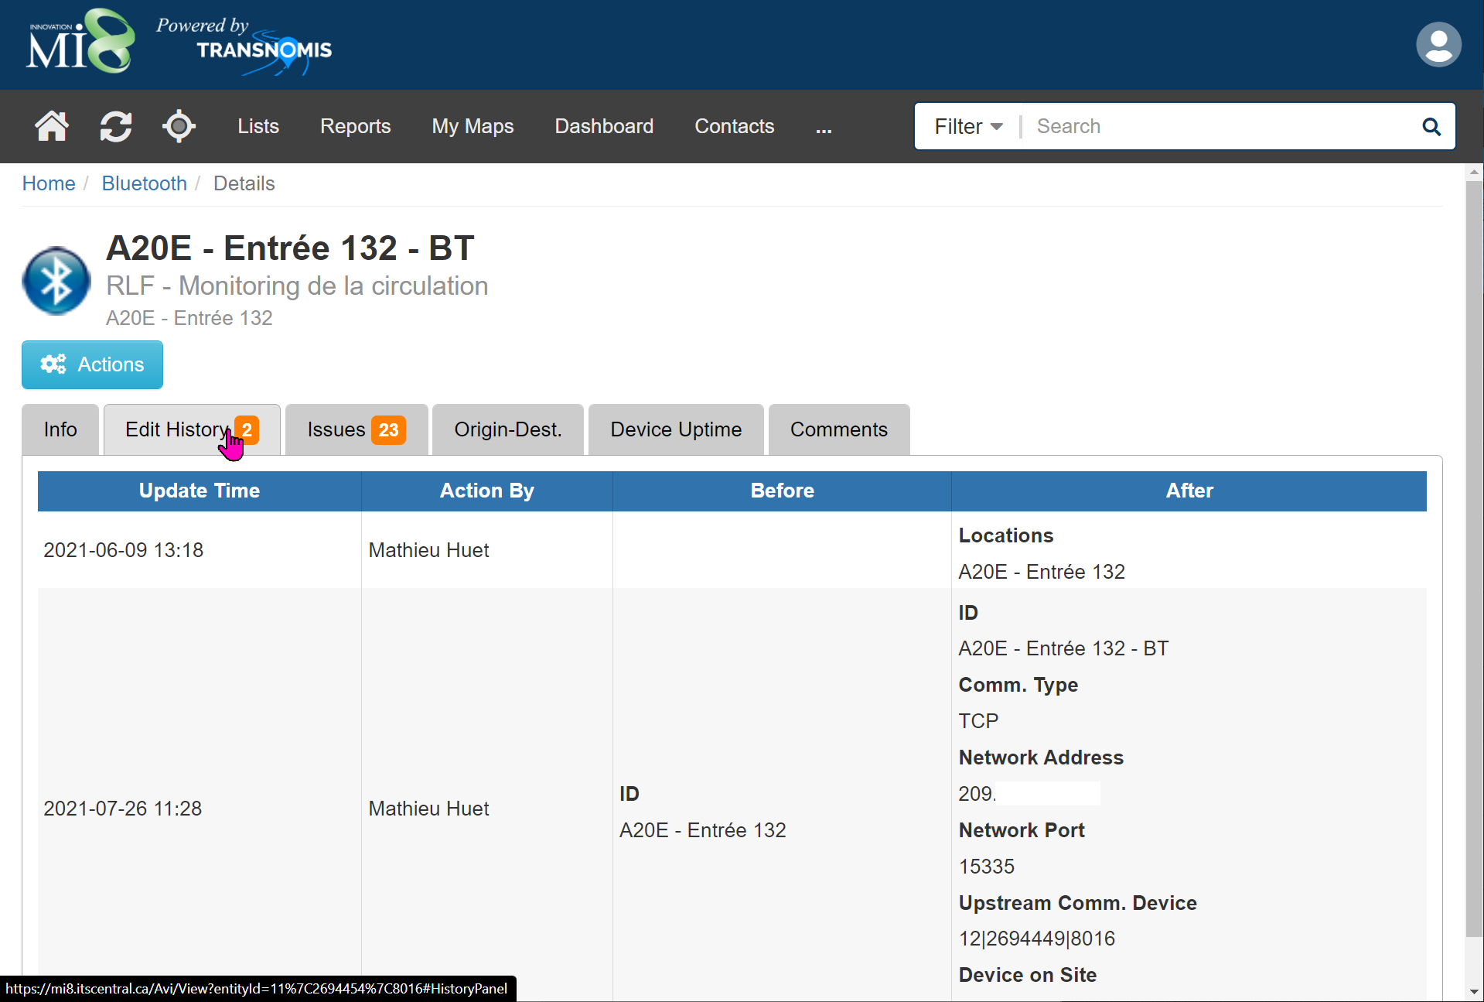

*4.8 The Media Access Control (MAC) IDs of all captured Bluetooth-enabled devices shall be encrypted automatically based on industry standard encryption and privacy requirements.*

The MAC ID’s captured by the Bluetooth readers are encrypted using a cryptographically secure one-way hash function in order to satisfy privacy requirements.

**Data Requirements (2.6.5.5)**

**Data Collection**

*5.1.1. The Solution shall be configured to collect and process data from all Bluetooth Readers deployed by the Proponent under this Contract.*

ITS Central will be configured to collect and process data from all the Stinson AIS Bluetooth/Wi-Fi readers deployed by our project team under this contract.

*5.1.2. The data processing time between receiving raw data into the Solution and processing travel time information shall not be greater than one (1) second.*

The data processing time between receiving raw data into the Solution and processing travel time information will not be greater than one (1) second.

**Data Processing**

*5.2.1. The Solution shall support all data processing procedures required for the development of travel time information.*

ITS Central’s Travel Time Module and the associated modules support all data processing procedures required for the travel time information development.

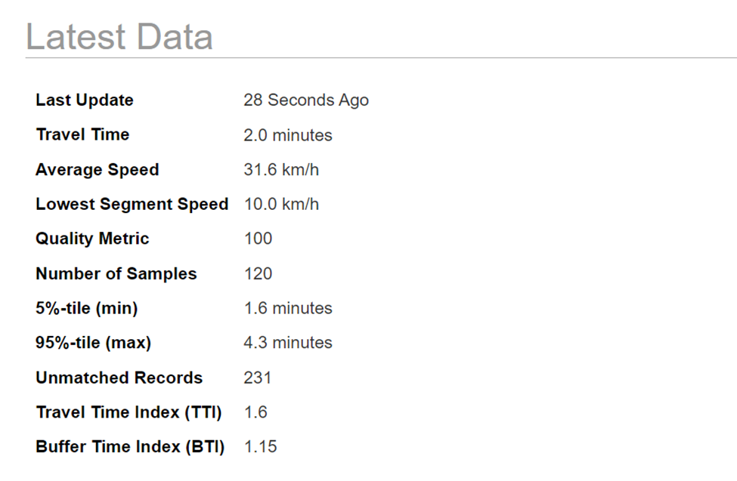

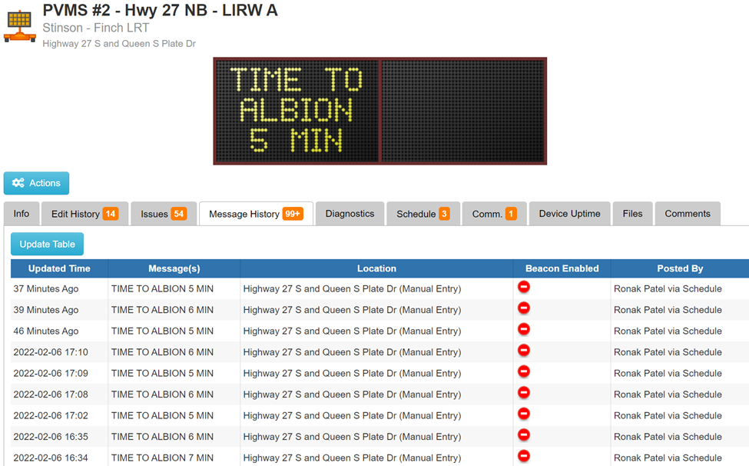

*5.2.2. The travel time for a route shall be calculated using the travel times of the links that make up the route.*

ITS Central uses the travel times of links to calculate the travel time for a route as shown in the route travel time displays below:

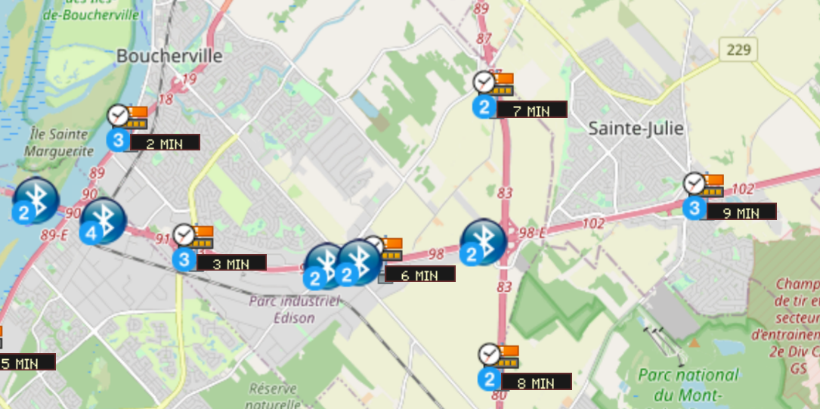

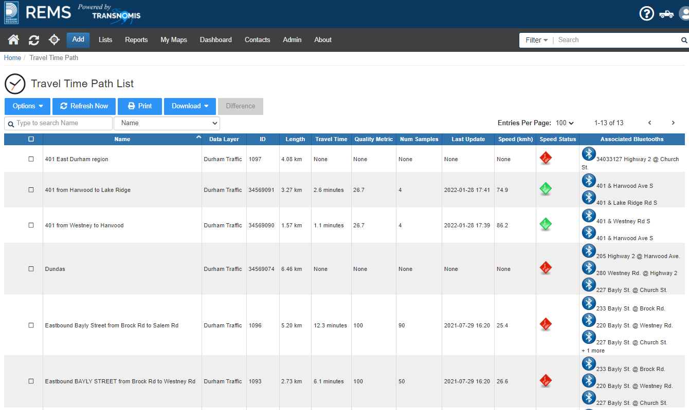

*5.2.3. The Proponent shall automatically infill route travel time information in the event of an origin Bluetooth reader failure.*

When ITS Central detects the restoration of communication to the sensor (regardless if it is an origin, destination or intermediate reader), it automatically downloads the archived data files needed from the sensor, and re-process the Bluetooth/Wi-Fi data by matching with data from other sensors, and re-computing the travel time data.

*5.2.4. The Proponent shall automatically infill route travel time information in the event of an intermediate Bluetooth reader failure.*

See above, Requirement 5.2.3

*5.2.5. The Proponent shall automatically infill route travel time information in the event of a destination Bluetooth reader failure.*

See above, Requirement 5.2.3

*5.2.6. The Solution shall be capable of filtering data to remove anomalies, outliers, and encrypted MAC IDs unmatched to a destination using robust statistical methods.*

ITS Central employs advanced algorithmic calculation of travel times between sensors by aggregating and filtering the raw travel time data eliminating aberrations and outliers. The parameters for this algorithm are configurable.

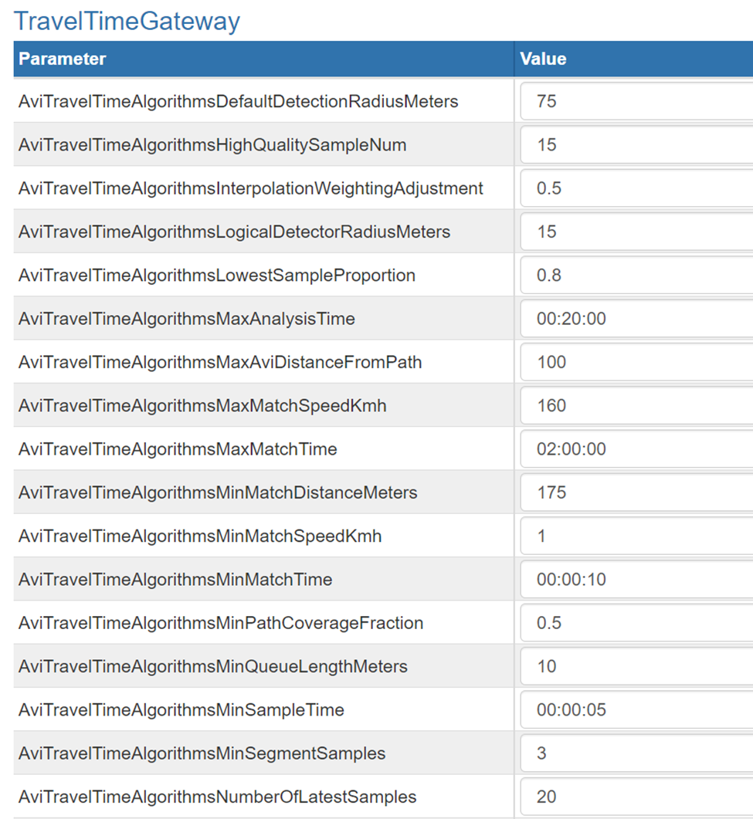

*5.2.7. Processing statuses and conditions, including recalculation, anomalies, and unmatched encrypted MAC IDs, shall be recorded with the processed data to support post-mortem analysis.*

The unmatched encrypted MAC ID's, processing statuses, conditions, recalculations, and anomalies are recorded by ITS Central, as well as the processed data.

**Data Feed Configuration**

*5.3.1. The Solution shall generate three (3) real-time secured data feeds: Link-based TT – TT between two adjacent BT; Route-based TT – TT between VMS and the displayed destination; and Sign-based TT message – for each destination defined for VMS.*

Transnomis has previously provided numerous custom REST API data feeds as per client requirements, such as the VDS and VMS API provided for the MTO QSVAS project.

ITS Central does not distinguish between routes or links, in that both routes and links are calculated using the same travel time algorithm. The ITS Central Travel Time calculation works for both the Link and Route based XML feeds. Once the locations of the Bluetooth Readers, VMS signs, and route destinations are configured, the XML feeds will fully comply with the specifications.

In preparation for this proposal submission, Transnomis has created 3 XML feeds, conforming to the MTO data specifications, applied to an existing deployment of ITS Central:

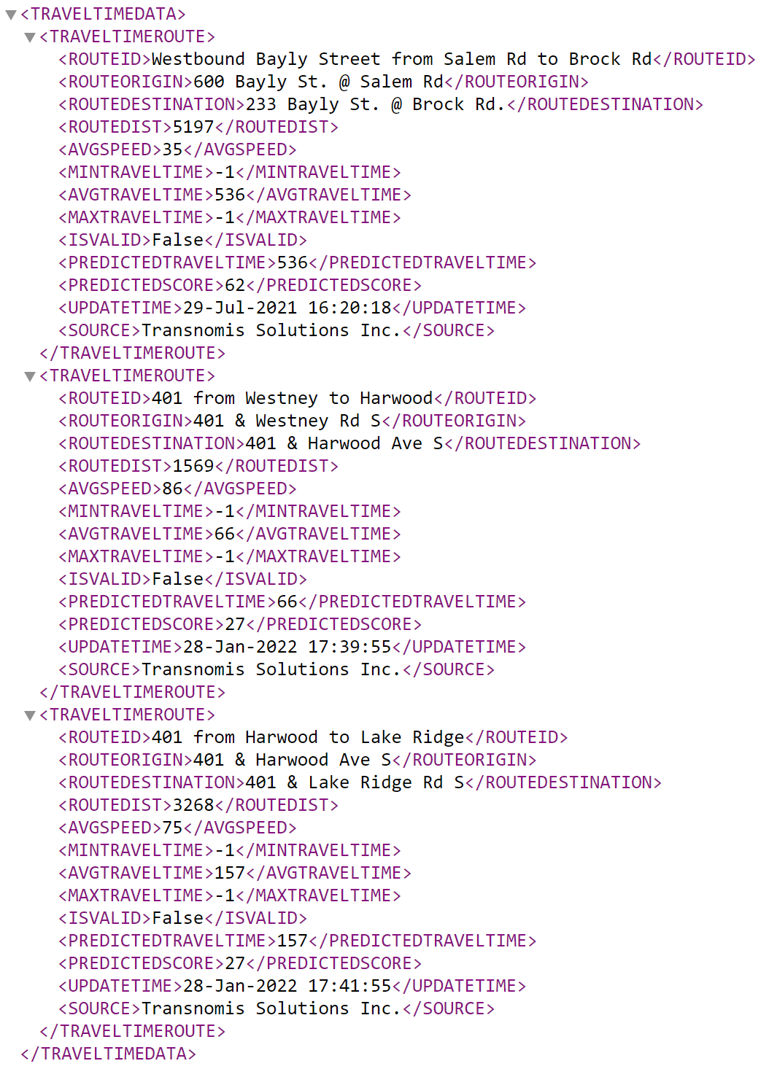

Route Based XML Feed

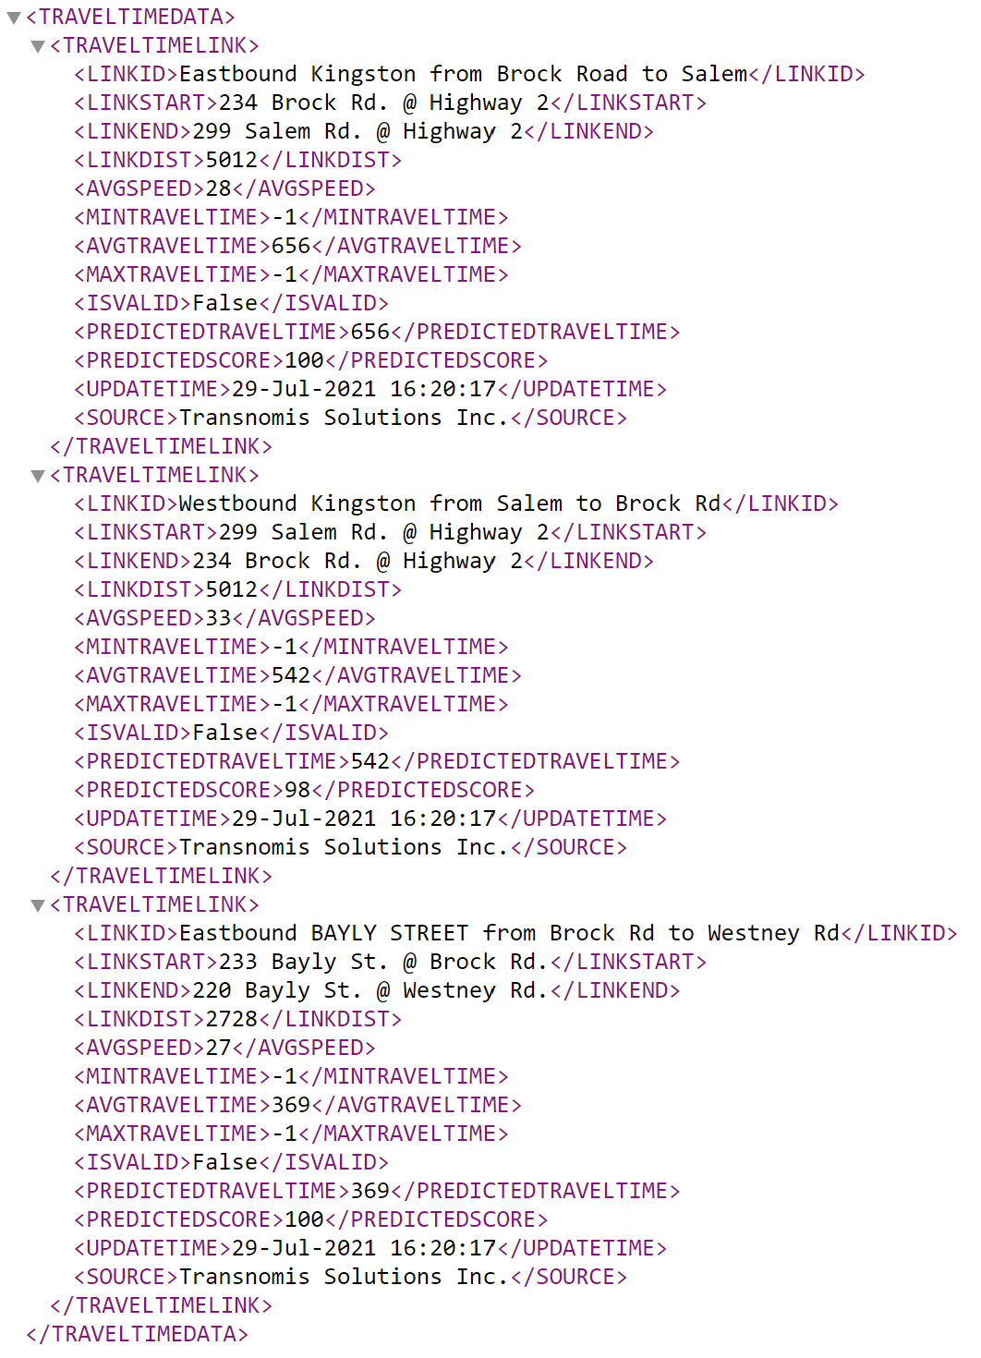

Link Based XML

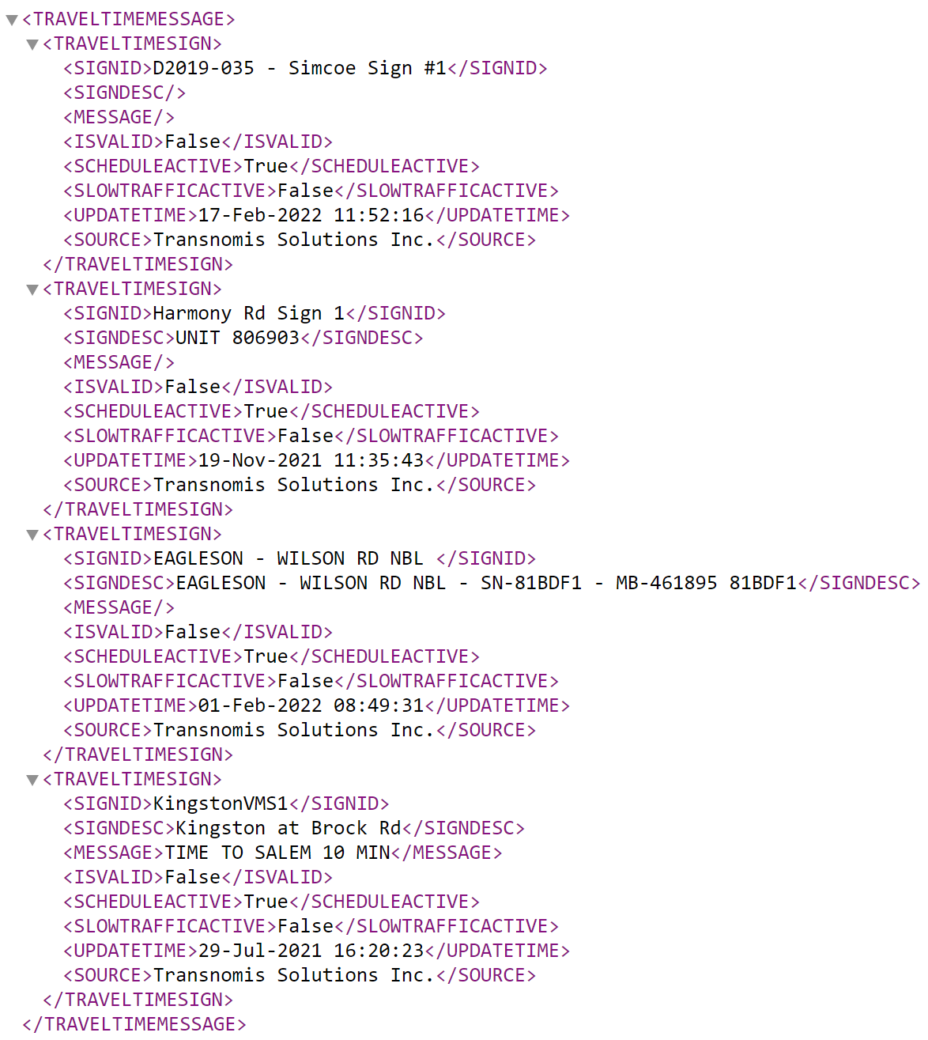

Sign Based XML

*5.3.2. The Proponent shall construct these data feeds in compliance with MTO data specifications provided in Appendix C.*

Transnomis has already customized three XML data feeds in accordance to the MTO data specifications provided.

*5.3.3. The link-based travel time data feed shall be in XML format.*

The ITS Central Travel Time REST API will export the travel time data feed in XML format, to MTO's specifications.

*5.3.4. The link-based travel time data feed shall be encoded in UTF-8 format.*

The link-based travel time data is encoded in UTF-8 format.

*5.3.5. The route-based travel time data feed shall be in XML format.*

The route-based travel time data feed is in XML format.

*5.3.6. The route-based travel time data feed shall be encoded in UTF-8 format.*

The route-based travel time data feed is encoded in UTF-8 format.

*5.3.7. The sign-based travel time message data feed shall be in XML format.*

The sign-based travel time message data feed is in XML format.

*5.3.8. The sign-based travel time message data feed shall be encoded in UTF-8 format.*

The sign-based travel time message data feed is encoded in UTF-8 format.

*5.3.9. The Proponent shall define data timeout limits signifying whether a travel time measurement is recent and representative of real-time conditions.*

Travel time data timeout limit can be defined for each link/route, with a system-wide default for convenience of configuration. When the travel time data is older than the specified timeout, the travel time will not be recommended for travel time messages, and the travel time will be marked as “Unavailable” in the data feed.

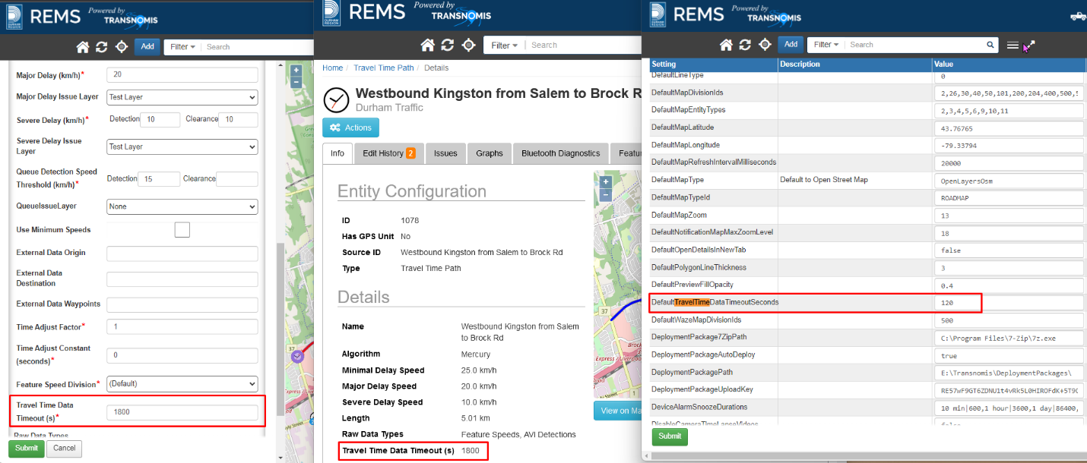

*5.3.10. Multiple data timeout limits shall be configurable to support differences in traffic patterns between rural and urban areas.*

See above, 5.3.9

*5.3.11. The default user-specified data timeout limit shall be two (2) minutes.*

The default timeout limit is configurable in ITS Central, and will be set to two (2) minutes.

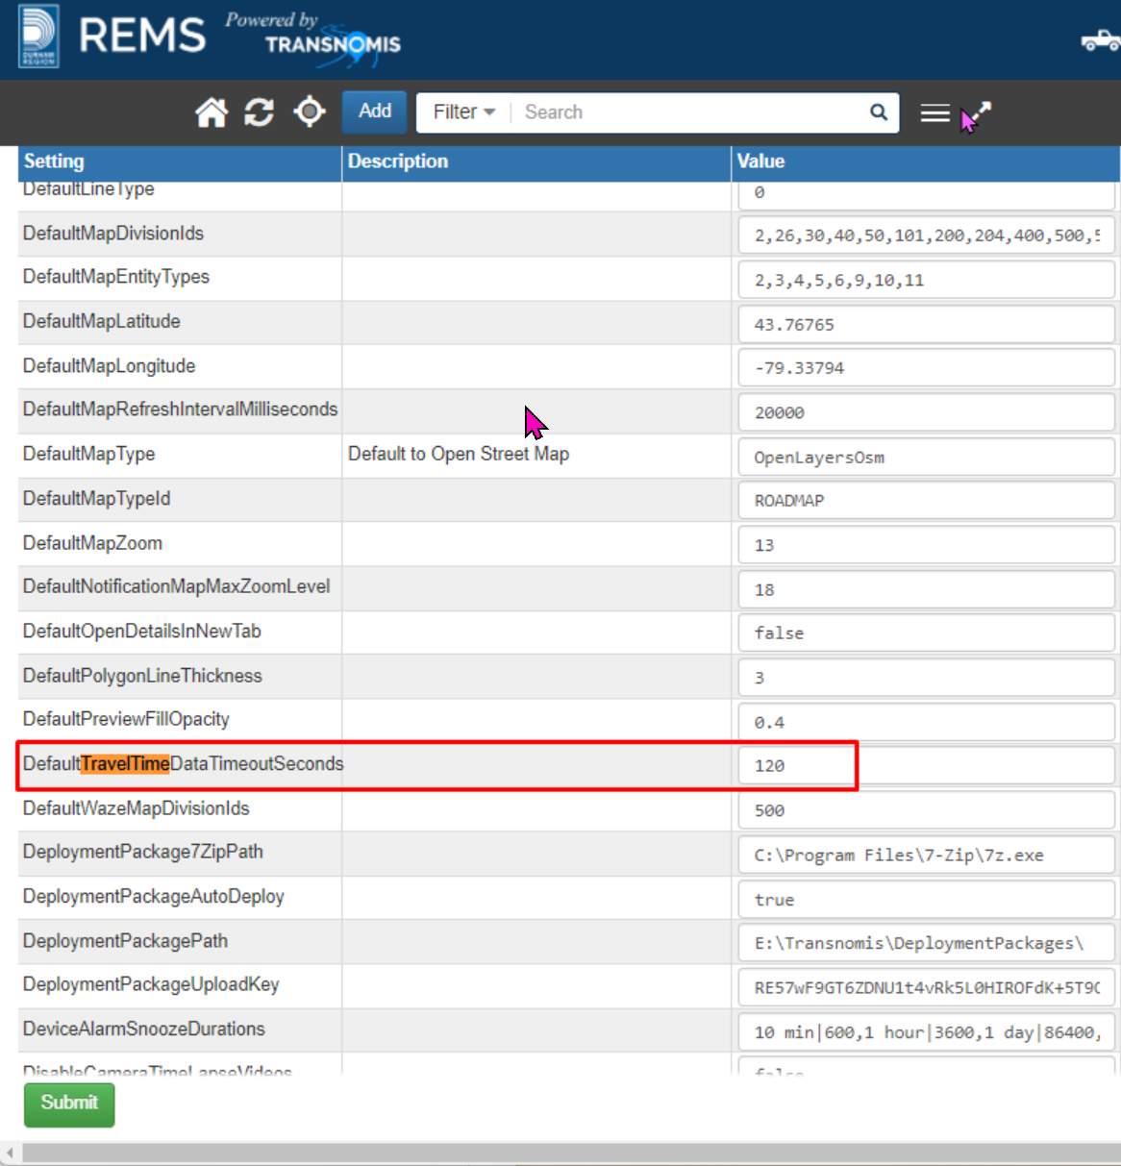

*5.3.12. The Solution shall automatically determine whether a VMS message is “valid” for a given time period. A message is “invalid” if one of the following occurs: • Route travel time information is unavailable (including but not limited to loss of communication, or no device matches); or • If the timestamp of the route travel time information provided exceeds the user-specified data timeout limit.*

If Route travel time is unavailable, or timed out, then ITS Central will post a default message as the "invalid" message.

*5.3.13. The Solution shall allow MTO to define a configurable, pre-specified time period, during which MTO will publish route travel time messages on VMSs. The initial default time period shall be: • Weekdays (Monday to Friday) – 6:00am to 10:00am, 3:00pm to 8:00pm; and • Weekends (Saturday and Sunday) and statutory holidays – 9:00am to 12:00pm, 5:00pm to 9:00pm.*

ITS Central allows MTO to define a configurable time period during which MTO will publish route travel time messages on VMS.  The initial default time period shall be: • Weekdays (Monday to Friday) – 6:00am to 10:00am, 3:00pm to 8:00pm; and • Weekends (Saturday and Sunday) and statutory holidays – 9:00am to 12:00pm, 5:00pm to 9:00pm.  These time periods are easily configurable as illustrated by the screenshot below.

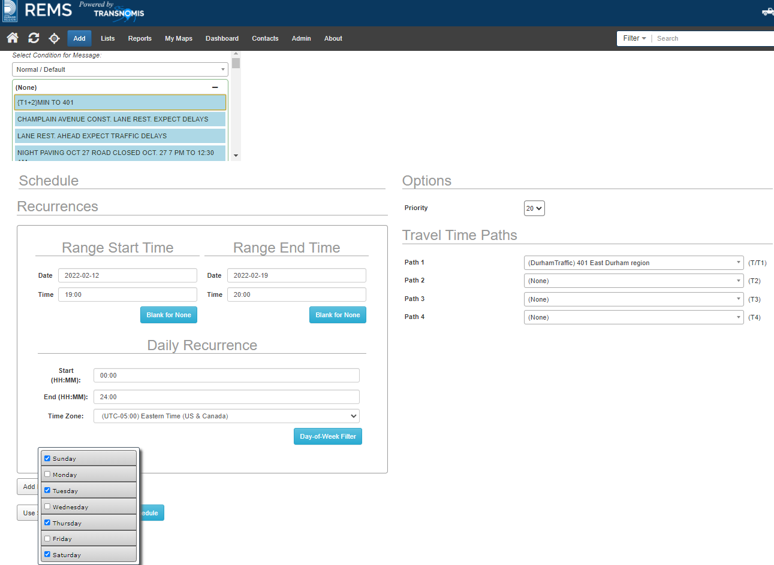

*5.3.14. The Solution shall have the ability to identify real-time route travel time as slow traffic condition as per MTO definition.*

ITS Central can identify slow traffic conditions, per MTO's definition based on measured speed.

*5.3.15. The slow traffic condition shall be configurable in the Solution.*

Real-time route travel times can be identified as slow based on configurable parameters within ITS Central.

*5.3.16. As a default, slow traffic shall be defined as two (2) times the free-flow travel time (i.e. travel speed is half of the speed limit).*

Slow traffic parameter is configurable, and will be defined as two (2) times the free-flow travel time as the initial configuration.

*5.3.17. The refresh rate of the secured link-based travel time data feed shall be no longer than one (1) minute.*

ITS Central's refresh rate of the secured link-based travel time data feed is not longer than one minute.

*5.3.18. The refresh rate of the secured route-based travel time data feed shall be no longer than one (1) minute.*

ITS Central's refresh rate of the secured route-based travel time data feed is not longer than one minute.

*5.3.19. The refresh rate of the secured sign-based travel time message data feed shall be no longer than one (1) minute.*

ITS Central's refresh rate of the secured sign-based travel time data feed is not longer than one minute.

**Data Storage and Archiving**

*5.4.1. Data shall be hosted and stored by the Proponent within Canada utilizing cloud-based solution, outside of MTO premises.*

For hosting, we propose the services of OVH (<https://www.ovh.com/>). It is one of the largest internet hosting companies in the world, with 400,000 servers, 33 data centers in 4 continents and 1.6 million customers. It is fully certified:

* PCI DSS
* ISO/IEC 27001, 27017, 27018, 27701, 50001
* SOC 1, SOC 2 and SOC 3
* Cloud Security Alliance STAR certified

OVH.com has a data center in Beauharnois, QC. Its facility is highly secure with access only by authorized employees. It has technician and security on-site 24/7. It has systematic double power supply, 250 kVA UPS and generators with an initial autonomy of 48 hours. It has a minimum of 2 network connections and two network rooms within each of its data centers.

Although hosting is provided by reliable third party, Transnomis Solutions is fully responsible for the availability of its software service. The Ministry will never have to deal with the hosting company. Transnomis Solutions will be the single point of contact for all issues related to services provided for this contract, including server availability issues.

*5.4.2. Historical aggregated travel time information shall be stored and accessible to users for the duration of the Contract.*

Historical aggregated travel time information is stored in ITS Central's database, and will be accessible for the duration of the contract.

*5.4.3. The aggregation period of historical aggregated travel time information shall be at least every five (5) minutes.*

The aggregation period of historical aggregated travel time information is configurable, and will be at least 5 minutes.

*5.4.4. Stored aggregated travel time information shall include at minimum: • Link; • Route; • Travel time; • VMS ID; • Number of encrypted MAC ID matches; and • VMS messages from the generated sign-based TT message XML feed.*

ITS Central stores aggregated travel time information that includes:

- Link

- route

- travel time

- VMS ID

- number of encrypted MAC ID matches

- VMS messages from the generated sign based TT message XML feed.

*5.4.5. VMS message archives in the stored aggregated travel time information shall include information traceable to the underlying VMS ID, defined routes on a specific VMS, assigned links, and Bluetooth reader’s aggregated recorded data for future analysis, as well as retroactive diagnostic capabilities.*

ITS Central stores aggregated travel time information and VMS message archives, which include information traceable to the underlying VMS ID, defined routes on a specific VMS, assigned links, and Bluetooth reader’s aggregated recorded data for future analysis, as well as retroactive diagnostic capabilities.

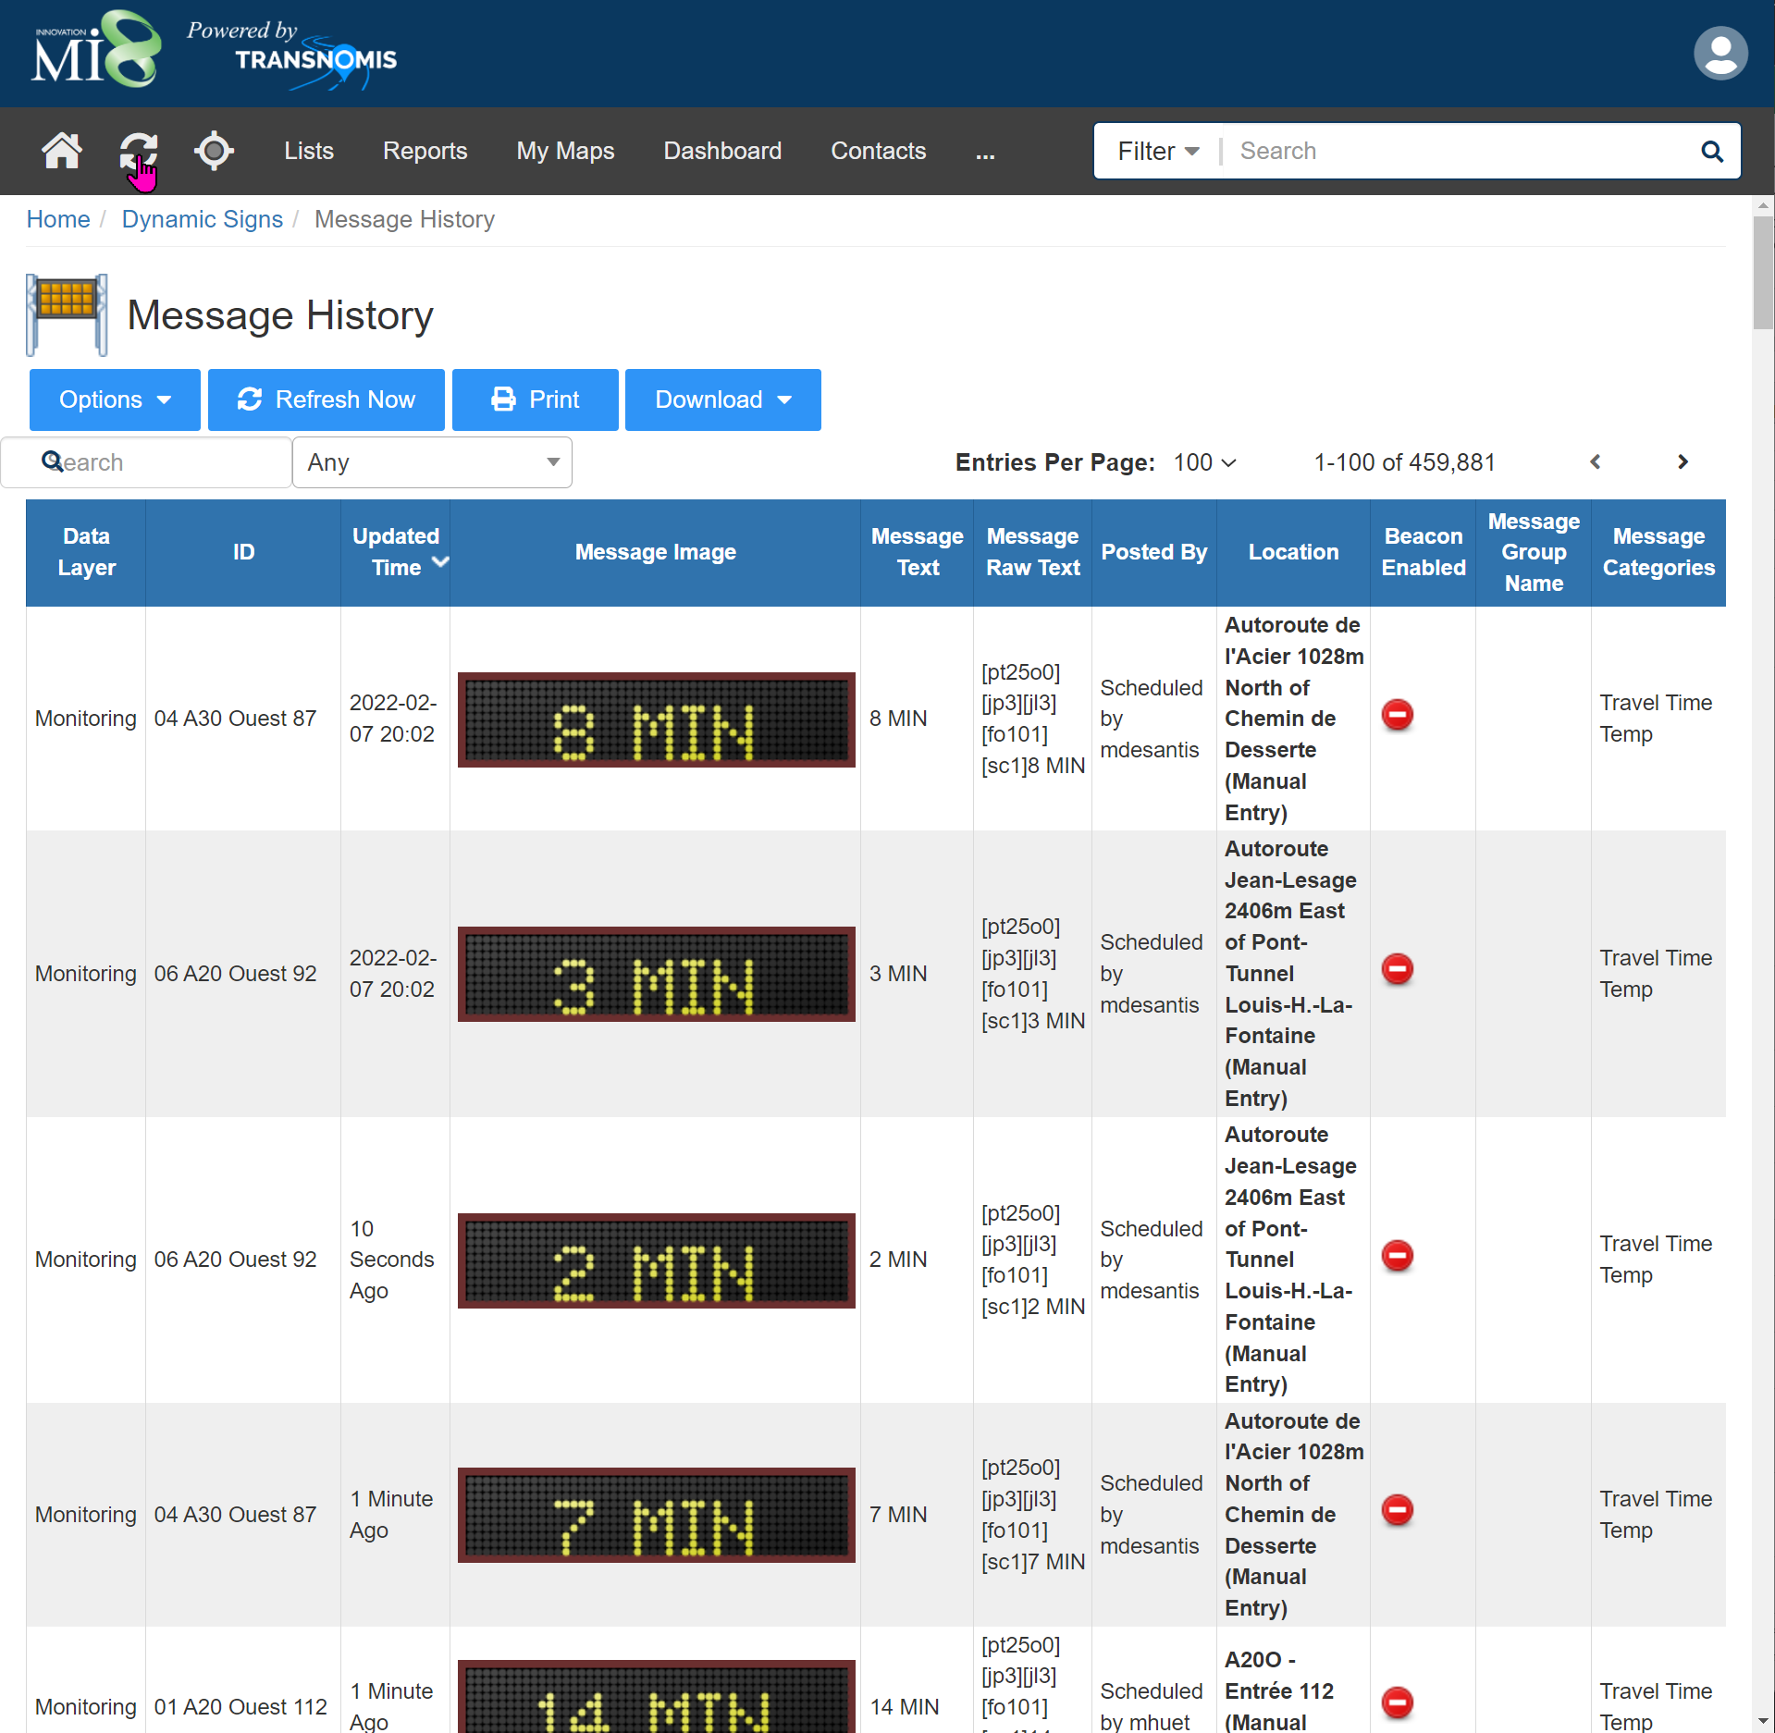

*5.4.6. The Proponent shall store a minimum of six (6) months of historical raw data for auditing purposes, including individual timestamped encrypted MAC ID records with their associated Bluetooth Readers.*

ITS Central will store the historical raw data for a minimum of 6 months, including individual timestamped encrypted MAC ID records with their associated Bluetooth Readers.

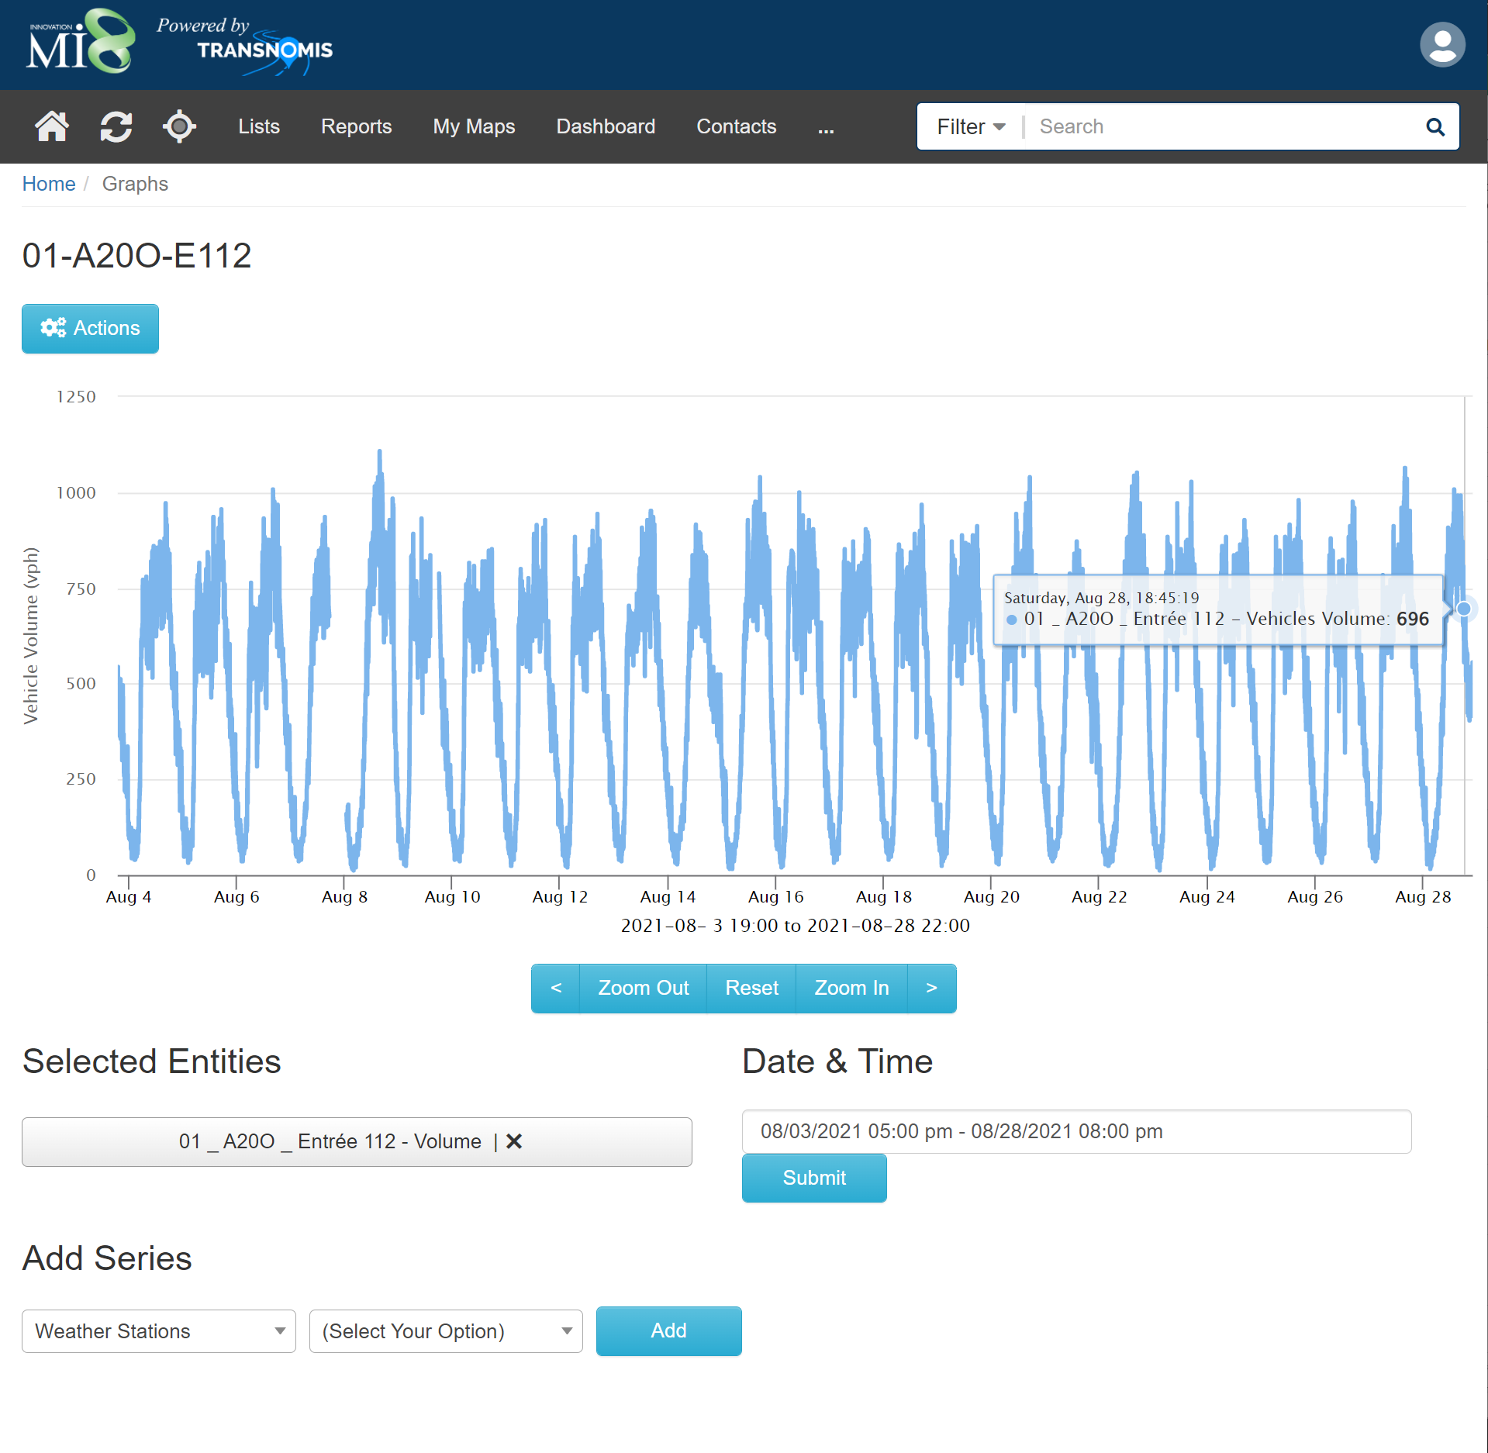

**Historical Data Access**

*5.5.1. All historical data access and querying by users, or by user request to the Proponent, shall be done through use of the GUI historical data portal module.*

The ITS Central GUI allows for historical data access and querying.  See 5.5.2.

*5.5.2. The data portal screen shall provide, at minimum, the following selection criteria for data querying: Time period type (single, continuous or recurring); Time period (time of day, day of week, time of year); Location (All locations, a specific region or zoomed area, selected routes); and Field hardware (selected VMSs and Bluetooth Readers).*

ITS Central provides a GUI for users to query all historical travel time data, with all of the filtering options as stated.

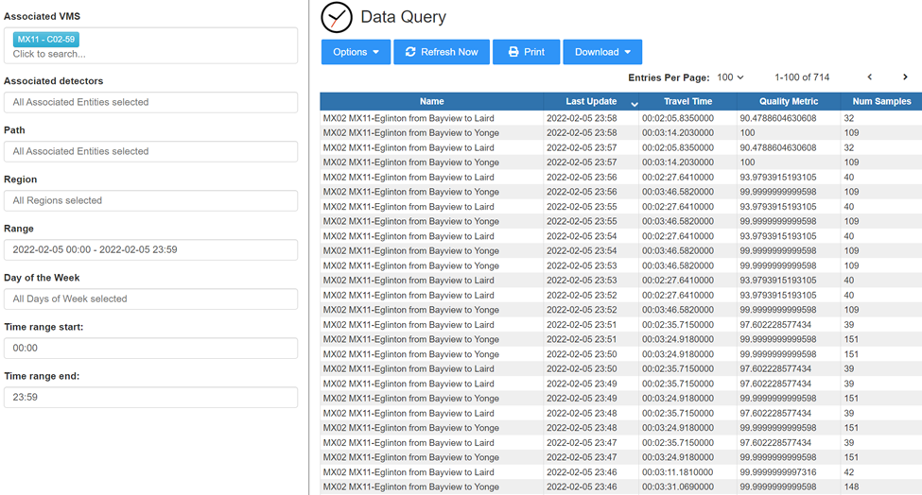

*5.5.3. The historical data portal shall be accessible remotely by MTO users.*

The ITS Central data query portal is available to all authorized users.

*5.5.4. Historical data shall be readily accessible to MTO users within five (5) minutes of travel time information publishing.*

ITS Central allows for historical data to be readily accessible to MTO users as soon as the travel time information is computed and published, in real-time.

*5.5.5. VMS messages shall be included in queries of field hardware and location for auditing and accuracy checking purposes.*

ITS Central includes the VMS Messages when querying field hardware and location.

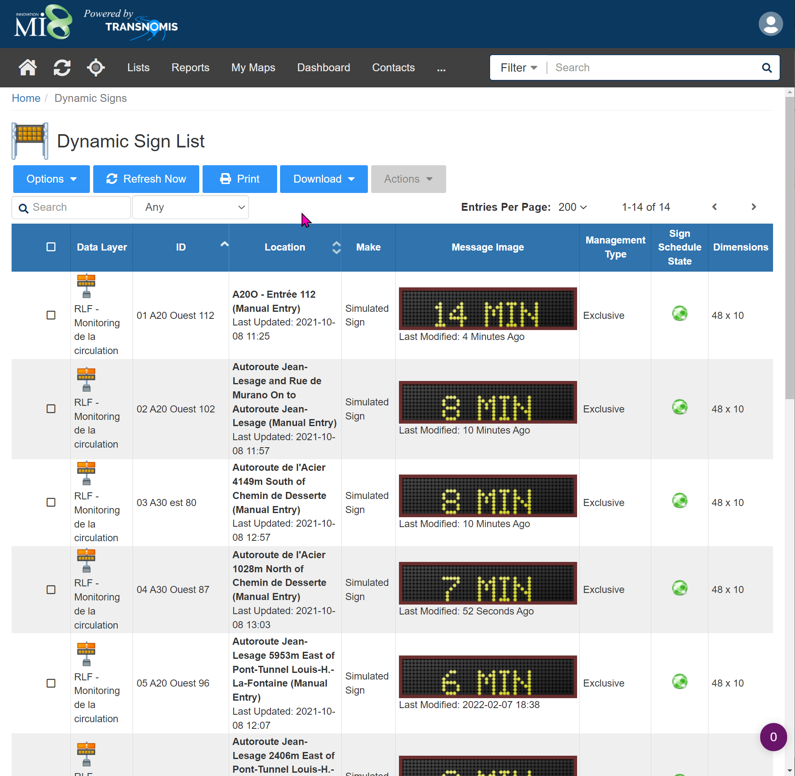

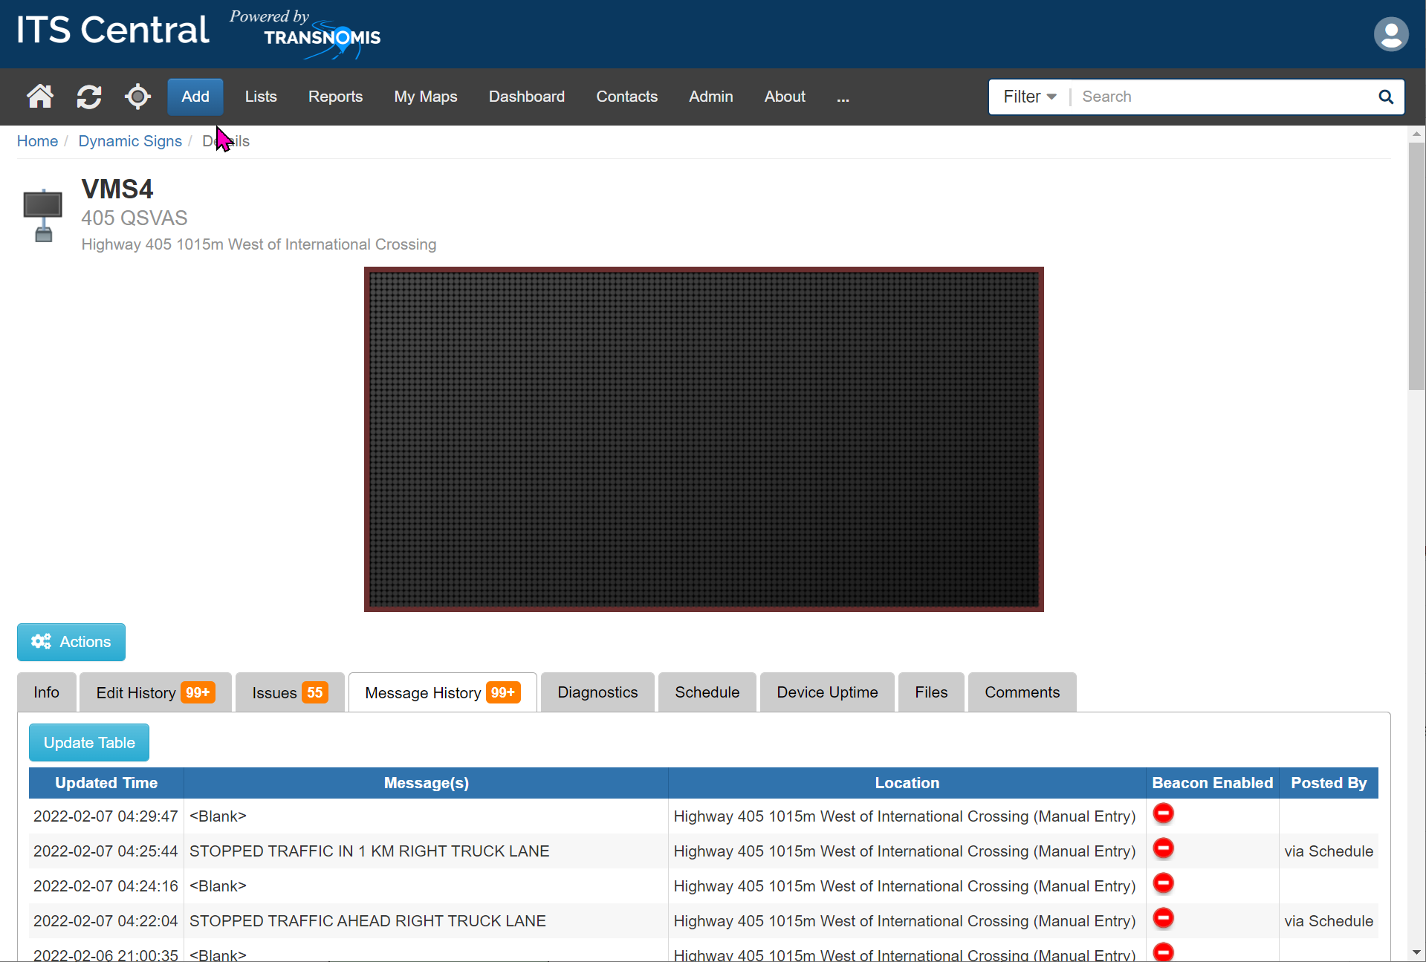

*5.5.6. Users shall be able to query travel times of routes over a specified time period.*

ITS Central allows users to query travel time routes over one or more specified time periods.

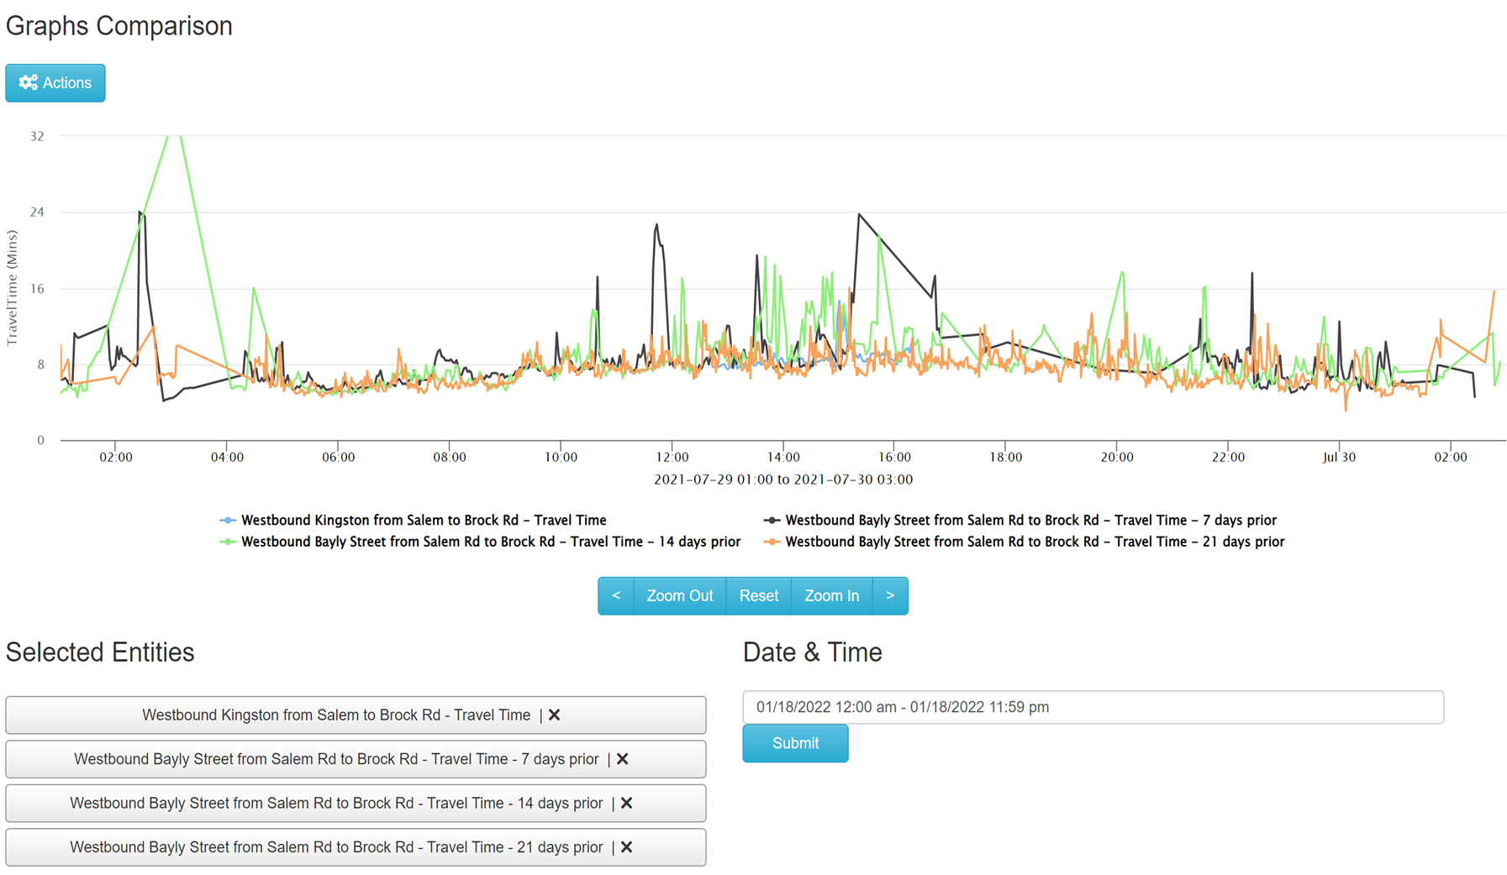

*5.5.7. Users shall be able to query travel times of routes by recurring time periods, including but not limited to specific days of the week over a specified number of weeks.*

Users are able to query travel times of routes by various days over a number of weeks.





*5.5.8. Each link travel time query shall include individual check-in and check-out timestamps of the Bluetooth pair forming the link, and the calculated travel time for each encrypted MAC ID.*

Link travel time queries include individual check in and check out timestamps of the Bluetooth pair forming the link, and the calculated travel time for each encrypted MAC ID.

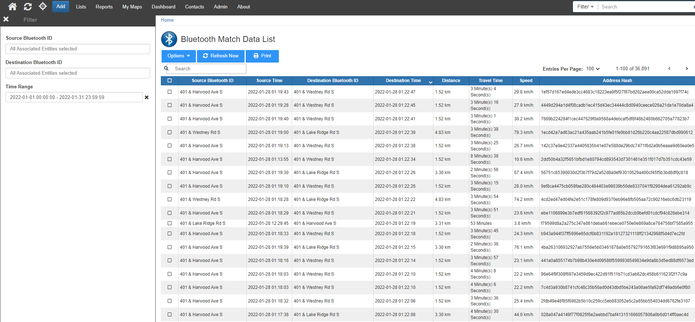

*5.5.9. Each route and link travel time query shall include the travel time average, maximum, and minimum values over the records in the query.*

ITS Central computes and include the required data fields in the data query.

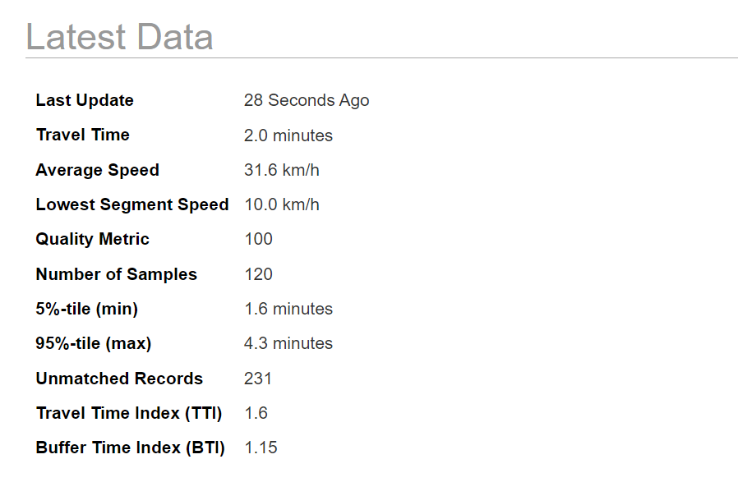

*5.5.10. Each route and link travel time query shall show the number of matched and unmatched records in that time period.*

ITS Central computes and include the required data fields in the data query.  see 5.5.9

*5.5.11. Each route and link travel time query shall display the MTO-assigned IDs of the origin and destination Readers.*

ITS Central route and link travel time queries display the MTO assigned IDs of all of the readers associated to the route / link.

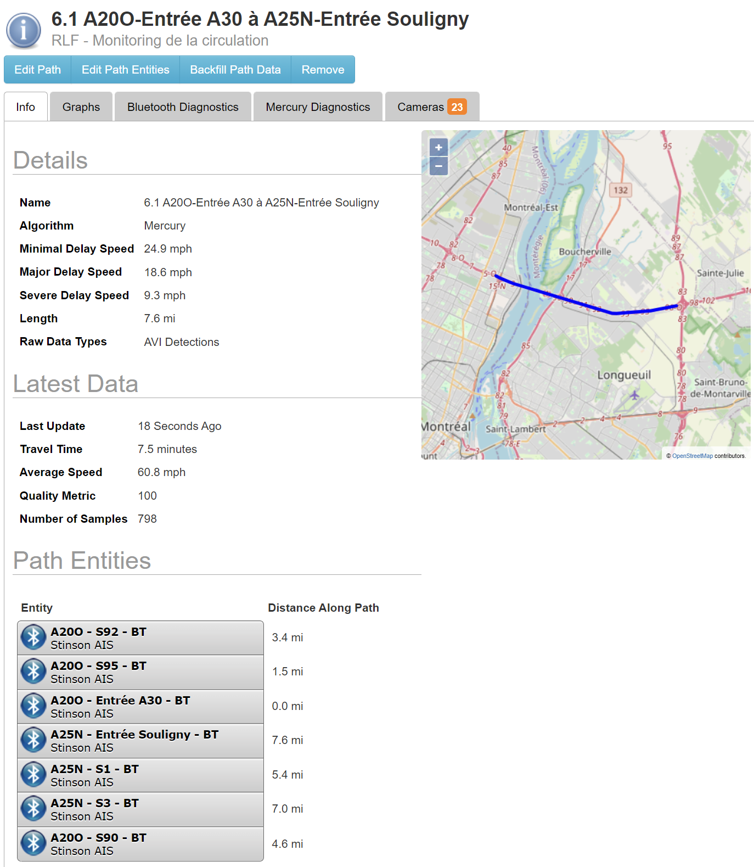

*5.5.12. Each route and link travel time query shall include the MTO-assigned ID of the query’s selected routes and links.*

ITS Central route and link travel time queries display the MTO assigned IDs of the selected routes and links. See “Name” in screenshot above.

*5.5.13. Each route and link travel time query shall include the MTO-assigned VMS ID of any sign that displays information for the route.*

VMS ID's are shown for each route and link travel time query, for signs displaying info for a travel time path.

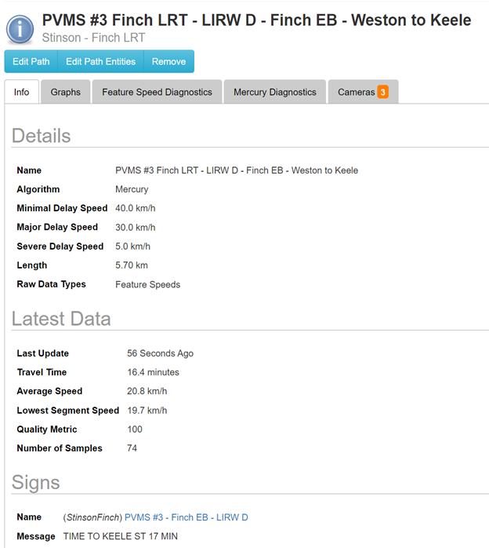

*5.5.14. The data portal shall be able to query historical data for any Bluetooth reader or VMS, based on its unique MTO-assigned Bluetooth or VMS ID.*

The ITS Central data reporting portal can query historical data for any Bluetooth reader or VMS based on its unique MTO assigned ID.

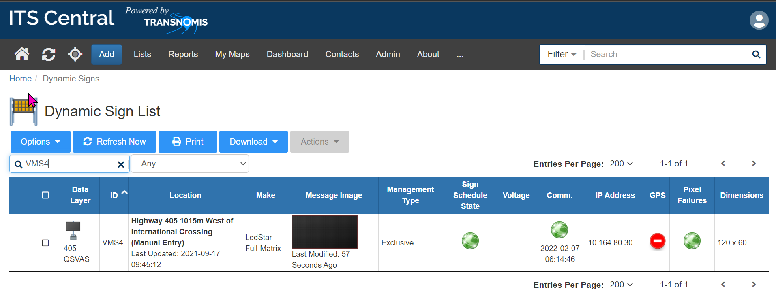

*5.5.15. Queries of Bluetooth Readers shall include individual encrypted MAC ID records with check-in and check-out timestamps for the Bluetooth pairs.*

Users can query for MAC matches between pairs of Bluetooth sensors within ITS Central.



**Data Ownership**

*5.6.1. MTO shall own all data, including aggregated and archived data.*

MTO will own all data including raw, aggregated and archived data.

*5.6.2. The Proponent shall perform a regular data dump to MTO. MTO to provide the Proponent with details on frequency of these data dumps and which data to include. Data to include at minimum processed travel time data for all links and routes in Central Region.*

Transnomis will facilitate a regular data dump to MTO based on the further details to be provided.

**Travel Time Dashboard (2.6.5.6)**

*6.1. The GUI shall provide a dashboard for MTO to access real-time travel time and hardware (Bluetooth reader, VMS) information.*

ITS Central includes a robust configurable dashboard that can display real-time travel time, and hardware/maintenance issues.

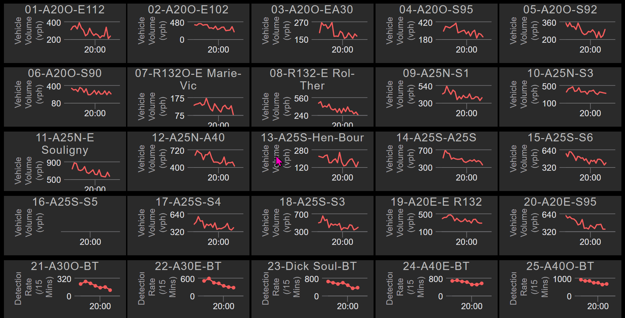

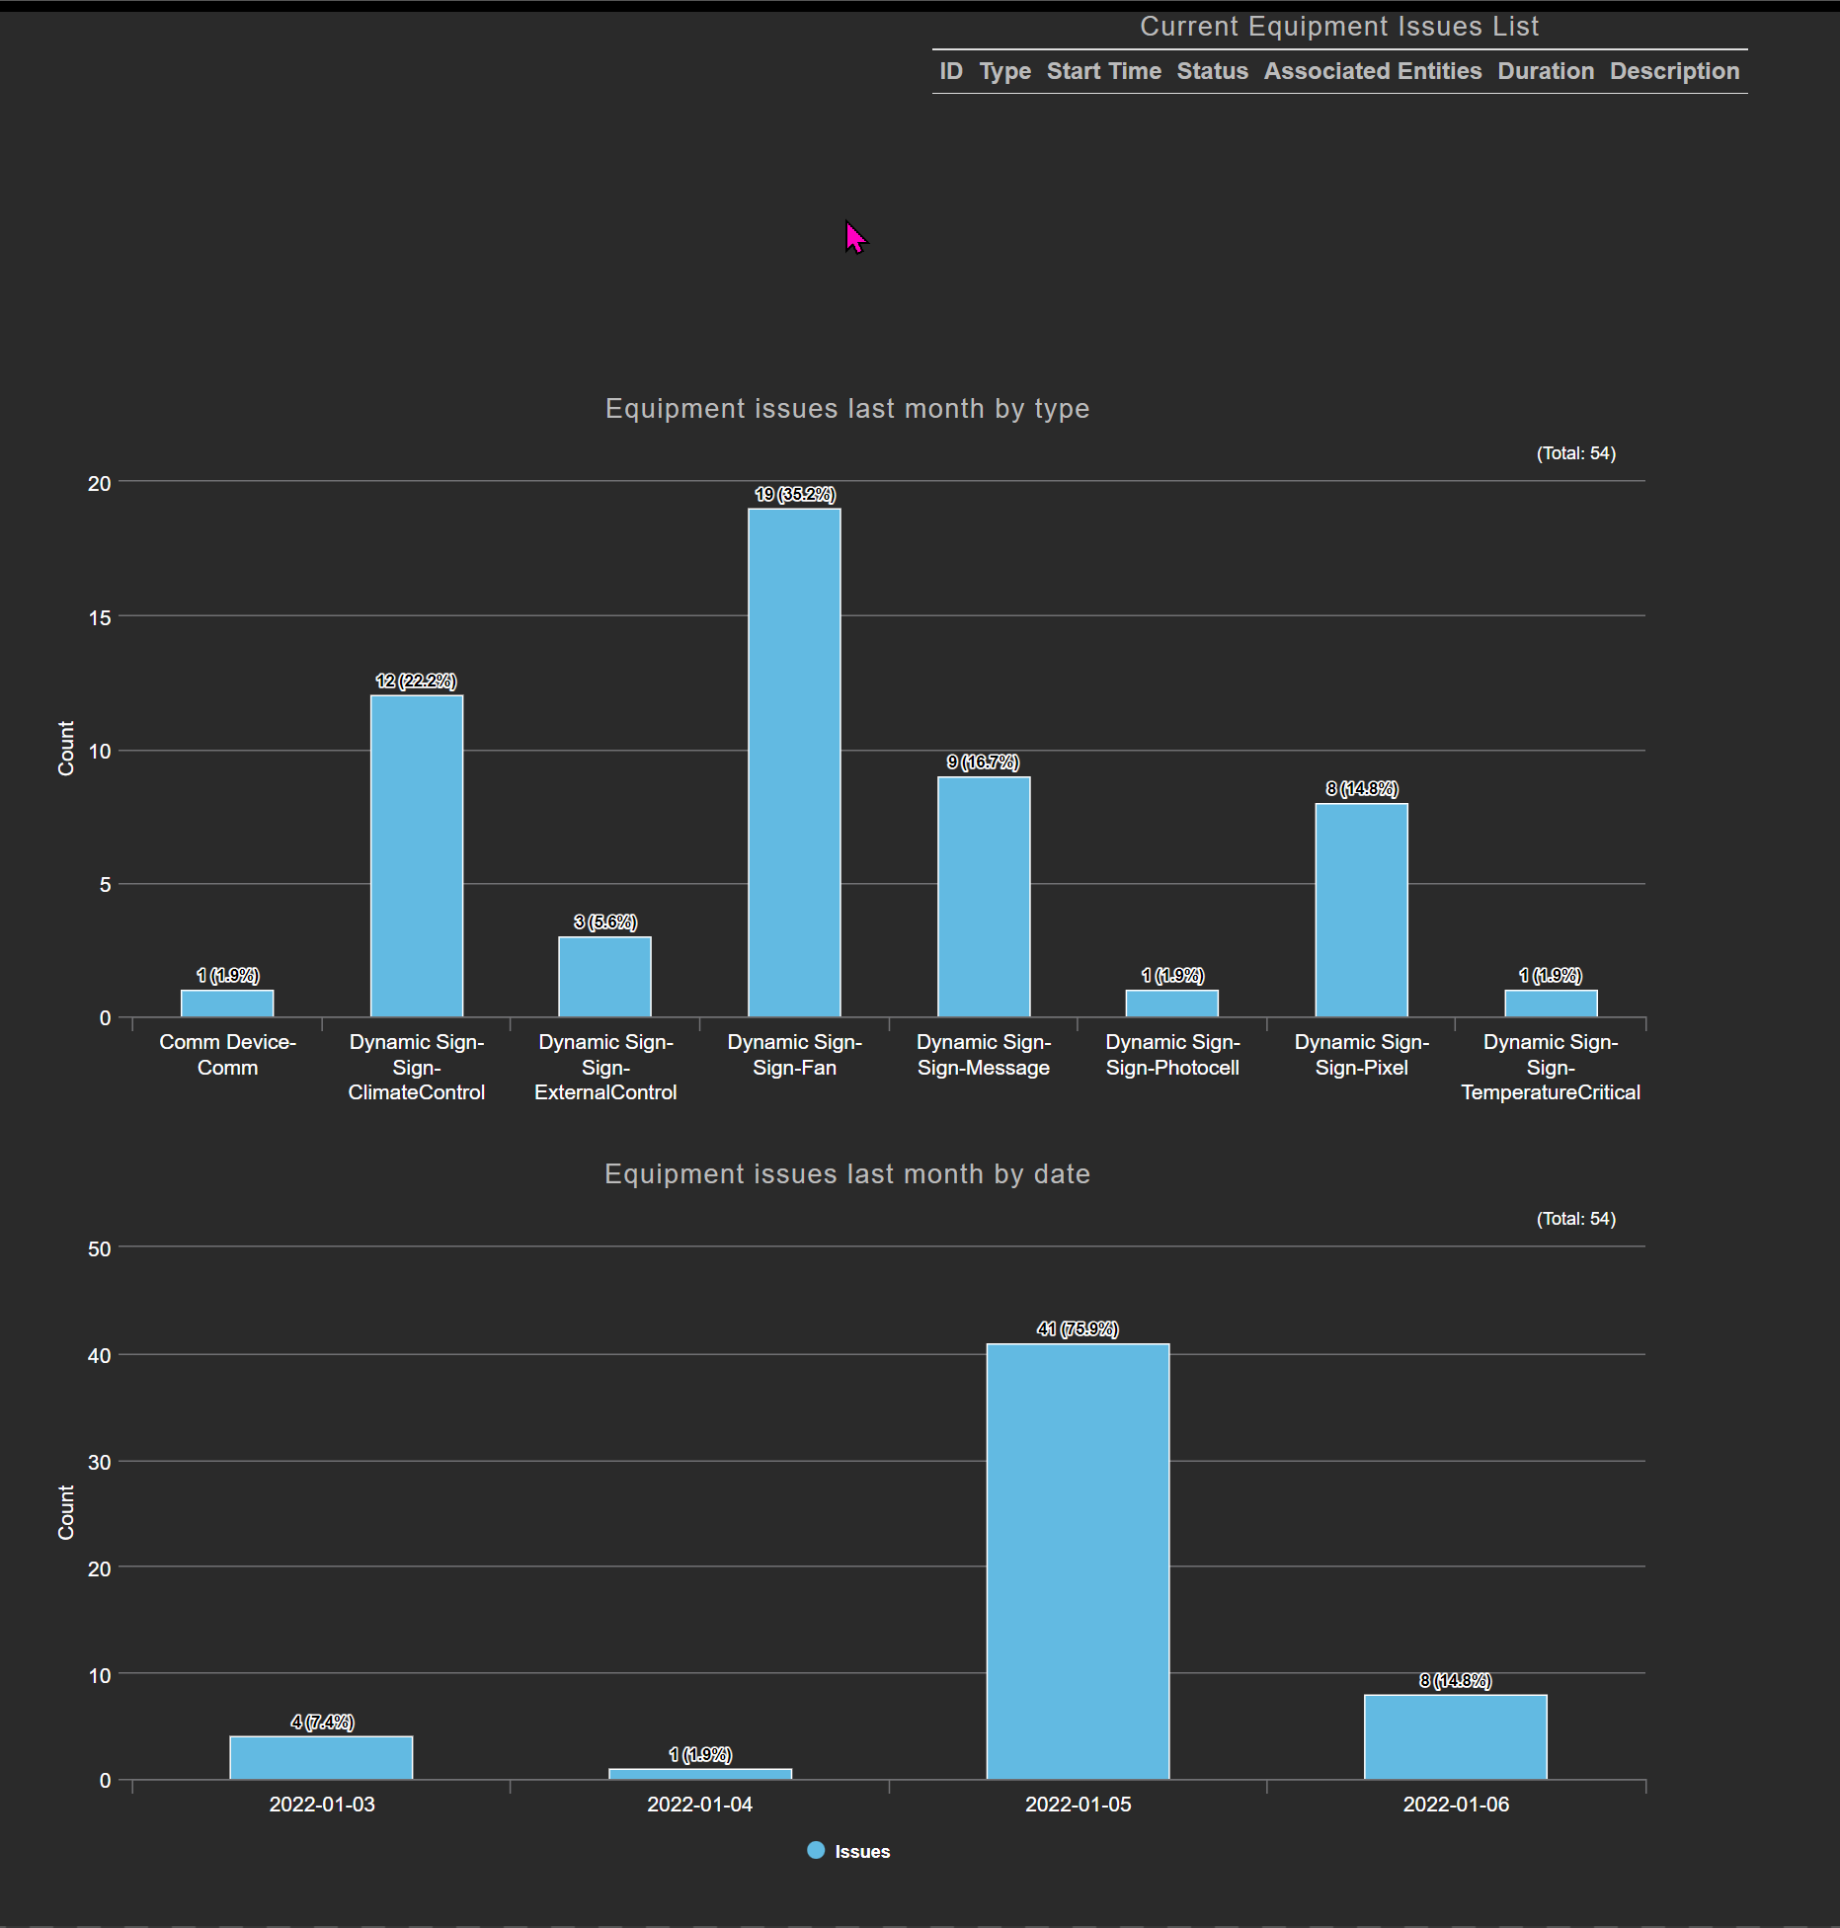

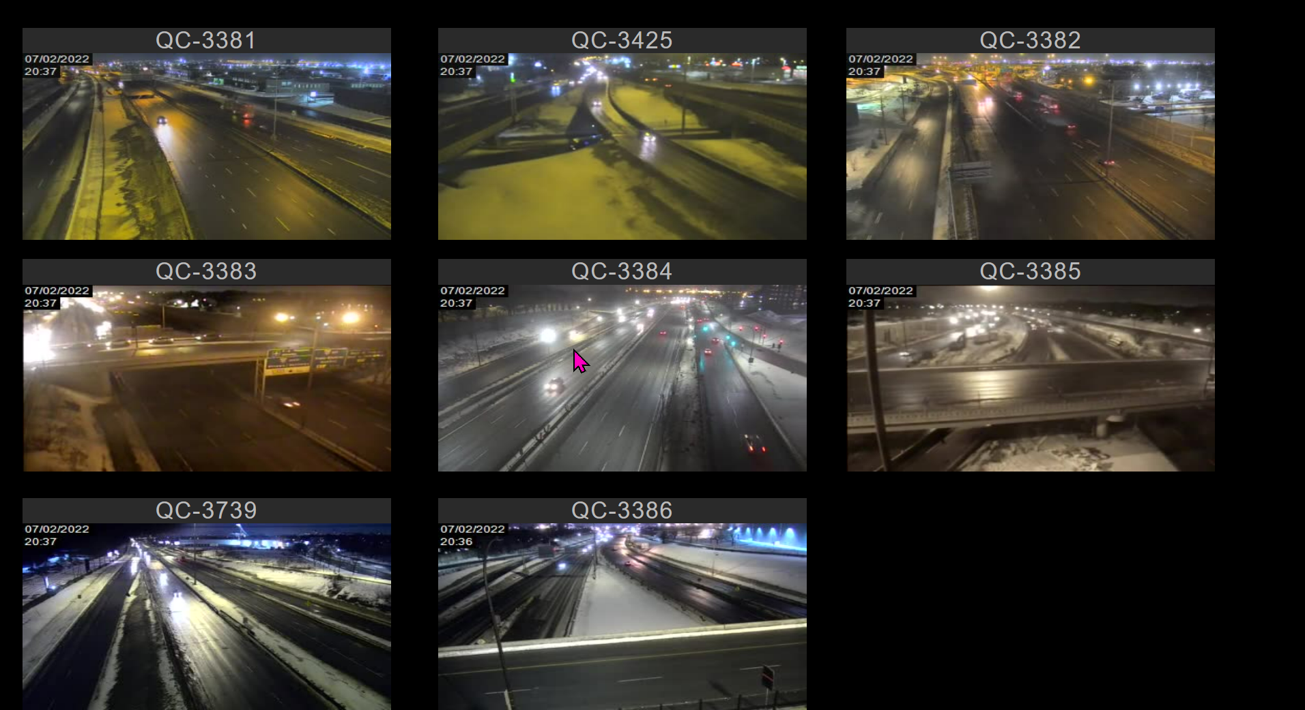

*6.2. The dashboard shall include a map view.*

ITS Central's dashboard is user configurable, and can be configured easily to include a map view that suits the individual operator’s needs.

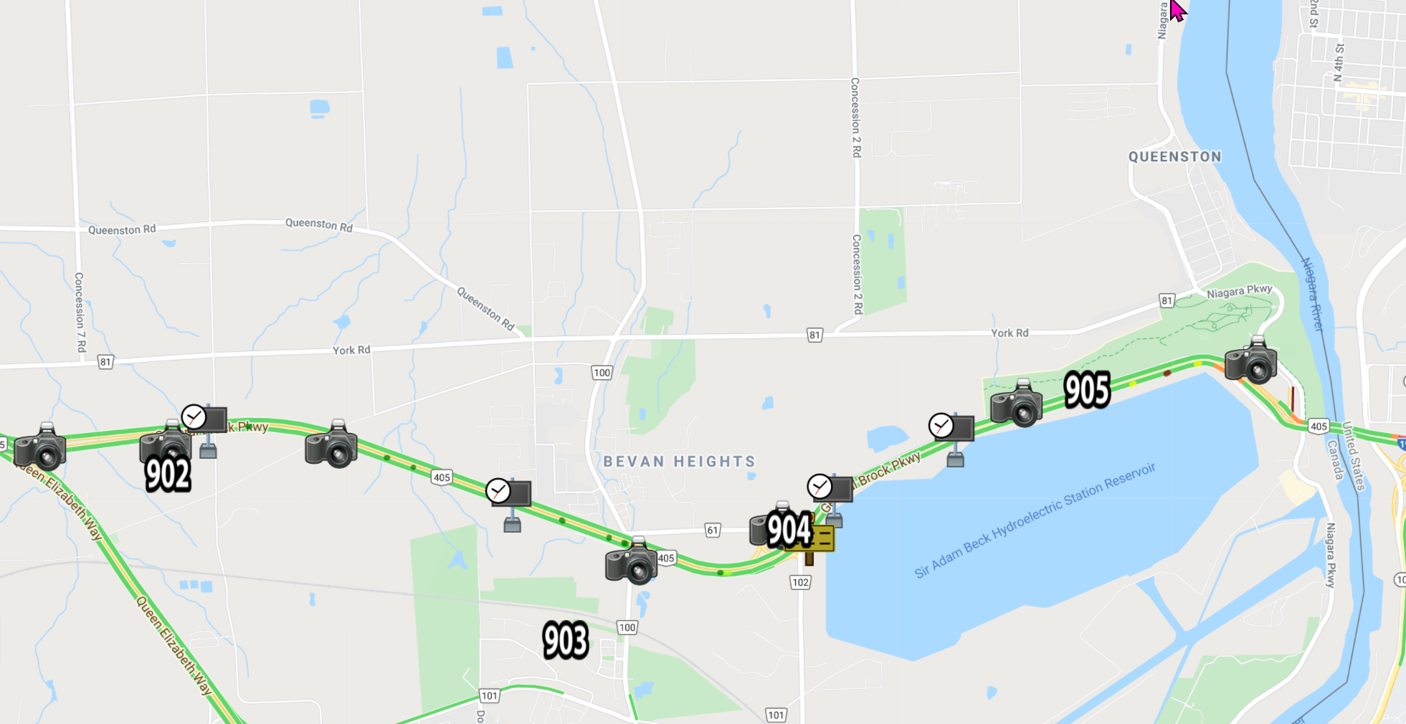

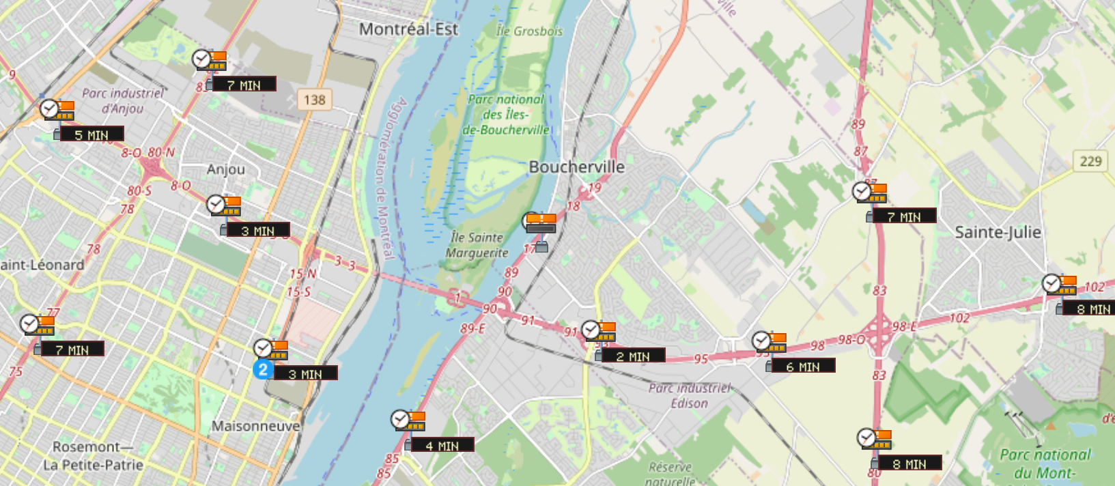

*6.3. The dashboard shall include a map view.*

See above, 6.2

*6.4. The dashboard shall provide information on travel time index (TTI) for links and routes. TTI = TT (real-time) / TT (free-flow)*

The dashboard display provides the information on TTI and BTI for each link and route.

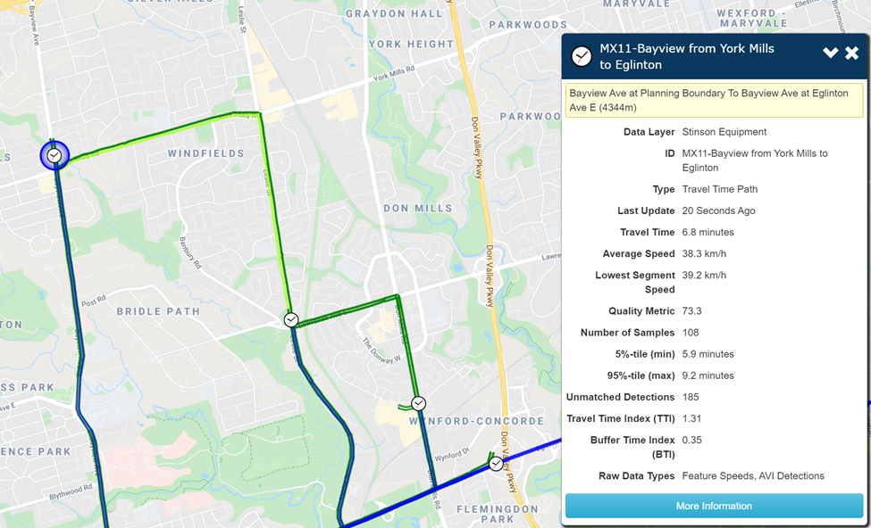

*6.5. The dashboard shall provide information on buffer time index (BTI) for links and routes. BTI = (TT (95th percentile) – TT (real-time)) / TT (real-time)*

See above, 6.4.

*6.6. The dashboard shall provide information regarding the number of matched encrypted MAC ID records for a specified link, route, and time period.)*

The dashboard is configurable to provide the number of matched records for a specified link, route, and time period.

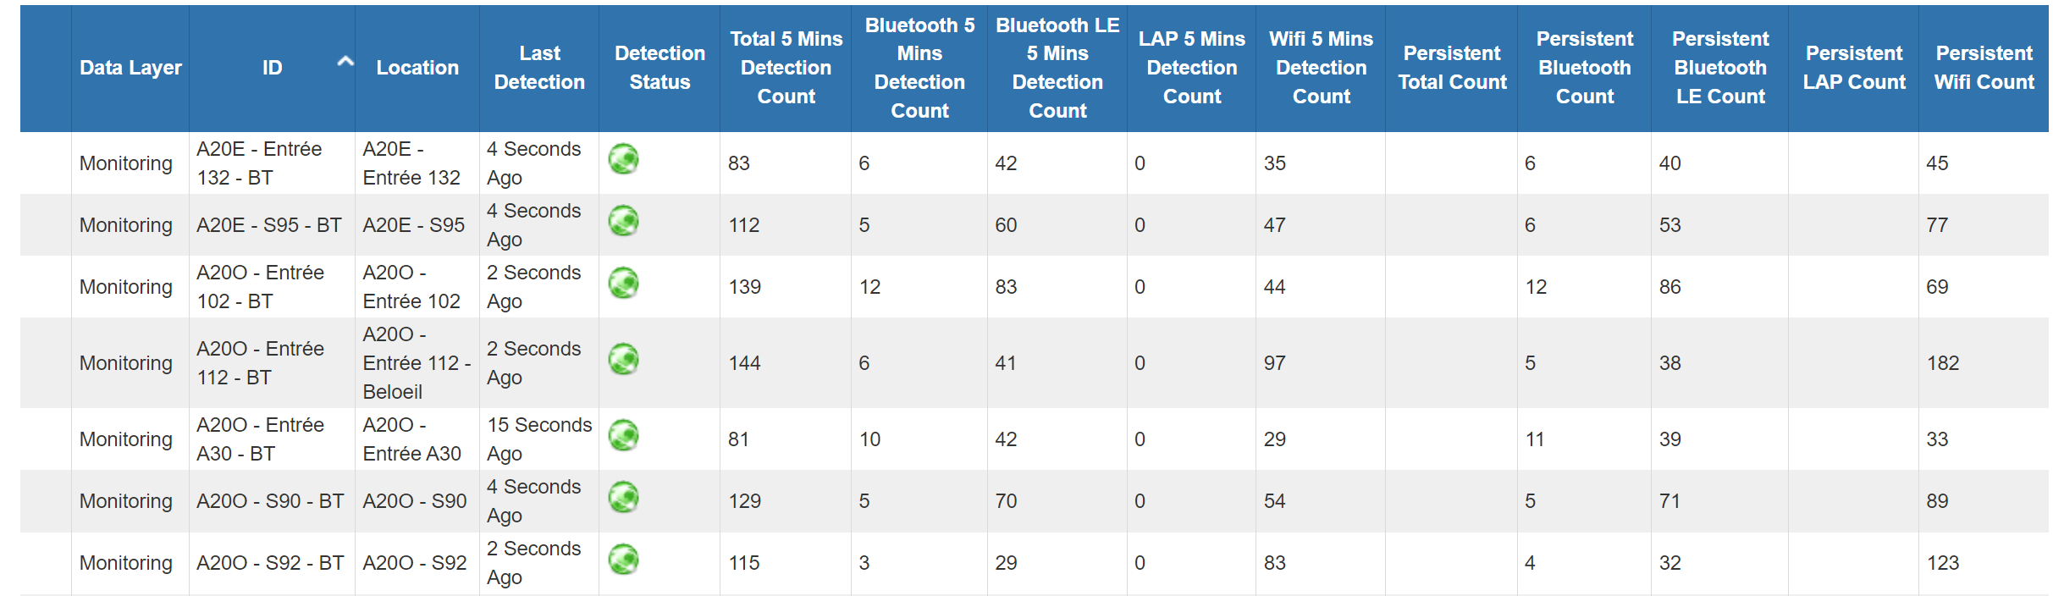

*6.7. The dashboard table/graphical view shall default to displaying VMSs and their associated route destinations and their most recent travel time information and the associated date/time stamp information for each VMS TT message.*

The Dynamic Sign list shows the associated travel time information (last column below), and the associated date/timestamp information for each VMS travel time message.

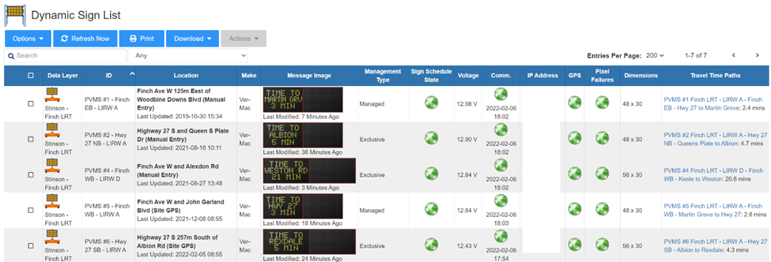

*6.8. The dashboard table/graphical view shall have the capability of listing historical route travel times and messages.*

ITS Central provides the capability of listing historical route travel time messages – for each sign, as well as for all signs.



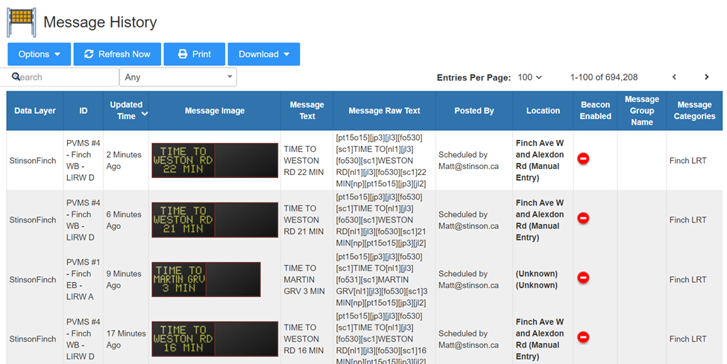

*6.9. The dashboard table/graphical view shall have the option to tabulate travel time routes, displaying their associated Bluetooth Readers, travel times, and historical travel times.*

ITS Central provides a table for travel time paths (applies to both link and routes) and display their associated Bluetooth Readers, travel times, and various other information.

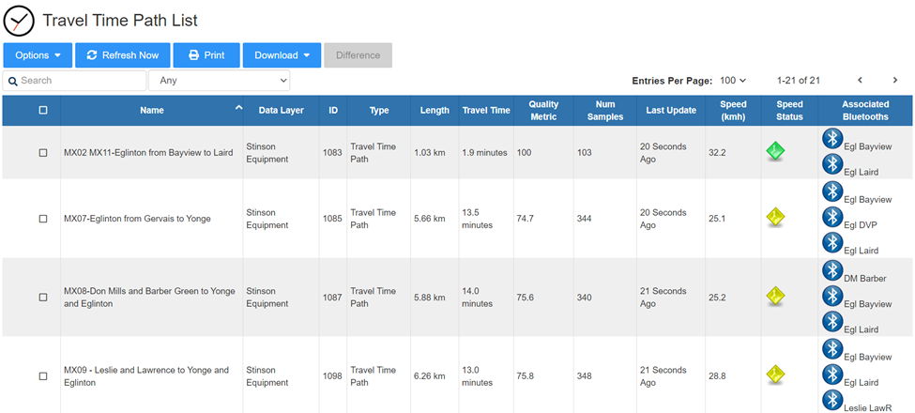

Historical travel times are available on a path-by-path basis:

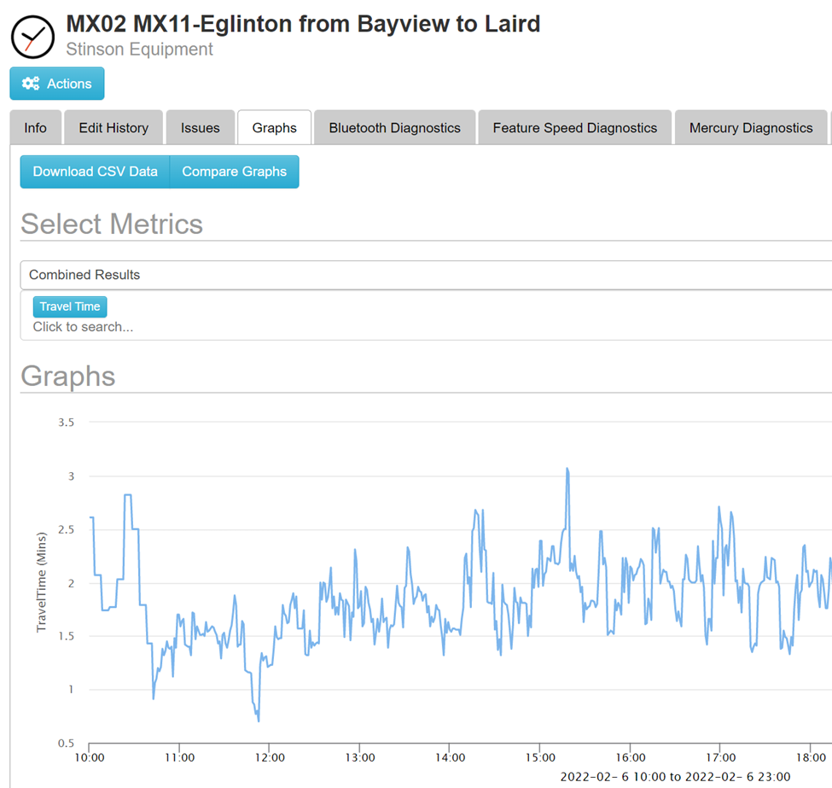

*6.10. The dashboard table/graphical view shall have the option to tabulate Bluetooth Readers, and display the associated routes, real-time travel times, and historical travel times.*

ITS Central provides a table view of all Bluetooth Readers, providing their associated travel time paths (routes) and their travel times, and their detection counts of different types of detection technologies (Bluetooth, Bluetooth LE and WiFi).

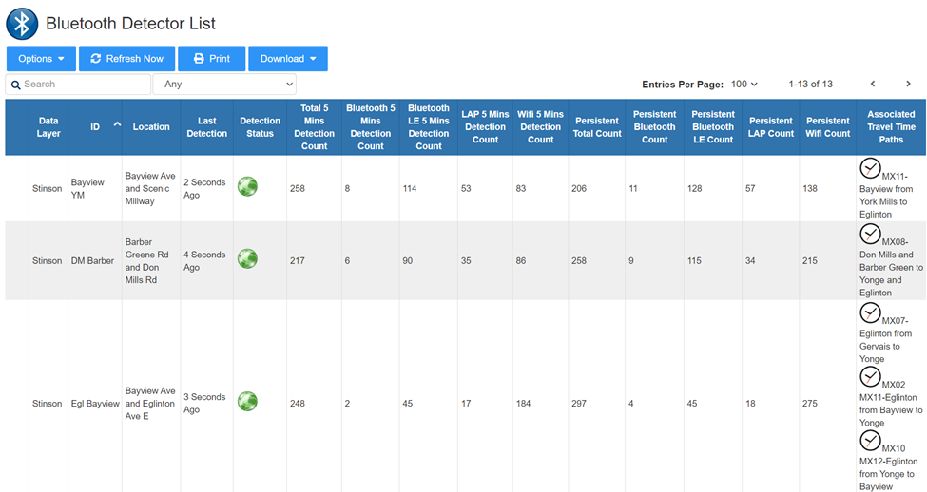

Historical travel times are available on a path-by-path basis as shown in the screenshot in 6.9.

*6.11. The dashboard base map shall be up-to-date, and shall be based on Google Maps, Bing Maps, or equivalent.*

A selection of base maps are available to choose from, including Google Maps, and Open Street Map. Users may configure the map to their preference.

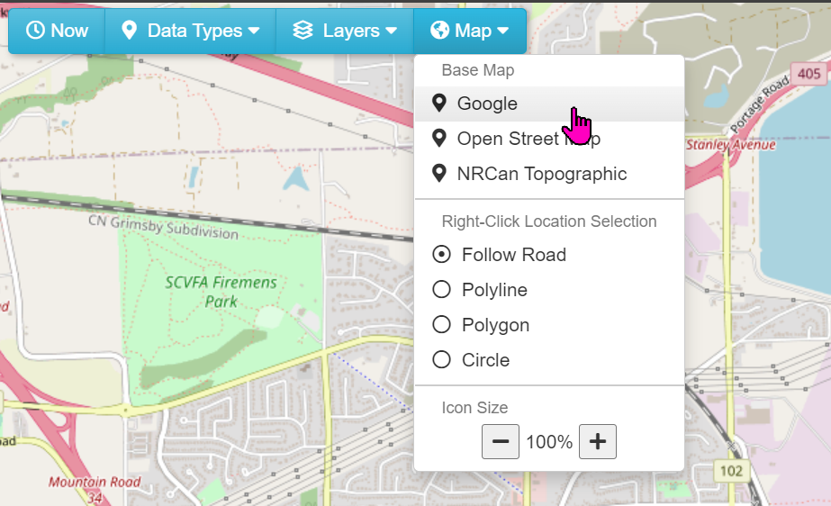

*6.12. The base map shall be updated annually, and/or when a new section of highway is open within MTO jurisdiction.*

The base maps are updated by the map sources – Google and Open Street Map, based on input from thousands of community map editors. They are typically updated very frequently as millions of users depend on these maps on a daily basis..

*6.13. The Proponent shall be responsible for obtaining and renewing the map license.*

Transnomis will be responsible for obtaining and renewing the map license throughout the duration of the contracted agreement period.

*6.14. The dashboard map shall be used to display travel times as coloured lines overlain on roadways.*

Colour coded links are automatically drawn following the roads indicating congestion level. The speeds and colours are configurable.

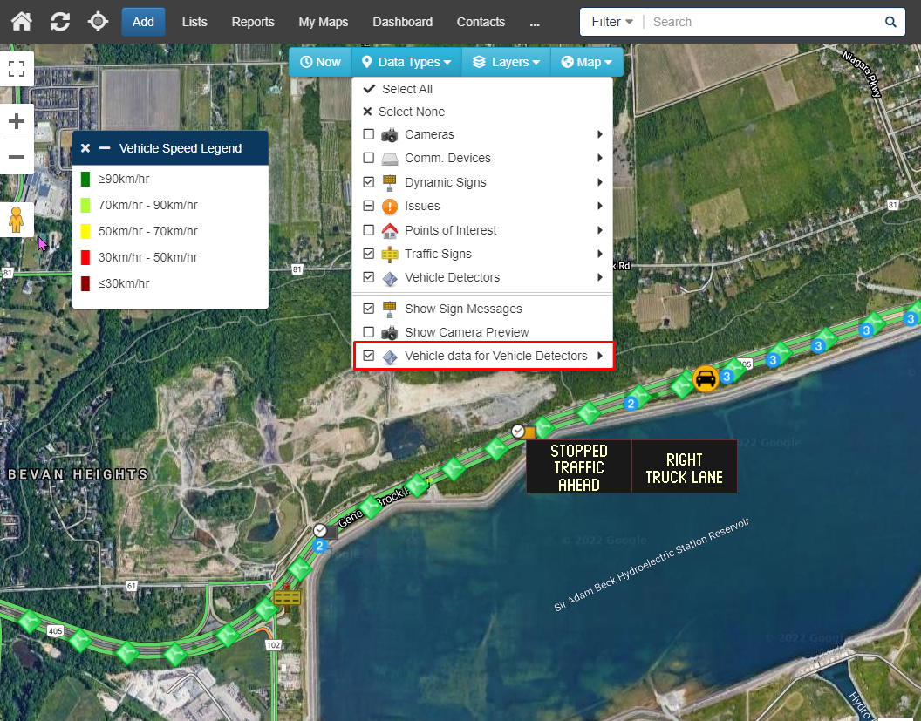

*6.15. The dashboard map view shall default to displaying MTO Central Region. The map view shall include functionality to configure zoom and focus to suit display size.*

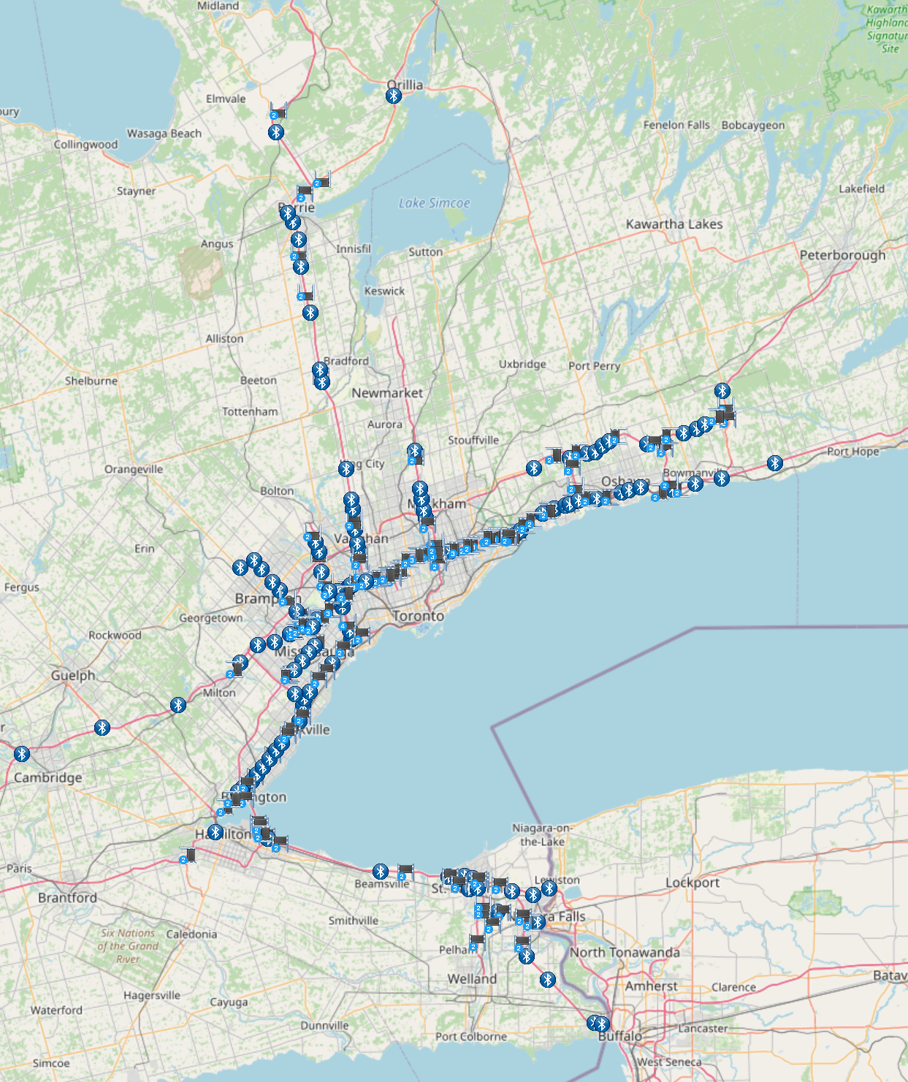

The dashboard is user configurable. A map view will be customized for the display, and the remainder of the dashboard real estate can be used for reports, charts, and travel time indicators.

*6.16. All MTO roadways included in the TT System shall be labelled by default.*

All MTO roadways included in the system are labelled by default. 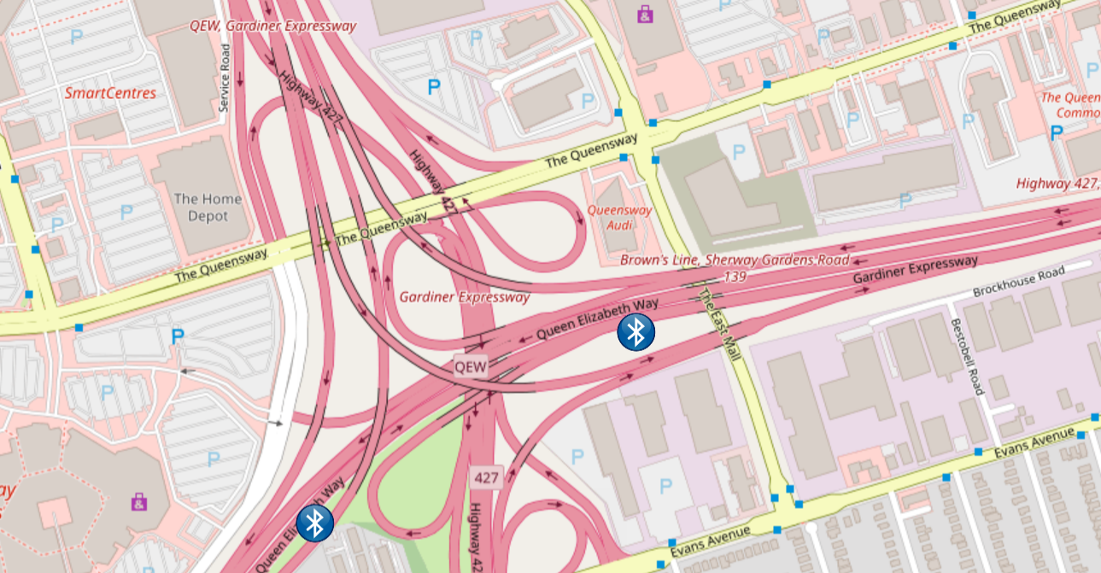

*6.17. The dashboard map shall include an option to display a map of individual municipalities within Ontario.*

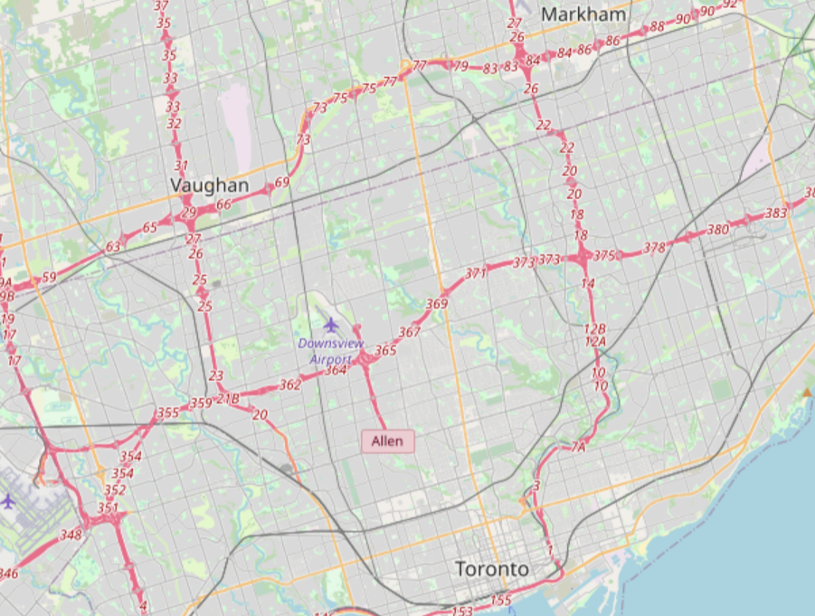

The base map includes a display of individual municipalities. Users may also search and display the municipal boundary.

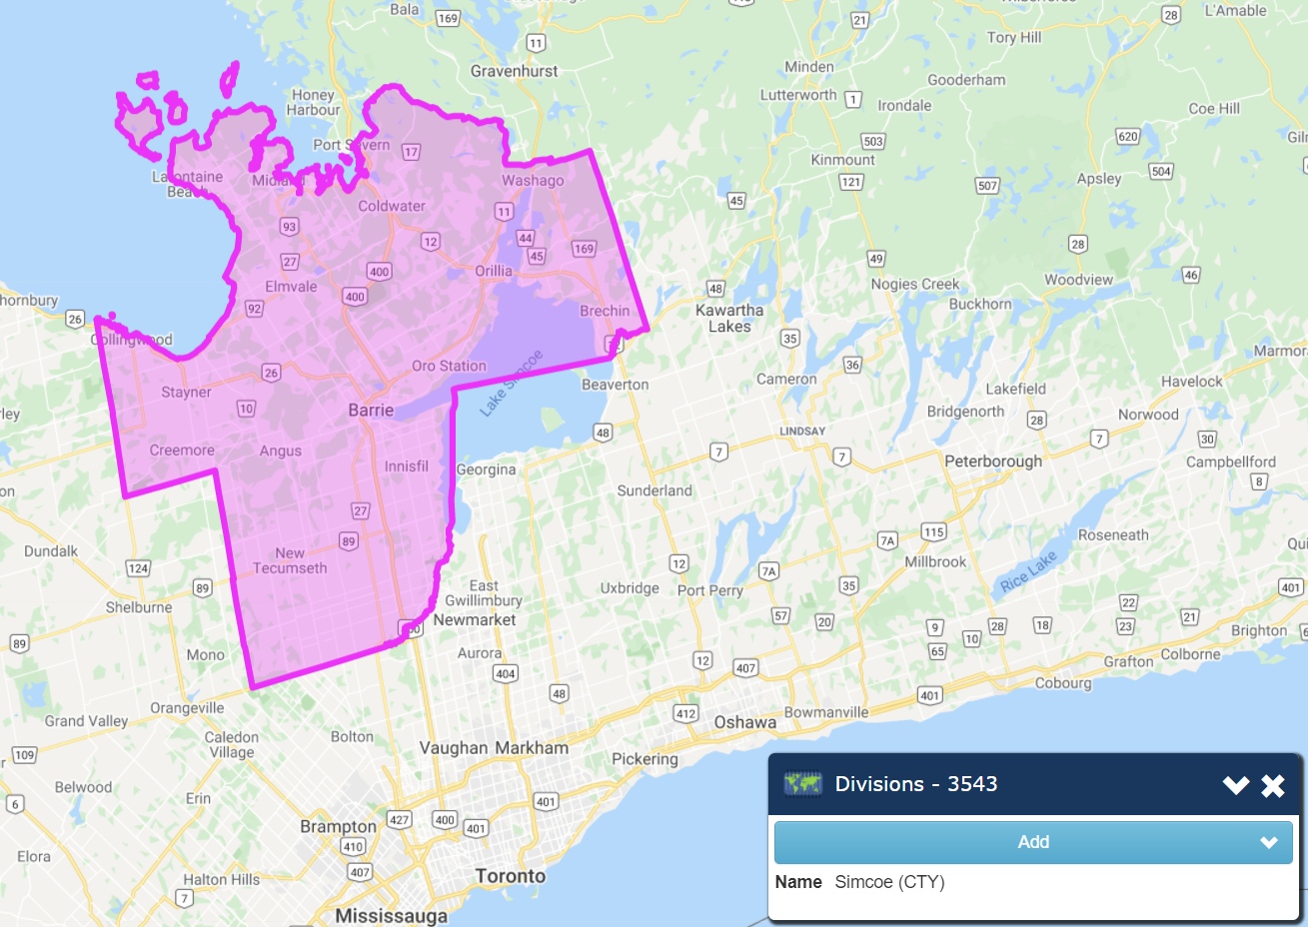

*6.18. The dashboard map shall include an option to display a map of other MTO Regions and the full province of Ontario.*

The dashboard map (based on Google Maps and Open Street Map) can display a map of other MTO Regions and the full province of Ontario.

*6.19. The dashboard map shall include a zoom feature to display a selected area of the province of Ontario.*

The dashboard map has the standard pan and zoom mapping features. In addition, Google Street View is also available under Google Map.

*6.20. The dashboard map shall be able to display the locations of TT System components, including Bluetooth Readers, VMSs, and routes.*

The dashboard map is user configurable, and can display the locations of the travel time system components.

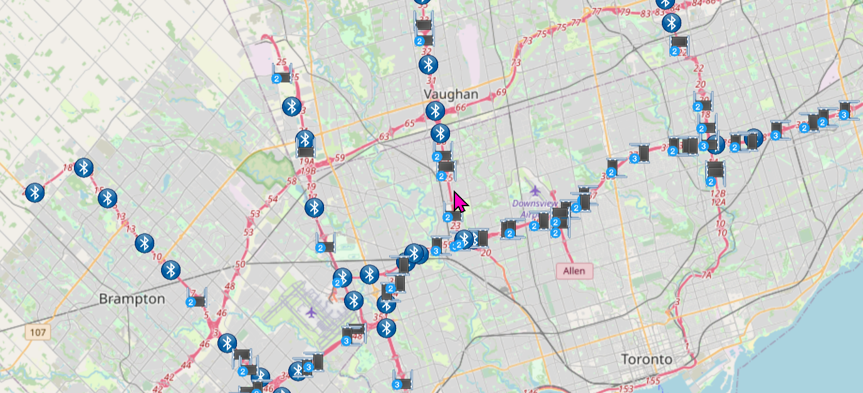

*6.21. The dashboard map shall default to showing real-time travel time information on its routes. Data shall be refreshed every one (1) minute.*

The dashboard is configurable for refresh rate and contents. Real-time travel time information will be displayed by default.

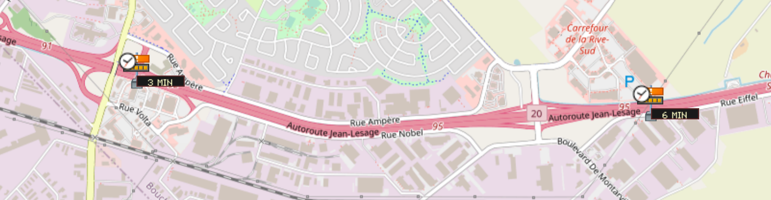

*6.22. The dashboard map shall be able to display historical travel time if desired by the user.*

The dashboard map is configurable and will display historical travel time if desired by the user. Multiple dashboards will be created for different purposes.

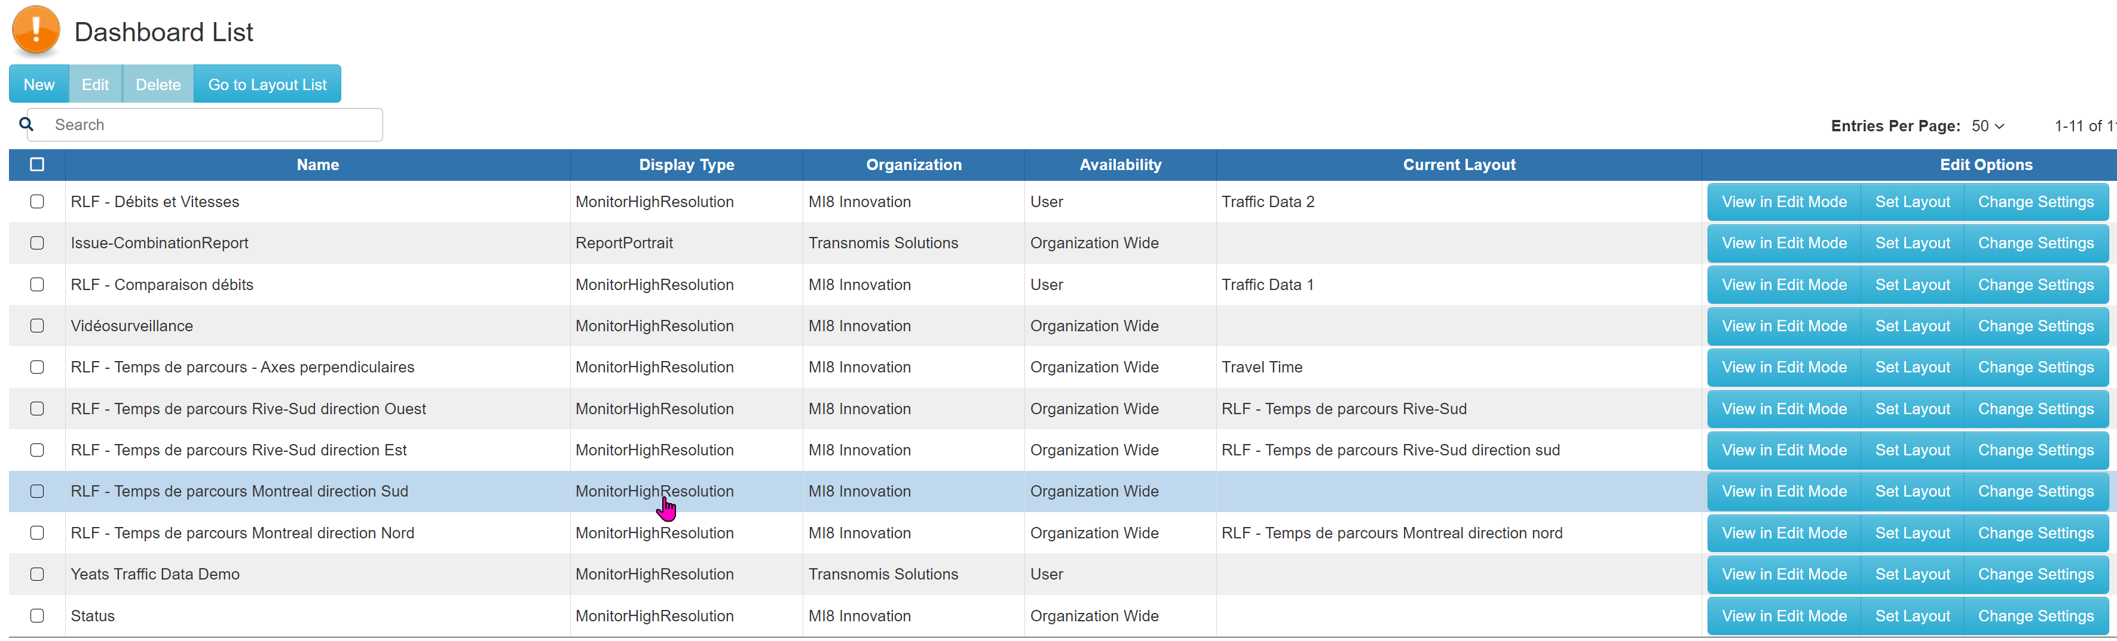

**Reporting System (2.6.5.7)**

*7.1. The GUI shall consist of a user-accessible reporting system.*

ITS Central includes a reporting system, accessible by users:

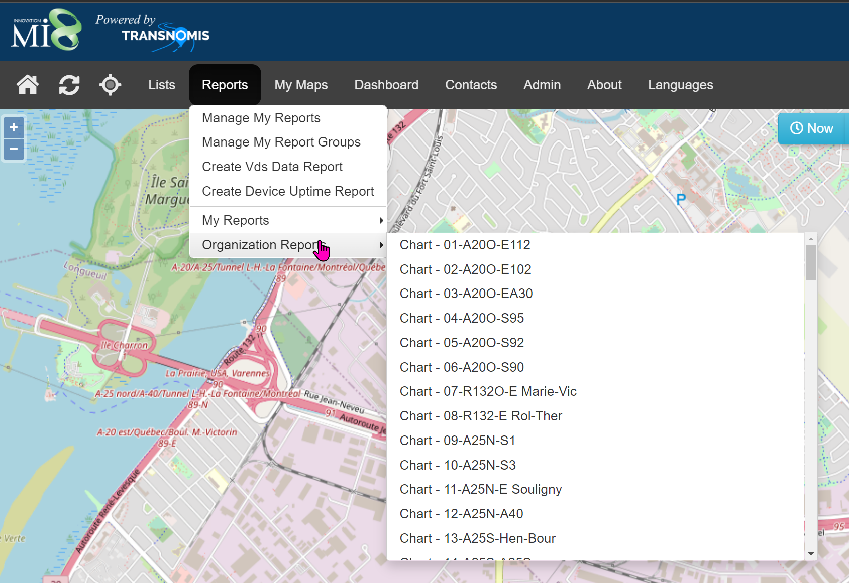

*7.2. The GUI shall consist of a user-accessible reporting system. Reads (number of Bluetooth-enabled devices detected at each Bluetooth reader); Matches (number of matched encrypted MAC IDs for any pair of Bluetooth Readers); Instances of “slow traffic” in the sign-based TT message XML feed (see Item 5.3.14 in Section 2.6.5.5.3); Validity of VMS messages in the sign-based TT message XML feed (see Item 5.3.12 in Section 2.6.5.5.3); Bluetooth reader health and a log of trouble tickets; Bluetooth reader communications disruptions; Travel Time (for any route configured in the system); and Origin-Destination patterns.*

ITS Central includes robust reporting tools. Transnomis will customize reports within ITS Central to address all of MTO’s needs.

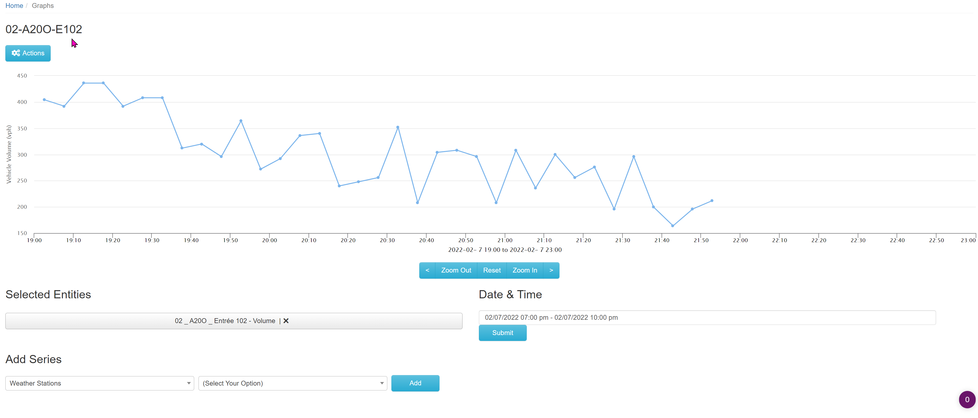

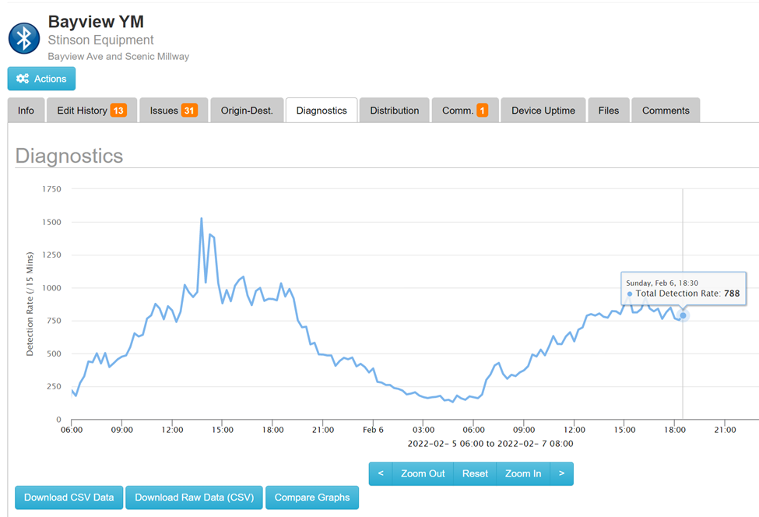

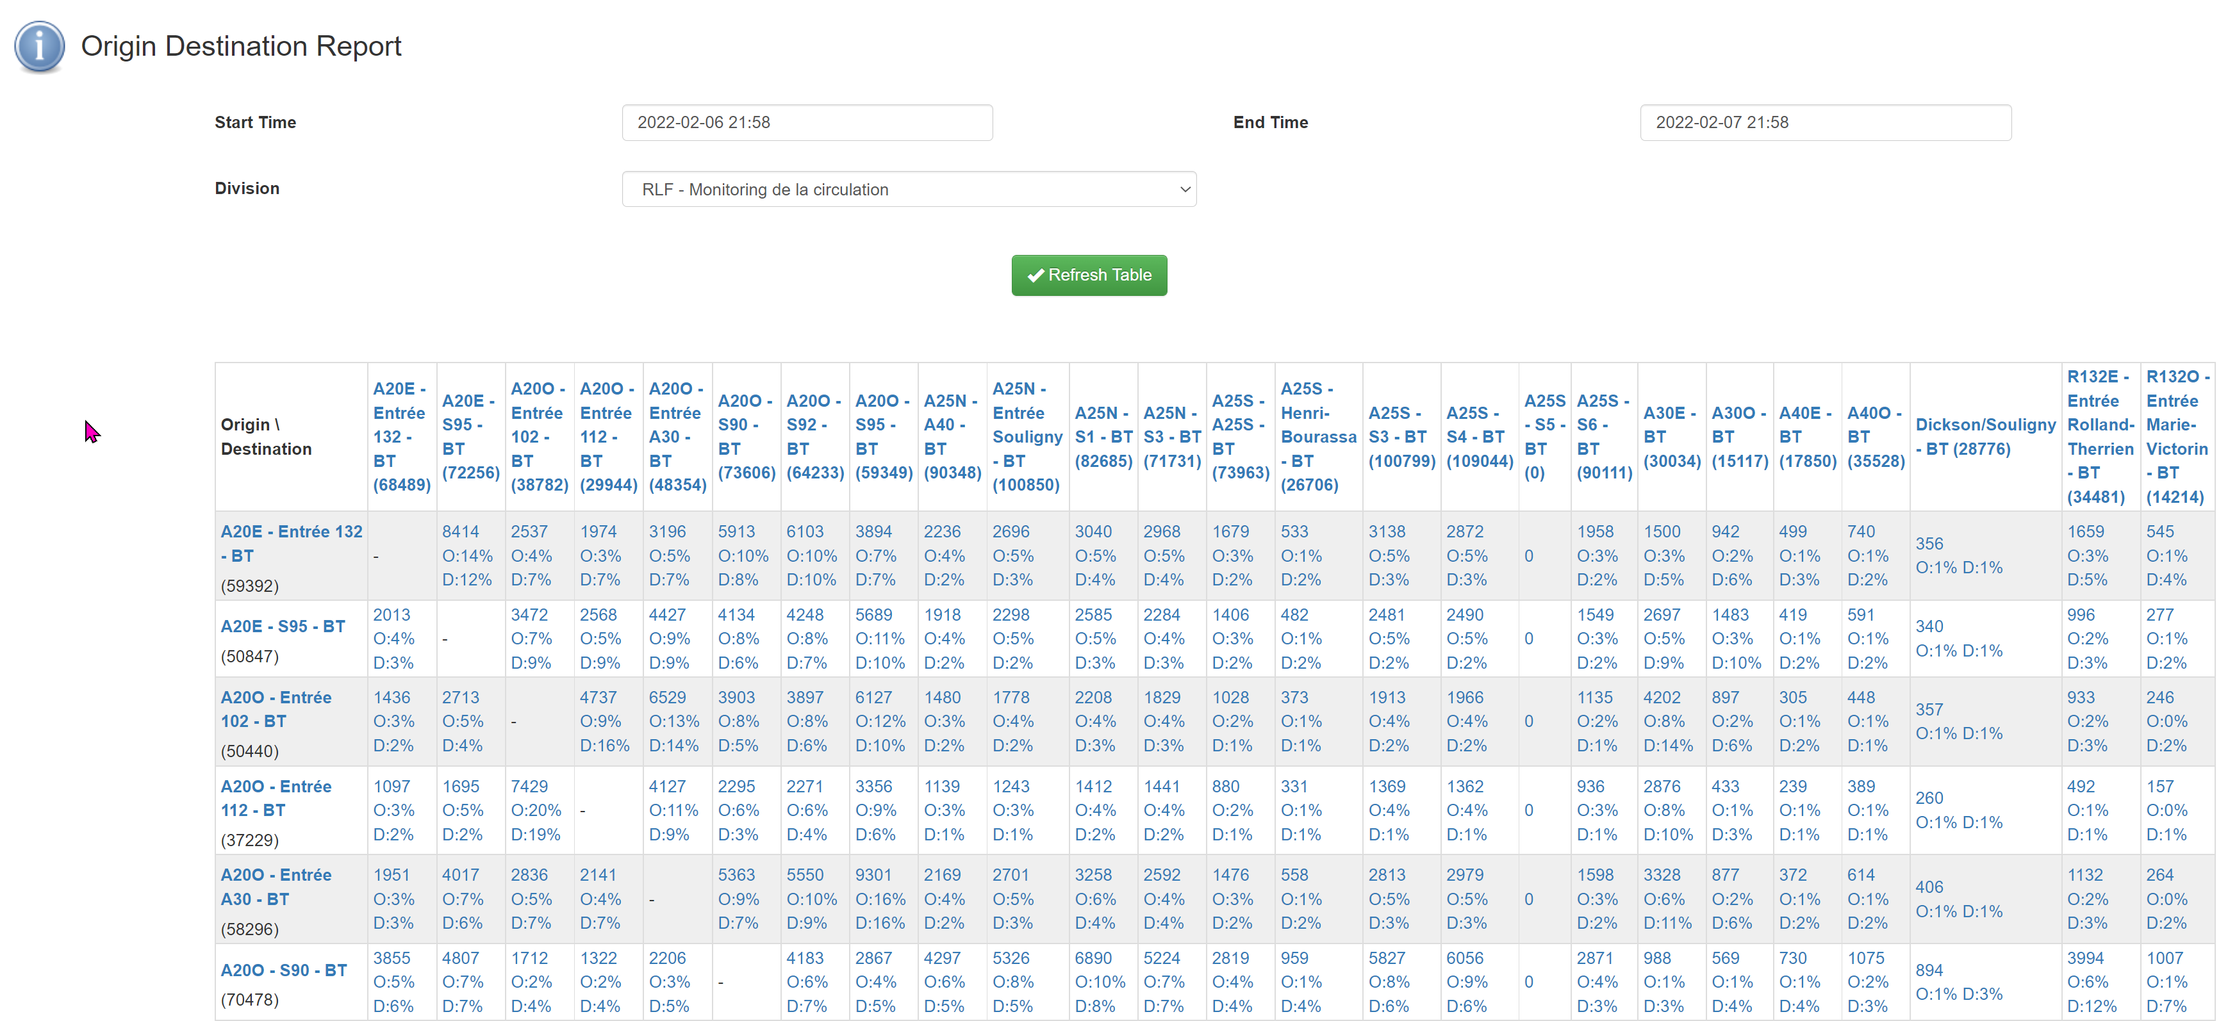

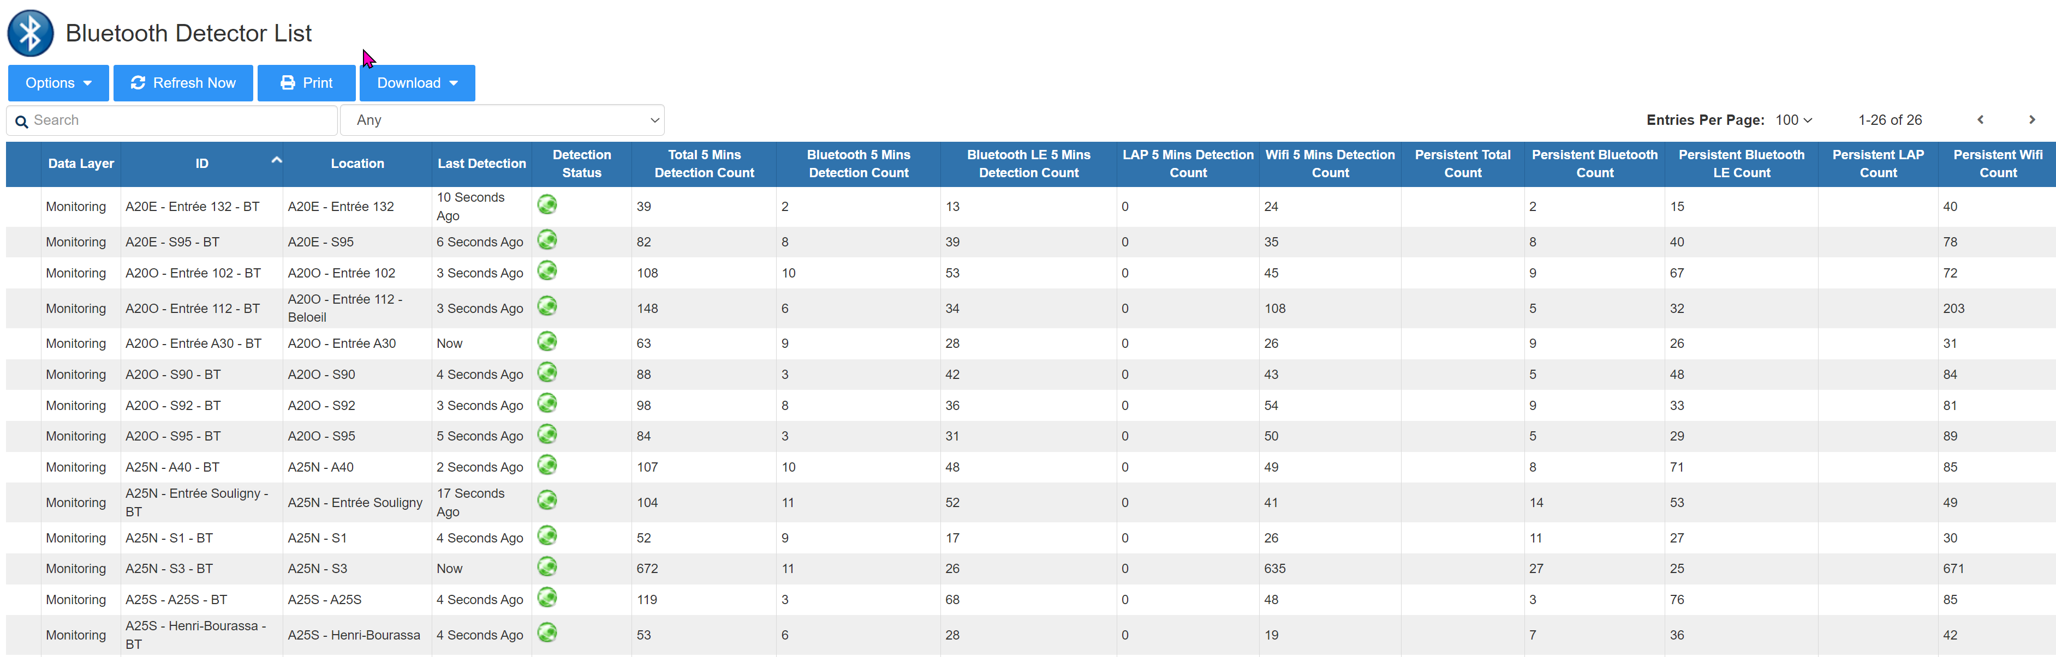

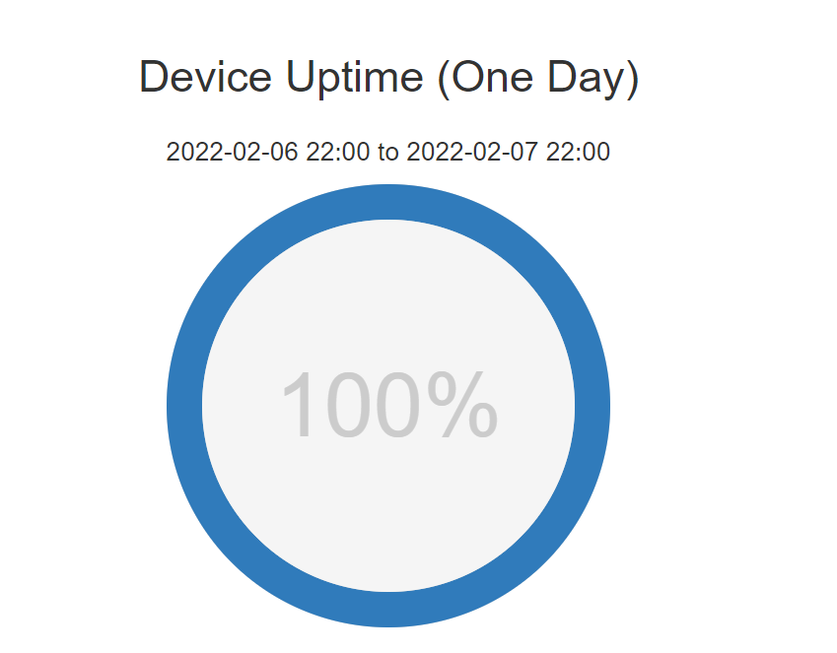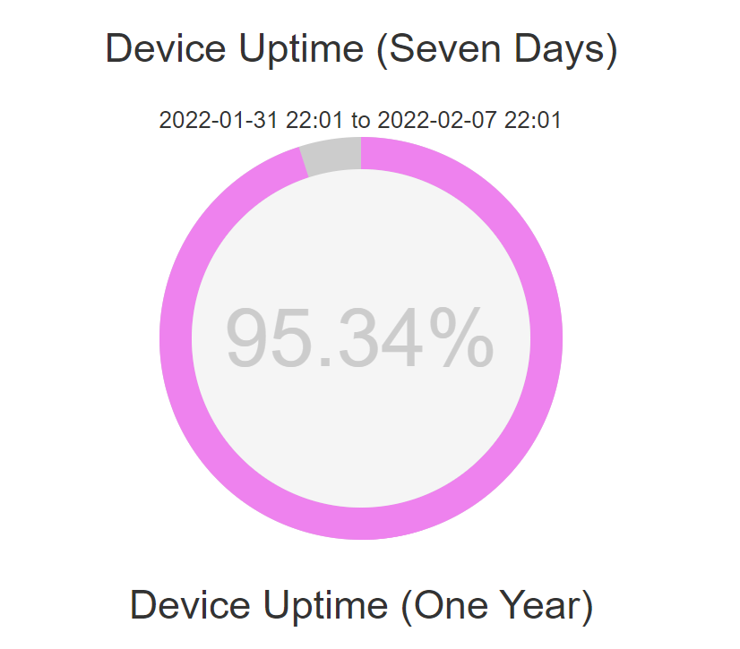

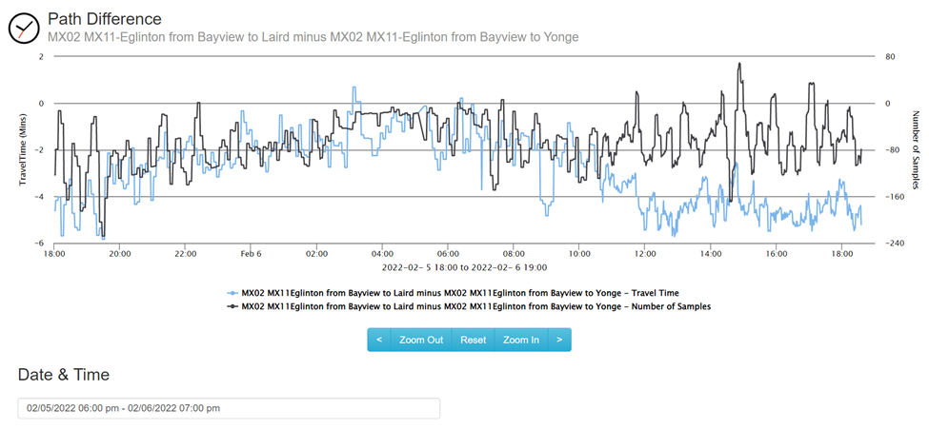

*7.3. The reporting system shall be able to report on any user-specified historical time period and location.*

The reporting system includes filters to define the time periods, regions, paths, and devices.

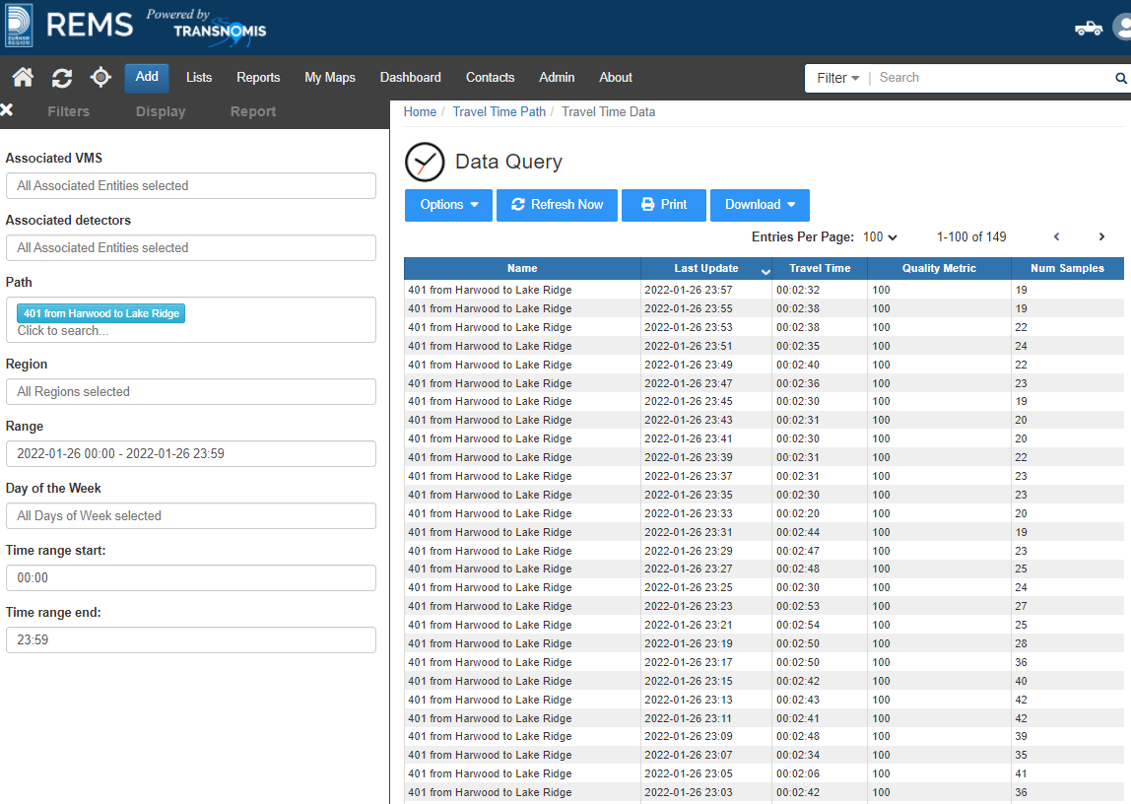

*7.4. The reporting system shall allow users to generate and display, as a minimum, the following comparisons of travel time information in graph and chart form: • Comparison of raw data reads from two or more Bluetooth Readers for a specific time period; • Comparison of travel time between two or more specified time periods for a specific link or route; and • Comparison of travel time between two or more routes for a specific time period. Output shall be customizable.*

Comparison of raw data reads from two or more readers for a specific time period:

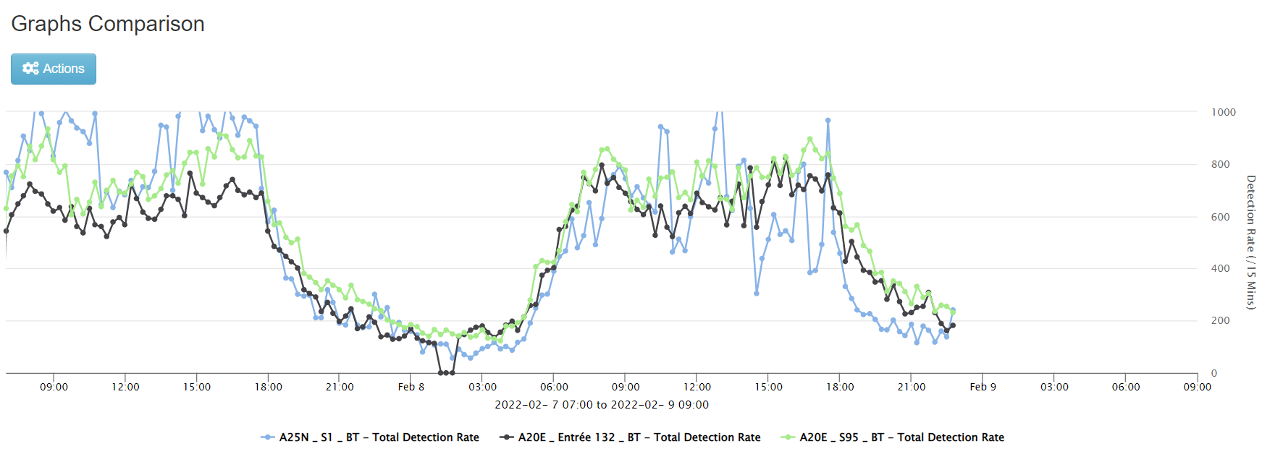

Comparison of travel time between two or more time period of a specific route:

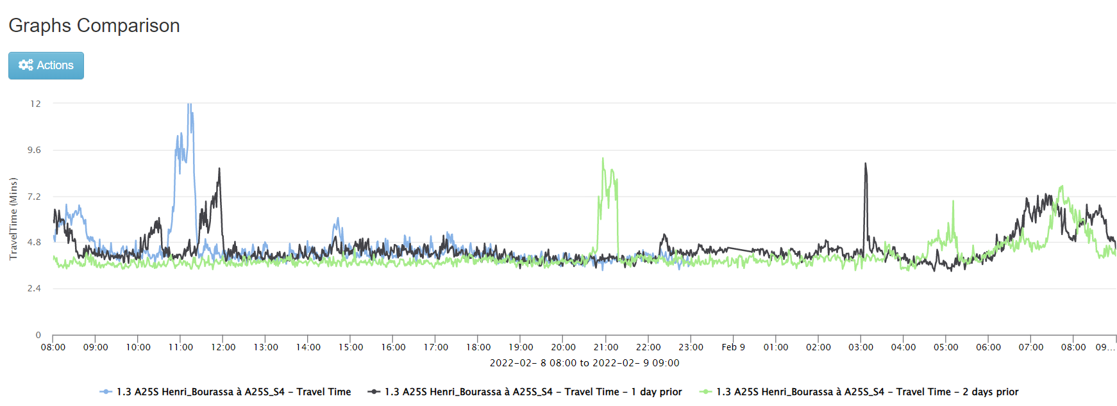

Comparison of travel time between two or more routes for a specific time period:

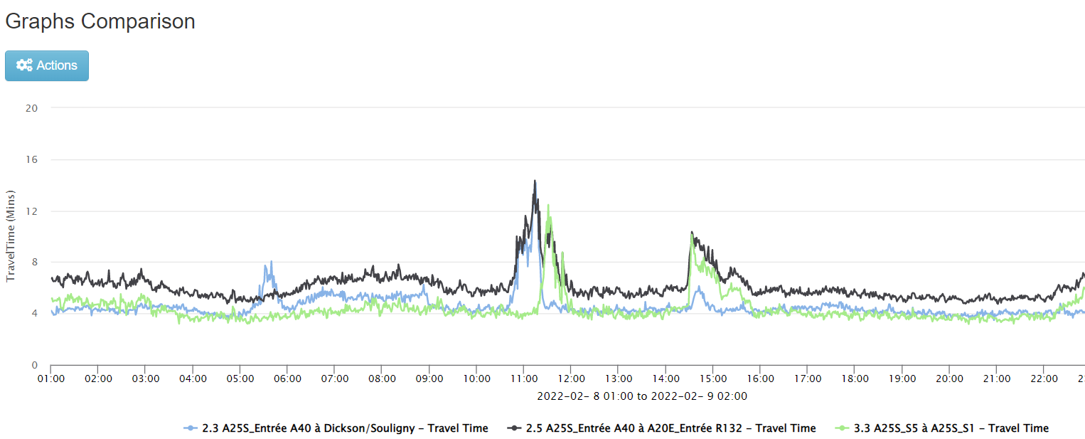

*7.5. The reporting system shall be able to present data distributions of travel times for a specified time period and location.*

ITS Central provides a chart for the distribution of travel times for a specified time period and location.

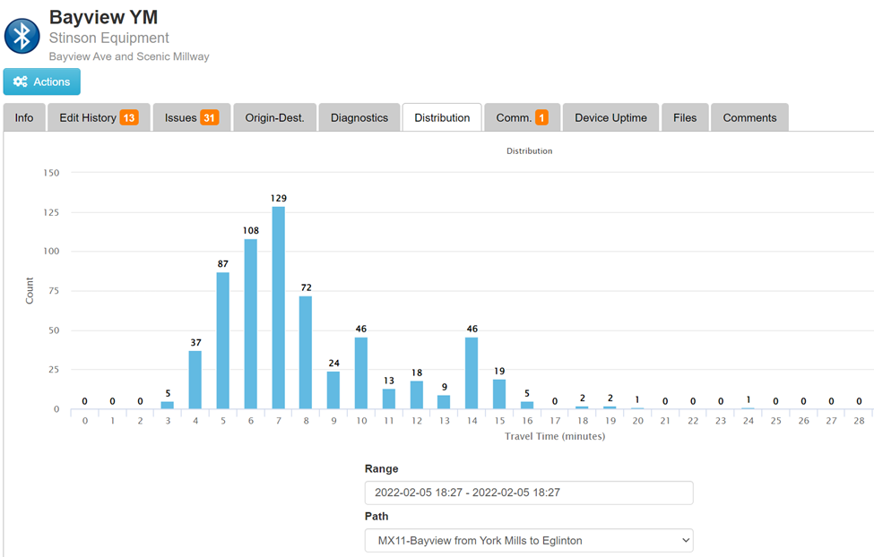

*7.6. The reporting system shall have the ability to generate reports based on ad-hoc queries, including but not limited to: Selection of any Bluetooth reader to generate reports of detected Bluetooth-enabled device counts (reads) at any date; and Selection of any two routes to generate and display differences in the number of matches and travel time for a selected time interval.*

ITS Central provides users to select any Bluetooth reader to generate reports of the detection counts for any time period.



In addition, user can also select any two travel time paths (routes) and display the differences in the number of matches and travel times for any selected time interval.



*7.7. The reports from the reporting system shall be generated in a printer-friendly and clearly organized format.*

Reports are preconfigured to be printer friendly and organized. It is anticipated that some further customization and feedback from MTO will be needed to ensure reports meet MTO’s needs.

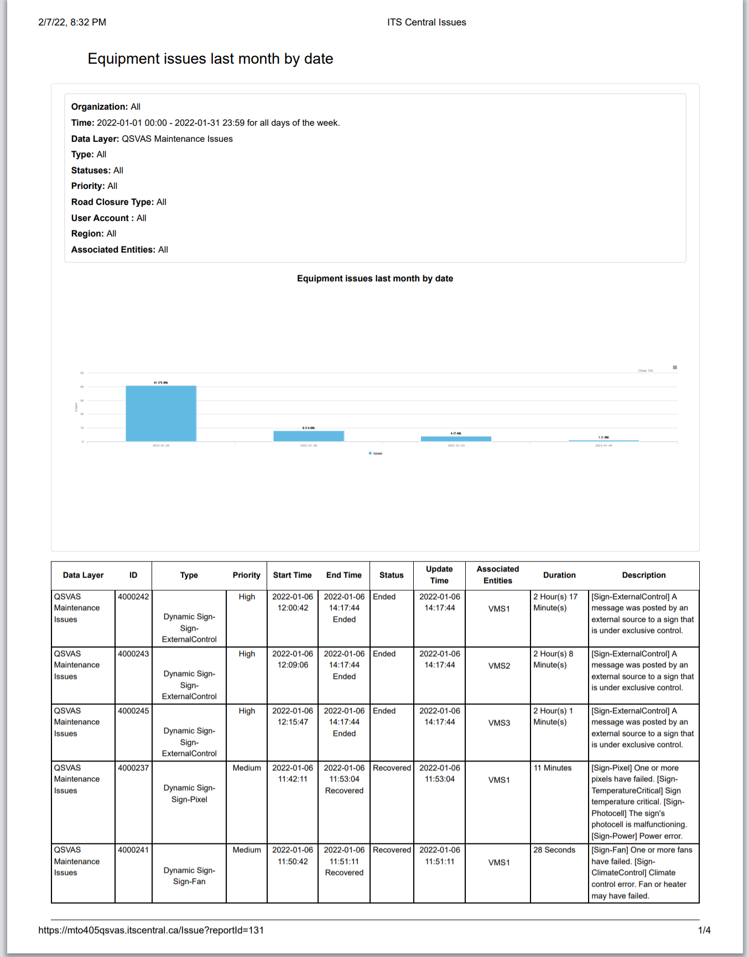

*7.8. The reports shall be exportable in CSV file format.*

Reports are exportable in CSV format

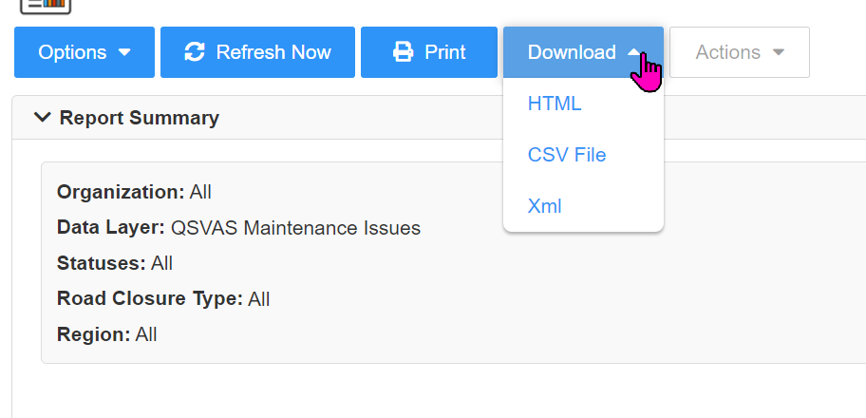

*7.9. The reports shall be exportable in XML file format.*

Reports are exportable in XML format.

**

*7.10. The reports shall be exportable in PDF file format.*

Reports can be exported in PDF file format by using browser’s built-in “Save as PDF” feature.

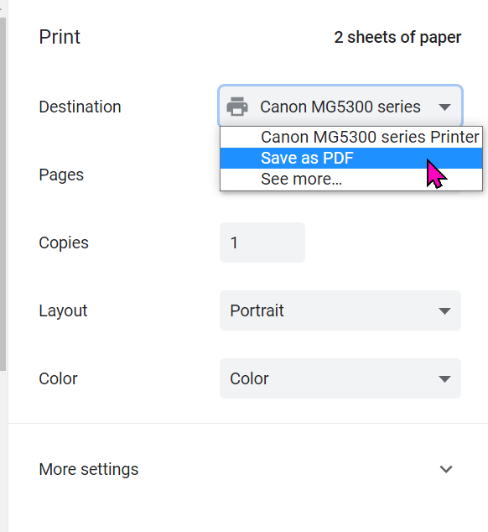

*7.11. The reporting system shall automatically generate the following reports on a daily, weekly, and monthly basis, and archive these reports: Ranking of routes by average speed; and Ranking of routes by average travel time per kilometre.*

ITS Central provides for a ranking of routes by average speed and average travel time per distance, subject to a large array of filters.

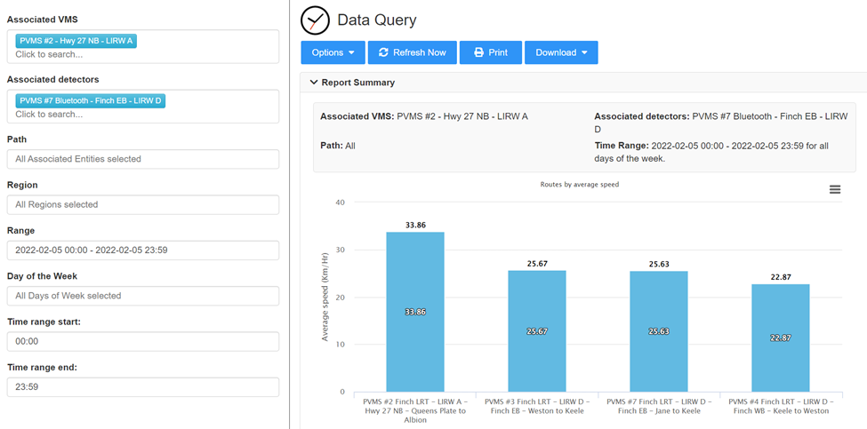

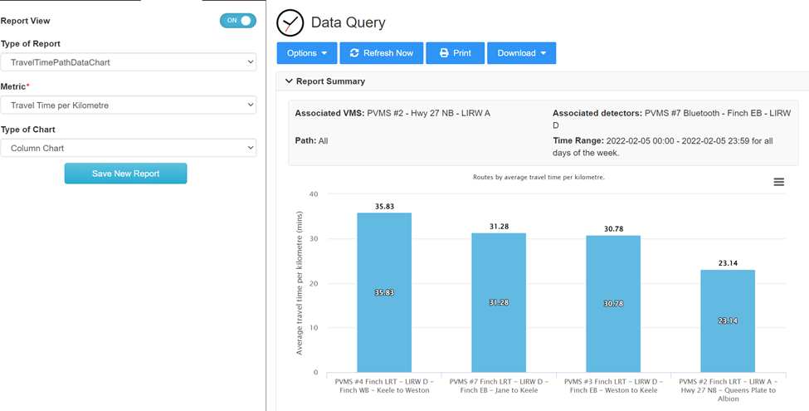

All reports may be generated on-demand in real time by users, or may be configured to be automatically generated on a daily, weekly and/or monthly basis, using the Report Automation configuration tool.

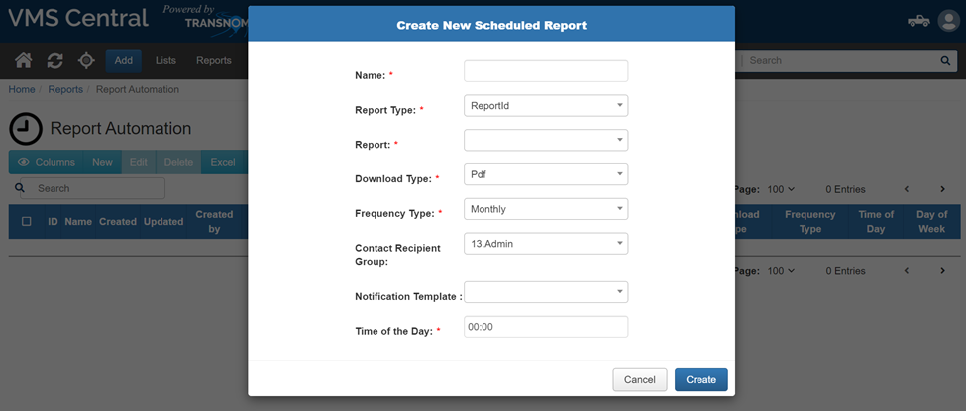

*7.12. Reports generated shall be automatically forwarded by email to a pre-set list of users compiled by the System Administrator.*

Reports will be generated and automatically forwarded to the pre-set notification group compiled by the system administrator.

**Partner Data Sharing (2.6.5.8)**

*8.1. Data feeds generated by the solution shall be sharable with partners as defined by MTO.*

Transnomis will setup access to the data feeds for partners who require access, as requested and authorized by MTO.

*8.2. The Solution shall share the data feeds with MTO West Region and East Region for its links which cross into Central Region jurisdiction. These data feeds shall match the format presented in Appendix C. MTO to provide a list of these locations following Contract award.*

Transnomis will provide a new data feed matching the format presented in Appendix C.  Transnomis has previously developed various custom data feeds for customers, including a couple of data feeds for the MTO’s QSVAS project.

*8.3. The Solution shall integrate with MTO West Region’s and East Region’s TT System in order to receive relevant shared data feeds. MTO to provide a list of these locations following Contract award. West Region’s and East Region’s data feeds follow the data dictionaries outlined in Appendix C.*

Transnomis has already integrated with TPANA’s XML feed for the City of Toronto’s implementation of ITS Central. It has developed a data gateway that polls the TPANA for the XML data every minute, and update its detectors, links and routes data within ITS Central. Toronto is then able to use that data to post travel times on its VMS and PVMS on arterials and Toronto freeways.

*8.4. The Solution shall operate with other link-based TT for route-based and sign-based TT measurement and shall be able to add TT from data feeds received from other jurisdictions (MTO West Region and East Region) to TT generated by the Solution’s central software to complete TT routes which span the two jurisdictions.*

Transnomis has excellent experience in integrating custom data feeds; the specified data feeds will be incorporated in this Central Region instance of ITS Central to complete any travel time routes with span the specified regions.

**System Maintenance**

*9.1. The Proponent shall be responsible for all maintenance of the Solution during the Term of Agreement.*

The project team will be responsible for all maintenance of the solution during the term of the agreement. Details are provided in the Operations and Maintenance plan of in the proposal.

*9.2. All scheduled and routine maintenance performed by the Proponent must be done outside the pre-specified time period for VMS message publication, as specified in Item 5.3.13 in Section 2.6.5.5.3.*

Scheduled and routine maintenance will be done outside of the pre-specified time periods.

*9.3. In the event the Proponent makes any changes to its processes or methodologies during the Term of Agreement, including but not limited to data collection, processing methodology, storage, hosting, or cybersecurity, the Proponent shall inform MTO in detail of these changes in advance. Prior to these changes, the Proponent shall provide documentation to demonstrate that these changes comply with the specifications of this Agreement. MTO to test and approve these changes at their discretion.*

Transnomis will provide notice and advance documentation of changes to processes and methodologies during the Term of Agreement. MTO will test and approve these changes at their discretion.

*9.4. The Proponent shall keep the Solution up to date with the latest available software updates for the duration of the Term of Agreement.*

Transnomis will keep the ITS Central software up to date with the latest available software updates for the duration of the Term of Agreement.

*9.5. The Proponent shall provide all bug patches to the Solution upon development.*

Transnomis will provide bug patches for the Central Region ITS Central as the patches are rolled out.

*9.6. The Proponent shall refer to the SLA for operational procedures to process maintenance requests by MTO.*

The Service Level Agreement shall be used by the project team for operational procedures to process and maintain request by MTO.

**System Parameter Configuration (2.6.5.10)**

*10.1. All system parameter configuration by users, or by user request to the Proponent, shall be done through use of the GUI system configuration module.*

ITS Central includes a system configuration parameters, only accessible by users with system configuration authorization. This allows for global parameter changes for ITS Central Gateways. Other system configurations are done through ITS Central modals, with user permissions defined to permit system configuration.

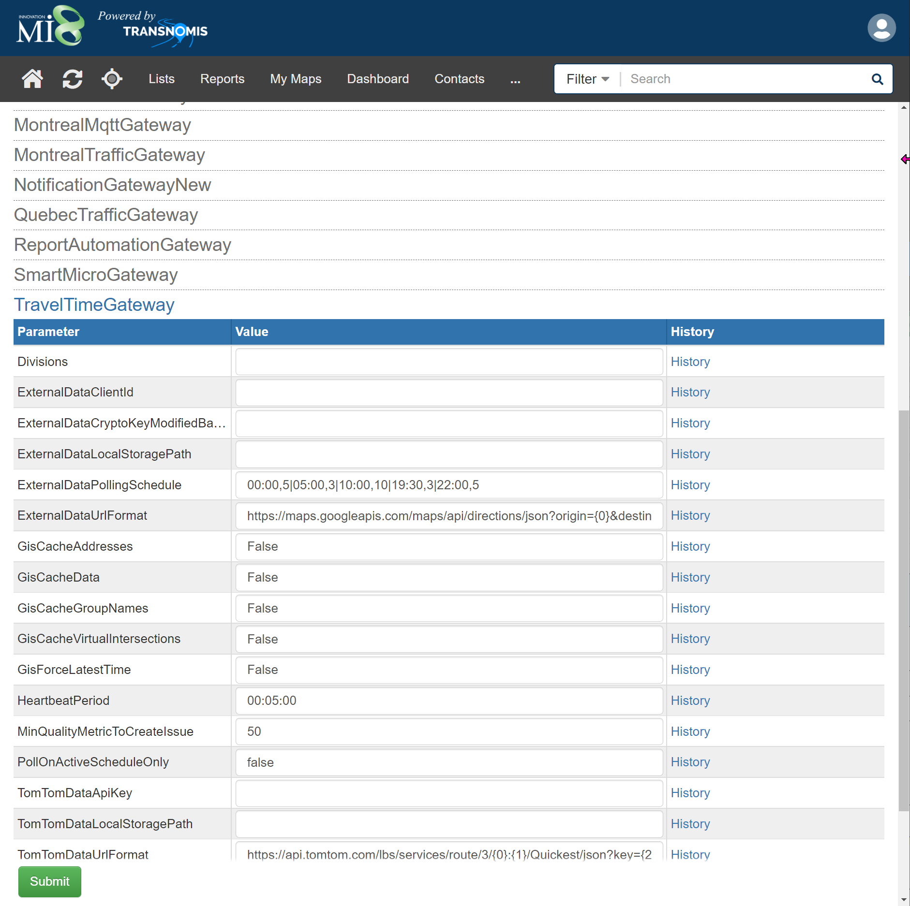

*10.2. The system configuration module shall be able to perform device configuration changes described in Section 2.6.5.4.*

The system configuration parameters will be customized to meet the specified requirements of MTO as described in section 2.6.5.4.

*10.3. The system configuration module shall be able to add, modify, and delete Bluetooth Readers.*

Adding modifying local devices is permitted through an Add /Configure Device modal. This allows the user to add, modify, and delete Bluetooth readers.

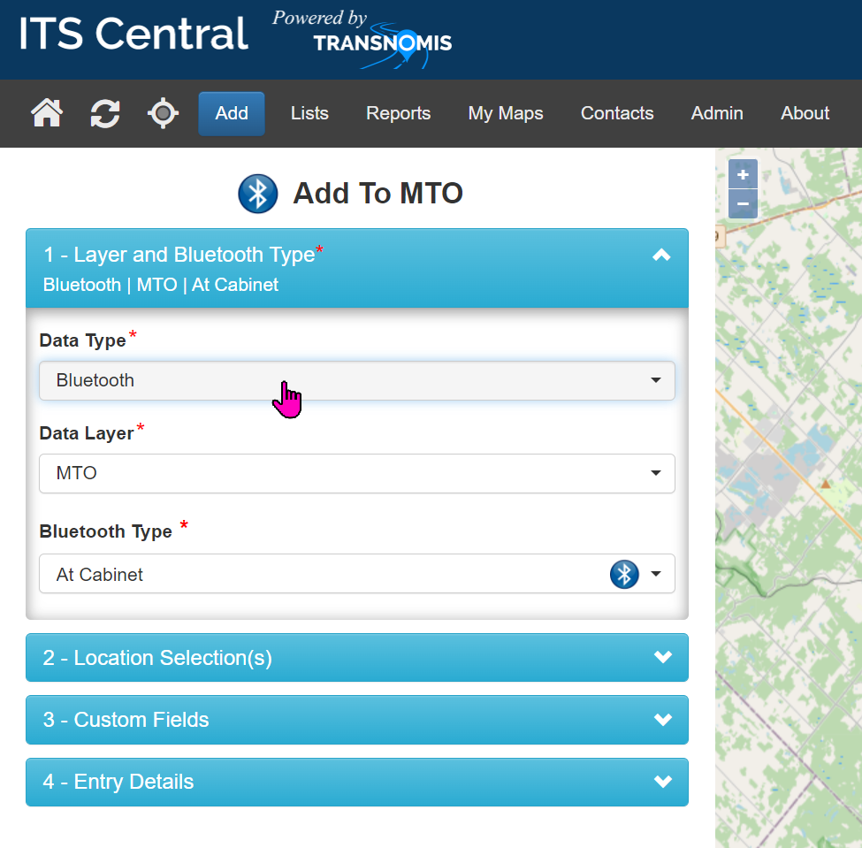

*10.4. The system configuration module shall be able to define and configure routes by combining multiple links together and pairing Bluetooth Readers to VMSs.*

Routes and links are configurable by simply pointing and clicking on the map. Bluetooth readers along the routes/links are automatically added:

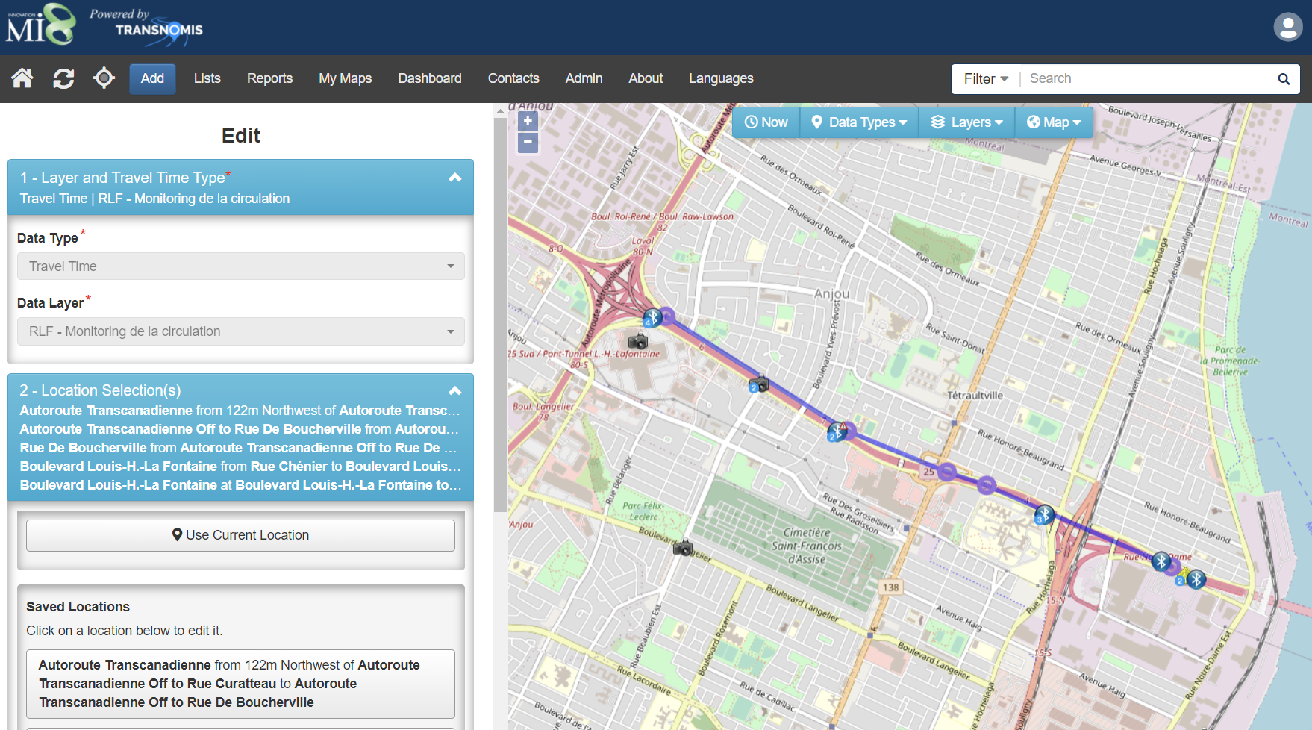

VMS are linked to the route/link by scheduling travel time messages. See 5.3.13 screenshot.

*10.5. The system configuration module shall be able to configure the data feed refresh rate.*

The gateway parameters allow the user to configure data feed refresh rate.

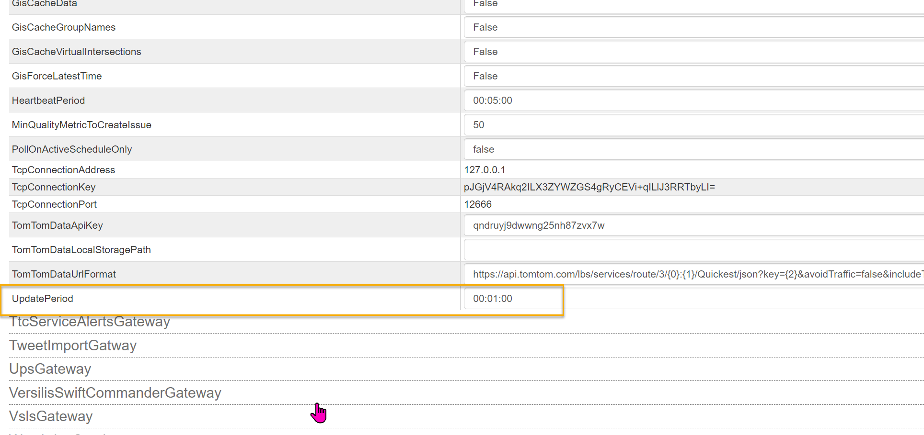

*10.6. The system configuration module shall be able to configure the outlier filtering algorithm.*

ITS Central allows System Administrators to configure the various parameters involved in the outlier filtering algorithm.



*10.7. The system configuration module shall be able to configure the pre-specified time period for VMS message publication.*

Users can configure the time period for VMS message publication.

**

*10.8. The system configuration module shall be able to configure the slow traffic condition.*

ITS Central has three different slow traffic thresholds and they can be configured through the ITS Central GUI.

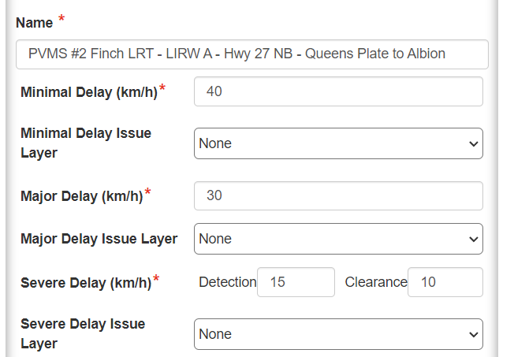

*10.9. The system configuration module shall be able to configure the data timeout duration.* Data timeout is configured for each route / link.

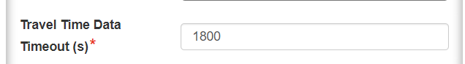

*10.10. The system configuration module shall be able to configure the map display, including placing Bluetooth Readers on the map, drawing routes, and defining travel time thresholds to change route colours.*

Users with system configuration permission may configure the map display, add device, draw routes, and define travel time thresholds.

*10.11. For auditing purposes, the Solution shall record details of any changes to the above parameters.*

All changes to the above parameters are logged within ITS Central as part of user action audit log.

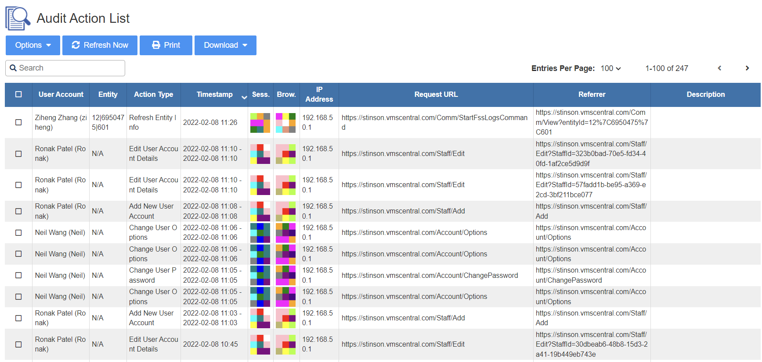

*10.12. The Proponent shall refer to the SLA for operational procedures to process requests by MTO to make changes to the service configurations listed above.*

The project team will refer to the SLA for operational procedures to process requests by MTO to make changes to the service configurations listed above.

*10.13. The Proponent shall back-up the parameters of the existing TT System configuration, including but not limited to properties and locations of all BT Readers, routes, links, and VMS messages. Parameter configuration back-ups shall be saved in an accessible file.*

The parameters configurations will be backed up to a file easily accessible by system administrators as needed on the server using ITS Central GUI.



*10.14. The Solution shall automatically send the configuration file (listed in Item 10.13) detailing the current system configuration to MTO on the last business day of every month.*

Transnomis will work with MTO to setup the automatic transfer of the configuration file to MTO on the last business day of every month.

*10.15. The Solution shall automatically send the configuration file (listed in Item 10.13) detailing the current system configuration to MTO on the last day of the Term of Agreement.*

The configuration file will be sent to the MTO on the last day of the Term of Agreement.

**System Performance and Diagnostics (2.6.5.11)**

*11.1. The Solution shall be capable of sending email alert notifications to pre-configured recipients in the event that the system availability has dropped below a threshold in a given day or week.*

ITS Central will integrate with UptimeRobot and send email alert notifications to persons in the appropriate contact group in the event that system availability has dropped below a threshold.

*11.2. The Solution shall generate daily, weekly, and monthly reports on the status of the Readers, including field hardware health and communications status.*

ITS Central will generate daily, weekly, and monthly reports on the status of the Bluetooth Readers.

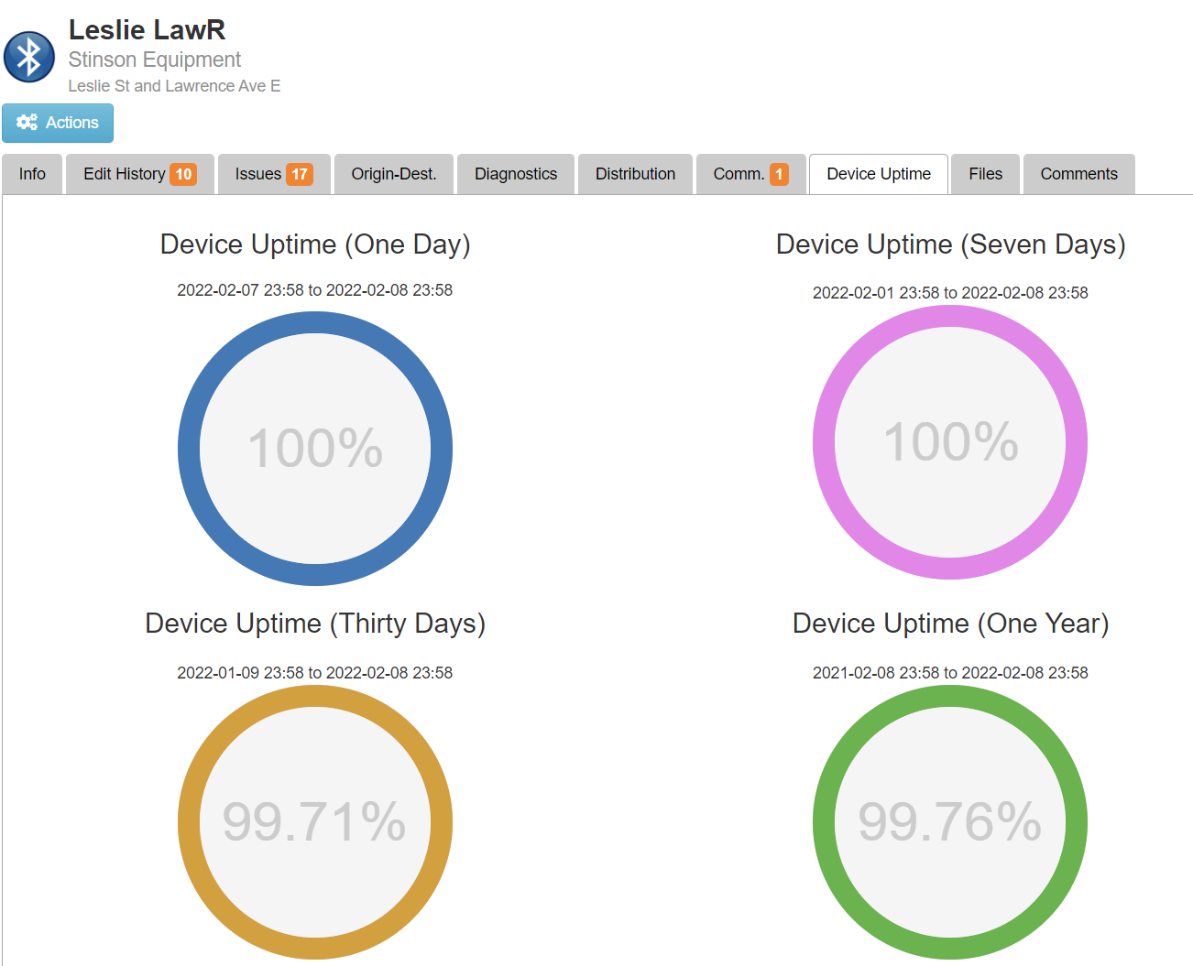

*11.3. The Solution shall monitor the status of the Bluetooth Readers in real-time.*

ITS Central monitors the status of the AIS Stinson Bluetooth/Wifi readers in real time, and provides alert on the map interface as well as email notifications if the device requires maintenance.

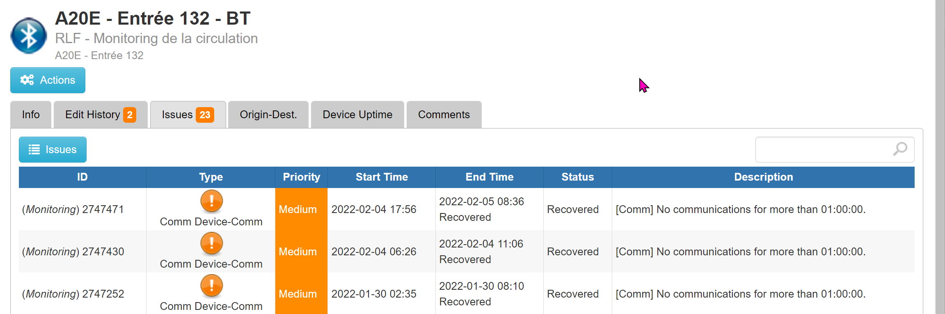

*11.4. The Solution shall display information regarding the status of Bluetooth Readers on a dedicated screen accessible from the GUI containing, at minimum, the MTO-assigned ID of the reader, IP address of the reader, and the last time data was received from the reader.*

ITS Central will provide dedicated display information on the status of Bluetooth devices, include the assigned ID, IP address, and the latest detection status of the device:

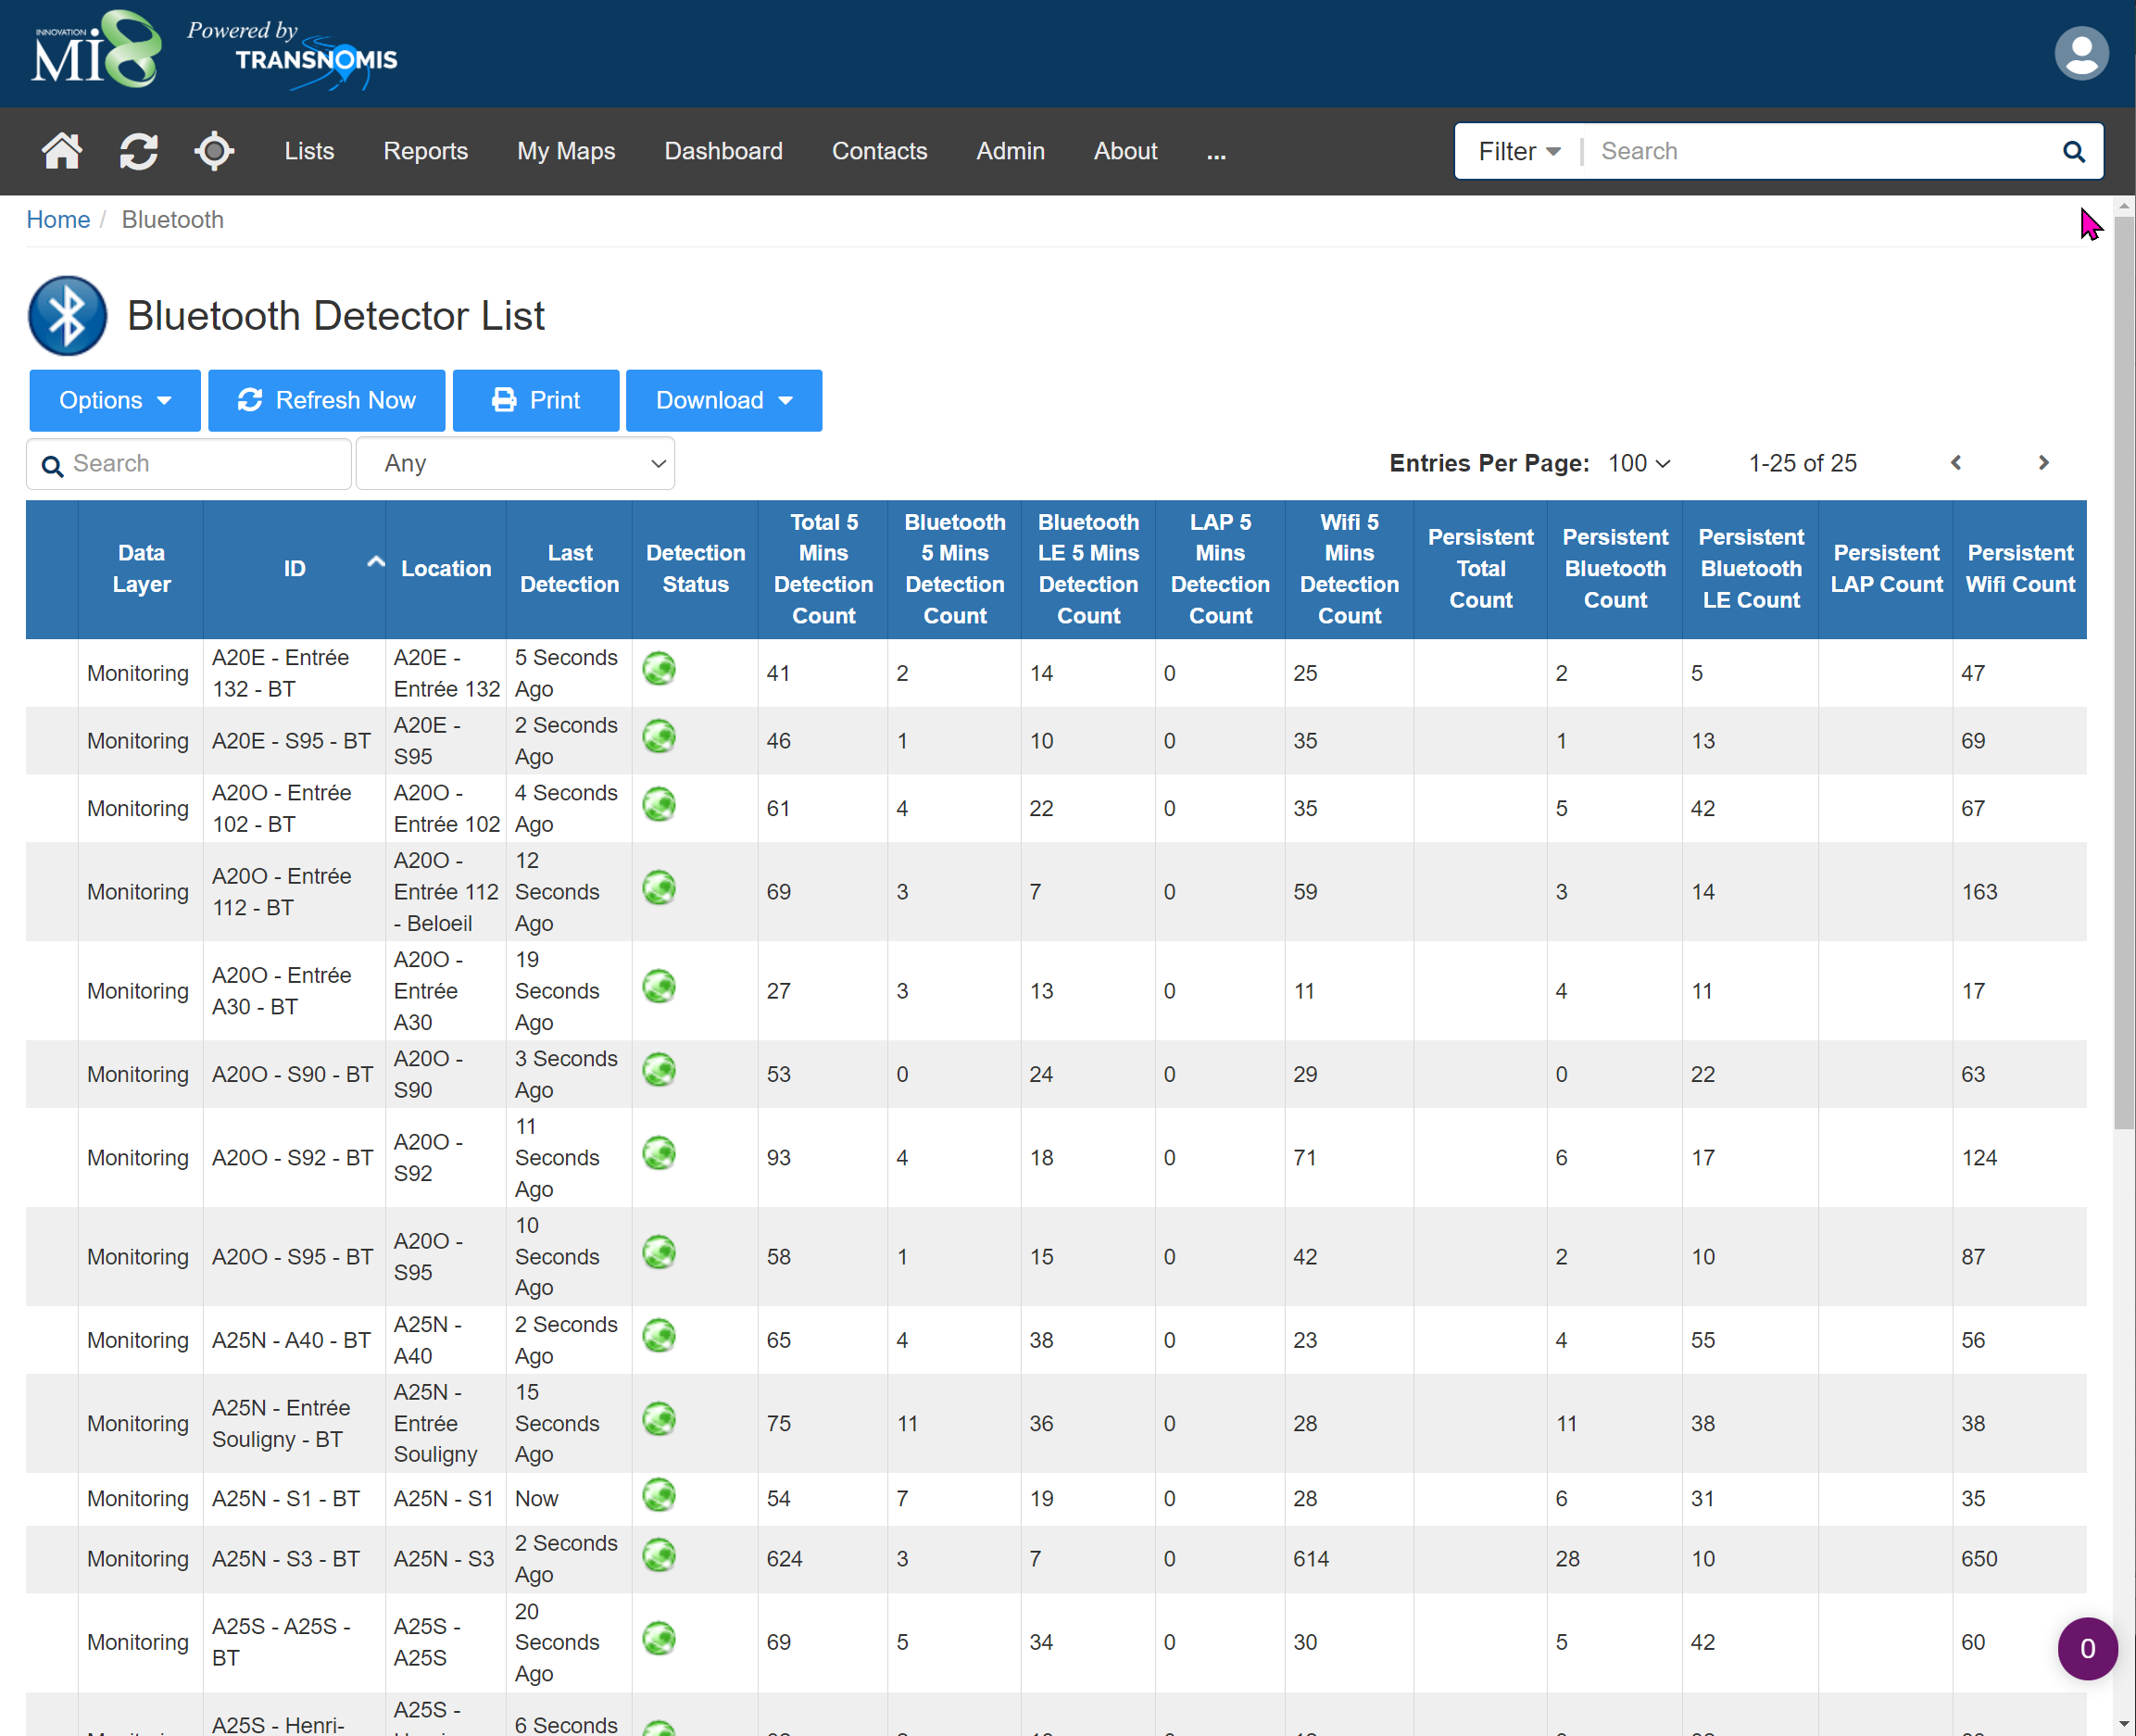

*11.5. The Solution shall be capable of sending email alert notifications to pre-configured recipients in the event that a reader loses communication with the Solution.*

ITS Central monitors the status of the AIS Stinson Bluetooth/Wifi readers in real time, and provides alert on the map interface as well as email notifications if the device requires maintenance.

*11.6. The Solution shall be capable of sending email alert notifications to pre-configured recipients in the event that configured link or route speed thresholds are exceeded.*

ITS Central is capable of logging an issue and sending an email alert notification to pre-configured group(s) of recipients when a configured link or route travel time threshold is exceeded.

Should it be necessary as deemed by the MTO, Transnomis will add the capability to logging an issue and sending an email alert when a configured link or route speed threshold is exceeded.

# 1.15.3.6 OPERATIONS, WARRANTY AND MAINTENANCE PLAN

## 1.15.3.6.1 OPERATIONS AND MAINTENANCE PLAN

Black & McDonald (B&M) will be responsible for System Operational Support, Warranty, System Emergency Repairs, and System Routine Maintenance for the TT system. B&M will maintain fault free operation of the TT system including the hardware and software parts as well as maintaining effective working conditions according to the contract’s specifications. B&M project management team will review the restrictions outline in Appendix C3 and create a maintenance plan based on information provided. The maintenance team will carry out successful coordination with any other contractors to stay away from working in the same area by providing the advanced notice to the contract administrator or representative from general contractors. All activities will follow the requirements specified in the Service Level Agreement to ensure equipment and system performance levels are met throughout the life of the Contract.

1. **Plan for meeting system performance requirements outlined in the Service Level Agreement**

Black & McDonald and the project team will meet all the system performance requirements outlined in the Service Level Agreement. A detailed plan is mentioned below in the following section. Plan will be developed by experienced staff working with high tech applications as well as maintenance. Our staff has great understanding on the importance of emergency response to meet the contract requirements on one hand, and make sure they are performing their task in the safest manner on the other hand. A detailed Routine Maintenance Plan as well as Emergency Maintenance Plan are outlined in part b below.

1. **How the Proponent will operate, maintain, and report on status of the system**

Plan for Reporting on System Status**:**

During the operational and maintenance phases of the contract, Black & McDonald will be responsible for monitoring the operation of all ITS components including BT readers installed under the contract. B&M will immediately notify the MTO if any MTO-supplied material or equipment (existing or new) is discovered to be broken or faulty, affecting system performance. Field devices will be monitored by ITS Central, and notifications will be sent to B&M if a device failure is detected. In line with the Agreement, the MTO will decide on a course of action with respect to such material or equipment. When Black & McDonald Limited is notified of an occurrence, it must respond within the specified time frame. Any incidents will be documented in detail and reported to the MTO, with a summary of the root cause and corrective action taken. In the event that road closures are required for routine maintenance or emergency repairs, B&M will notify the MTO prior to the start of work. If an ITS component is experiencing any sort of failure, the following resolution procedure will be followed, depending on the type of error reported. Any failures of components will be documented. Spot checks will be performed on components that have previously failed and been brought back to functionality. The following components will be checked as part of the ITS component spot checks:

* **BT Readers:** Field crews will conduct spot checks to ensure BT readers are online, aligned and communicating valid data to the network. BT readers can be checked by confirming status LEDs on front of unit. Ethernet cables on the sensor, POE and modem can be checked to ensure snug and seated. Antenna coax connections on the sensor & modem can be checked to ensure tightness, external omni antennas can also be checked to confirm snug and tight. Field crews will contact B&M support for any BT readers related issues found during a spot check. BT Readers will be monitored by ITS Central, and notifications will be sent to B&M if a device failure is detected.

Sensors can also be accessed remotely to confirm web interface is functional and responsive. From the web server active detections from Bluetooth, Bluetooth LE and Wi-Fi devices and be observed & verified through its live view.

* **Modems:** Field crews will confirm modems are online and communicating valid data. Crews will observe LEDs on the modem to confirm data is being received and transferred. In the event a fault is detected, crews will be directed to re-boot the component and have B&M support access the device remotely to confirm it’s back online.
* **Power Supply:** 
  + AC systems will be fed by the traffic cabinet supply, measuring supply voltage will confirm normal power voltage conditions.
  + Solar systems can be checked to ensure solar input voltage and battery voltage are within expected tolerances (18V and ~13 to 14V respectively).

Servers will be hosted professionally and reliably by OVH; onsite technician, security backup power supply, and redundant network connection will enhance the operational reliability. Transnomis will perform routine server update for operating system and security patches.

**Routine Maintenance Plan**

System performance requirements outlined in the Service Level Agreement will be fulfilled by B&M as per the following plans indicate:

|  |  |
| --- | --- |
| **Task 1**  **Maintenance Kick-off meeting with the MTO** | * Operations and maintenance kick-off meeting minutes * Review SLA execution plan * SLA contract administer appointed * Primary and secondary technical support contact information provided * Establish a yard |
| **Task 2**  **Document Submission** | * SLA execution plan within one month prior to SLA execution * Submit project safety and environmental management plan * Submit quality management plan for approval * Submit after hours dispatch centre contact information |
| **Task 3**  **SLA Approval and Schedule Meeting** | * SLA plan reviewed and approval provided by MTO * Schedule annual review meeting * Schedule quarterly review meeting * Schedule maintenance progress meetings |
| **Task 4**  **Execute Routine Maintenance Plan** | * Obtain all permits prior to mobilization * Coordinate with traffic management requests * Contact MTO upon arrival onsite * Conduct environmental health and safety meeting onsite * Setup traffic control devices * Perform routine maintenance as per mobilization plan (seasonal maintenance) * Complete maintenance and report * Complete log book entry, dismantle traffic control, clean site * Receive approval for any device replacement * Notify MTO when leaving the site |
| **Task 5**  **Information Management** | * Develop information management plan * Gather all maintenance reports form field crews * Scan and save electronic copies. File and organize such that reports are available. |

**TASK 1 Project Maintenance Kick-off Meeting with MTO**

**Purpose**

To establish a proper project management practices and to ensure they are implemented and maintained for the 5 years-term duration of this contract and as per the SLA execution plan. Also, to introduce SLA personnel administrator and technical support staff to exchange contact information with MTO.

**Approach and Methodology**

Once a successful completion of the Full Deployment System Acceptance is achieved as well as the Operability Period, a project maintenance meeting will begin between the MTO and the project assigned team. Questions, comments or concerns from either party will be addressed during this meeting and a detailed record of the minutes of the meeting will be retained for future reference. An SLA administrator for the project team will be appointed and will be provided with the required contact information. Primary and secondary technical support personnel are appointed by the project team. Technical support contact information will be provided to the MTO. B&M will ensure that technical support response times will comply with response and resolution limit requirements and associated penalties for outages as outlined in the SLA section 3.2. B&M believes that continuous communication between the project team and the MTO is essential to ensure that issues arising from production, operation, and maintenance are closely and rapidly monitored as well as appropriate emergency response plans are provided. Overcoming challenges requires a proactive approach to project management. Methodical meetings may be scheduled between the project foreman and the MTO to see ongoing maintenance activities.

**Key Deliverables**

* Meeting minutes
* SLA Administrator designated by the project team
* Primary and Secondary technical support contact information provided to the MTO
* Maintenance yard established in proximity to the project site for duration of SLA

**TASK 2 Document Submission**

**Purpose**

To provide MTO’s Contract Administrator with all required documentation for this project required documentations.

**Approach and Methodology**

**Scheduled System Maintenance Plan:** A Scheduled System Maintenance Plan will be submitted to the MTO for approval one month prior to SLA initiation. This plan will indicate all staff, staff responsibilities, resources, schedules and operating guidelines. The plan shall include a description of the processes and tasks required to carry out the Operations, Maintenance and Support of the TT Service including the procedures that address requirements of subsections 1.4.1, 1.4.2 and 1.4.3 of the SLA document. All asset locations will be included on a detailed map. Access to each asset location will be included along with a list of all potential safety hazards and traffic control requirements. In depth routine maintenance procedures will be outlined for all assets in the project inventory. Routine maintenance details and activity sequences will be in accordance with the agreed contract, previous routine maintenance experience and field information from on-site inspections. In order to produce an extensive routine maintenance document, all inputs from each member of the project team will be considered, this includes: The project manager, project safety/environmental manager, superintendent, foreman, and quality assurance specialist.

**Project Safety and Environmental Management Plan**: A comprehensive project safety and environmental management plan will be developed and submitted to the MTO for review. The project's safety and environmental protection plan will go through site-specific safety hazards, risk mitigation measures, and environmental protection strategy, as well as a list of all hospitals and clinics in the area. All environmental work will be conducted in compliance with MTO Environmental Reference of Highway Design regulations (ERD). This plan will be reviewed by the project's management team before submitting it to the MTO for approval. The Project's Safety and Environmental Management Plan must be followed by all project personnel, including office employees and field crews. Throughout the contract, this plan will be updated and maintained.

**Quality Management Plan:** The project’s team will establish a detailed quality management plan, which will be reviewed by the project quality control specialist. The requirements for quality standards for all work related with this contract will be outlined in the quality management plan. This plan will be submitted for an approved by the MTO and then evaluated at frequent coordination meetings.

**Dispatch Center Contact List:** Contact information will be submitted to the MTO for B&M’s 24/7 dispatch center. After hours emergency calls will be directed to the scheduled on-call field crew. Contact information and schedules for on-call after-hours field crews will also be provided to the MTO.

**Key Deliverables**

* Submit Project Safety and Environmental Management plan for approval
* Submit Quality Management for approval
* Submit Dispatch Center Contact List

**TASK 3 SLA Approval and Scheduled Meetings.**

**Purpose**

Review and finalize SLA plan with the MTO for approval. Schedule meetings as per the contract requirement.

**Approach and Methodology**

Obtain confirmation from the MTO that the SLA plan has been approved or if any adjustments are necessary. If any revisions are required, the project team will incorporate the necessary information and resubmit the plan promptly. Meetings will be organized in accordance with the terms of the contract.

**Key Deliverables**

* Receive SLA plan approval from the MTO
* Annual review meeting
* Quarterly review meeting
* Maintenance progress meetings

**TASK 4 TT System Routine Maintenance**

**Purpose**

To provide routine maintenance services in accordance with the requirements of the project agreement.

**Approach and Methodology**

**System Routine Maintenance Services:**

Routine maintenance services will be scheduled in accordance to the approved Scheduled System Maintenance Plan. It will be conducted for all TT system components within the contract limits. Routine maintenance and inspection services will comply with the Equipment Specific Scheduled Maintenance Requirements outline in the SLA, manufacture recommendations and be in accordance with the ITS elements and operation and maintenance manuals. Any ITS maintenance work related to the upgrade of system components will be reviewed by approved MTO consultants and all products used for upgrades will meet the applicable project agreement requirements, in accordance with the Designated Source Material (DSM) List. Maintenance services will be mobilized from the B&M closest yard. Prior to mobilization, B&M will coordinate with the MTO for any traffic management requests to avoid disrupting any other MTO contractors operations. Unspecified conditions such as accidents, stalled vehicles, etc. will be taken into account prior to mobilization. If such conditions exist or occur causing disruption to regularly scheduled maintenance activities, this will be communicated to the MTO and an appropriate alternate mobilization strategy will be provided. B&M will mobilize the necessary manpower, equipment and traffic control devices based on the routine maintenance required for that site. All traffic control devices will be setup in accordance to MTO Book 7 procedures. Upon arriving on site we will notify the MTO and then conduct a workplace safety & environmental protection briefing based on our analysis of the site. All hazard will be addressed immediately and no preventable conditions causing a hazard will exist. Routine maintenance activities will then be executed in accordance to the approved Scheduled System Maintenance Plan. Maintenance reports will be completed in detail. Upon completion, we will clean the job site of any garbage or debris, record maintenance activity and sign and date the log book, dismantle traffic control and notify the MTO of the work that was completed and that we are leaving the site. A follow up ESA inspection will be scheduled if required to inspect any electrical work that was done and a copy of the report will be kept on file. Pictures of specific problems will be taken if necessary with corrective direction.

**System Software Maintenance Services and Support:** Software updates will be rolled out to the TT System to enhance performance, resolve system bugs and to address requests for system changes. Software bugs will be identified by system operators (self-identification), automated system performance reports and user feedback. A ticketing system will be implemented to maintain a monthly log of issues and resolution timelines. Upon ticket resolution, the root cause of the software issue will be documented and included in the ticket close-out. System software assistance will be provided for MTO operators in the event it is requested. Written notice to the MTO for approval of any scheduled routine maintenance impacting operations or requiring full system outage will be provided at least two (2) weeks in advance. Any software routine maintenance requiring full system outage will be conducted between 10:00 am and 3:00 pm pending prior notification and approval.

**System Enhancements:** Modifications to enhance the functionality of the TT System will be implemented as they become available over the duration of the SLA. Any new features or functionalities added to the system will be communicated though software release notes. The release version of the software will be updated to include the latest enhancement.

**Key Deliverables**

* Obtain all necessary permits prior to mobilization
* Coordinate with the MTO for traffic management request
* Contact the MTO upon arrival on site
* Conduct environmental health and safety meeting on site
* Setup traffic control devices
* Perform routine maintenance or inspection for devices
* Ensure maintenance procedures confirm with maintenance and operation manuals. All ITS replacement conforms to DSM list.
* Receive approval from the MTO for any device replacement
* Notify the MTO upon leaving the site
* Complete log book entry, dismantle traffic control, clean site.
* Conduct software maintenance services and support
* Conduct system enchantments
* Conduct semi-annual performance assessments

**TASK 5 Information Management**

**Purpose**

To create a document control system to guarantee that all routine maintenance reports are completed, structured, and available to the MTO. To put in place an electronic ticketing system to track, manage, and respond to system outages and other operational concerns. To monitor and record monthly system performance, ensuring system performance metric and submitted to the MTO each month along with the monthly invoice.

**Approach and Methodology**

Management of maintenance reports are of critical importance to the project. Maintenance documentation must be completed with the required information at the time activities are conducted. Maintenance reports will be gathered from field crews. Project coordinator will gather, organize and file all maintenance reports such that it is available. Reports will be scanned and saved electronically.

**Monthly Service Reports:** The project team will prepare a template for monthly field maintenance service. The template will be completed on a monthly basis, based on maintenance services provided and submitted to the MTO. Monthly Reports will be accompanied by each invoice.

**Electronic Ticketing System:** The project team will implement an electronic ticking system which logs and reports system outages or equipment operation issues. Trouble tickets will be assigned a number, priority level and technician responsible for resolution. Upon resolution, the ticket will be updated to indicate the outcome, resolution details and lessons learned.

**Monthly Invoicing and Status Reporting:** The project team will proactively monitor and record the performance status of the TT System. Each monthly invoice will be accompanied by a performance status report providing a summary of system performance for the month. Performance reports will include: System uptime for the month, monthly log of trouble tickets, monthly log of penalties, ongoing maintenance activities/ unresolved issues, completed emergency repairs/ routine maintenance tasks, ongoing roadway project which may impact delivery of the SLA, items which require escalation and environmental concerns. System performance report and monthly invoice will be submitted on or before the 10th calendar day of each month.

**Key Deliverables**

* Develop information management plan
* Gather maintenance reports from field crews on daily basis
* Prepare monthly service report template, submit on monthly basis
* Implement electronic ticketing system
* Scan and save electronic copies, file and organize such that reports are easily available
* Submit monthly invoice

**Emergency Response Plan**

|  |  |
| --- | --- |
| **Task 1**  **Develop Emergency Maintenance Plan** | * Develop detailed non-routine maintenance plan for ITS devices |
| **Task 2**  **Setup Dispatch Centre, Material/Equipment Management Plan** | * Setup 24/7 emergency dispatch centre and provide contact to CA * Assign manpower to the project schedule for emergency call out response * Provide additional emergency call contact list to CA * Develop detailed material and equipment management plan * Setup nearby yard |
| **Task 3**  **Respond to Emergency Maintenance** | * Receive call for emergency ITS maintenance from MTO * Dispatch on-call crew to arrive onsite within the required time frame * Gather appropriate DSM approved material and equipment * Contact MTO upon arrive onsite. Assess damage to equipment, request approval for any ITS element that requires replacement. Review safety plan. * Make site safe and setup traffic control * Perform temporary or permanent repairs * Contact MTO upon resolution and record require information in non-routine maintenance log book * Return to site to conduct permanent repairs within 10 business days if temporary repairs were made |
| **Task 4**  **Information Management** | * Record all emergency maintenance activities in the non-routine maintenance log book with the required details * Organize and maintain records, make available |

**TASK 1 Develop Emergency Maintenance plan**

**Purpose**

Creating a detailed emergency maintenance plan to prepare the project team for emergency maintenance / repair calls.

**Approach and Methodology**

Emergency response plan for ITS equipment will be based on manufacturer recommendations and installation / operation guides. If the findings become available during maintenance, the emergency response plan will be updated. The device / site status will be documented, photographed, and precautionary recommendations to prevent future device failures will be recorded and communicated to the MTO.

**Key Deliverables**

* Create a detailed emergency maintenance response plan based on information from the manufacturer and the contract.
* Continually update the plan based on maintenance discoveries during the agreement.
* Maintain proactive communication with the MTO and device management.

**TASK 2 Setup Emergency Dispatch Center, Establish Equipment/Material Management Plan**

**Purpose**

To construct a 24-hour emergency dispatch center. Give the dispatch center and all on-call emergency workers a contact list from MTO. Make a plan for managing equipment and material.

**Approach and Methodology**

For the length of the contract, a 24-hour emergency dispatch center will be constructed and staffed. The MTO will be provided with dispatch contact information. The project schedule will be assigned primary and backup on-call workforce. During bi-weekly manpower meetings, on-call crew availability will be discussed. A replacement crew will be scheduled if the availability of on-call crew changes, and the MTO will be advised of the change. The management of materials and equipment is crucial to maintaining quick response and repair times. All spare parts, materials, and consumables will be inventoried and placed into a digital inventory management system. Weekly, the responsible project coordinator will examine all maintenance operations and update inventory levels. Inventory will be automatically sorted as it is consumed.

**Key Deliverables**

* Setup 24/7 Emergency Dispatch Center and provide MTO with the necessary contact information.
* Develop a comprehensive material and equipment management strategy.
* Weekly inventory updates will be provided.
* Configure equipment and materials to be automatically ordered if they fall below a preset threshold.
* Establish a close vicinity yard to reduce response time.

**TASK 3 Respond to Emergency Maintenance**

**Purpose**

To provide emergency maintenance and repairs for all devices listed in the contract, in accordance to the required timeframes.

**Approach and Methodology**

The on-call crew will be briefed on the category of the call and sent after receiving an emergency call at either the 24/7 hour dispatch center or via the list of contacts provided to the MTO. On-call crew will have access to a service truck and some supplies from their home base. If more material or equipment is needed, one crew member will go to the yard to obtain supplies or spare parts, while another crew member will go to the job site to assess the situation and deal with any urgent dangers. All replacements components related to ITS will be compatible with the implemented TT system. The use replacement components will be in accordance to the Ontario Ministry DSM list. Response time on site will be less than four hours for all critical failures, less than six hours for major failures and less than twelve hours for minor failures.

Upon receiving the emergency call, traffic control measures will be coordinated based on the necessity of it. Hazards will be addressed immediately and no preventable conditions causing a Hazard will exist. After adopting proper safety precautions, an evaluation report of the failure will be provided to the MTO, along with an expected time to perform temporary or permanent repairs. Before beginning any work that necessitates the replacement of ITS components, crews will seek approval from the MTO. To restore system operation, emergency maintenance/repairs will be performed. Permanent repairs will be conducted within 10 days if temporary repairs were made to restore functionality. The MTO will be advised of the work done and the crew's departure time after temporary or permanent repairs are completed. The following information will be recorded in the non-routine log book by the on-call crew: When on-call workers were notified of the ITS malfunction or failure, when they arrived on site, and when the repair was finished and the component was restored to full functionality.

**Key Deliverables**

* Receive call for emergency ITS maintenance from the MTO
* Dispatch on-call crew to arrive on site within four hours for all critical failures, six hours for major failures and twelve hours for minor failures.
* Gather appropriate, DSM approved material and equipment
* Contact the MTO upon arrival on site. Assess equipment damage request approval for any ITS element that requires replacement. Review safety and environmental management plan
* Make site safe, setup traffic control
* Perform temporary or permanent repairs
* Contact the MTO upon resolution of critical or non-critical failure.
* Record required information in the non-routine maintenance log book
* Return to site to conduct permanent repairs within 10 business days if temporary repairs were conducted

**TASK 4 Information Management**

**Purpose**

To ensure reports of all emergency maintenance activities are recorded in detail and available.

**Approach and Methodology**

For all call out actions, the non-routine maintenance log book will be updated every time an attendance to an electrical or ITS asset is made. Crews will keep track of when the repair was finished and when the component was fully functional. All references to the time of day will be in 24-hour clock format. Logbook entries will be signed and dated, and they will be kept for the duration of the project.

**Key Deliverables**

* Record all non-routine maintenance activities in the non-routine maintenance log book with the required detail
* Organize and maintain records

1. **How the Proponent will provide a warranty of the products and services, any limiting terms or condition.**

**Warranty Requirements:** Black & McDonald Limited will provide warranty on all labour, equipment and materials provided. Upon completion of installation, all equipment and materials delivered will be free of material defects and will perform to the requisite standard for a period of five (5) years. All materials provided and work executed under this contract are covered by the warranty. Black & McDonald Limited will repair or replace any equipment that fails throughout the warranty period at no additional expense to the MTO. The B&M will provide warranty services in accordance with the Service Level Agreement's response times for repair or replacement of equipment that has failed.

The Stinson AIS devices will be provided with a 5 year all-inclusive warranty which will commence at the time of system acceptance. Advanced replacement spares will be provided to B&M maintenance staff to have on hand during any service calls. In the case that the contract is extended for an additional 2 years, the warranty will be extended accordingly as well.

## 1.15.3.6.2 SYSTEM REDUNDANCY PROCEDURE

**BT Reader Redundancy**

The Stinson AIS has a number of redundancy features which helps ensure data integrity and greater system uptime and availability. These include:

* *Onboard SD Card with Self-Healing* – The onboard SD card stores all detection data locally in raw format (after hashing/encryption). If the sensor loses connection to the central software it will continue to detect devices and record their unique IDs locally on the SD card, upon restoration of the network connection the software system will pull all missing data from the SD card and fill any gaps in the data.
* *Redundant Detection Radios* – As the AIS uses two separate radio transceivers (1 Bluetooth, 1 WiFi) for detection, even if one of those devices were to fail the other radio would continue detecting. Thus, allowing the travel time path integrity to be maintained.
* *Remote Access and Reset* – The AIS can be remotely reset from its onboard web interface allowing for remote troubleshooting before attending site. The status of various run-time services such as the BT detection service and the WiFi detection service can also be viewed from the web interface allowing one to force restart them if one is not operating correctly. Software services monitoring and diagnostics are useful tools for remote troubleshooting.
* *Standardized Device Settings* – The proposed architecture of providing a sensor & cell modem in each cabinet allows for the AIS sensor LAN IP addresses to be set the same in each system, while relying on the cell modem to provide a unique public static IP. This makes device swaps extremely quick and easy as no configuration is required on the sensor, they are very much plug and play.

**System Redundancy and Failover**

A total of 3 servers, hosted professionally by OVH within Canada, will be utilized in this project to achieve full system triple redundancy and fail-over.

OVH has technician and security on-site 24/7. It has systematic double power supply, 250 kVA UPS and generators with an initial autonomy of 48 hours. It has a minimum of 2 network connections and two network rooms within each of its data centers.

In addition to the primary server, an identical software installation will be created in two additional servers – one for failover and one for hot spare. The database will be set up with streaming replication such that the databases in all three (3) servers will always be in sync. In the event the primary server fails, the secondary server can quickly and automatically take over to become the primary server. Transnomis will then reconfigure streaming replication such that the secondary server will stream to the tertiary server, and reconfigure the failover to be the tertiary server. The failed server will then be replaced.

A Watch Dog process will be installed in the primary and secondary servers to monitor each other in order to detect if the other server has crashed. If the primary server detects an issue on the secondary server, a system issue will be logged so that the secondary server problem can be investigated. If the secondary server detects a catastrophic issue with the primary server, and it does not recover within a configurable period of time, the Watch Dog process will log the issue and instruct the secondary server to take over the operation as the primary server.

The Watch Dog process will ensure that between the primary and secondary servers, ITS Central will be highly available with no more than 10 minutes downtime should there be any system failures with the primary server.

Database replication is a built-in feature of PostgreSQL. In particular, PostgreSQL supports Logical Replication. An excerpt from the PostgreSQL user manual describing Logical Replication is provided below:

*Logical replication is a method of replicating data objects and their changes, based upon their replication identity (usually a primary key). We use the term logical in contrast to physical replication, which uses exact block addresses and byte-by-byte replication. PostgreSQL supports both mechanisms concurrently, see Chapter 26. Logical replication allows fine-grained control over both data replication and security.*

*Logical replication uses a publish and subscribe model with one or more subscribers subscribing to one or more publications on a publisher node. Subscribers pull data from the publications they subscribe to and may subsequently re-publish data to allow cascading replication or more complex configurations.*

*Logical replication of a table typically starts with taking a snapshot of the data on the publisher database and copying that to the subscriber. Once that is done, the changes on the publisher are sent to the subscriber as they occur in real-time. The subscriber applies the data in the same order as the publisher so that transactional consistency is guaranteed for publications within a single subscription. This method of data replication is sometimes referred to as transactional replication.*

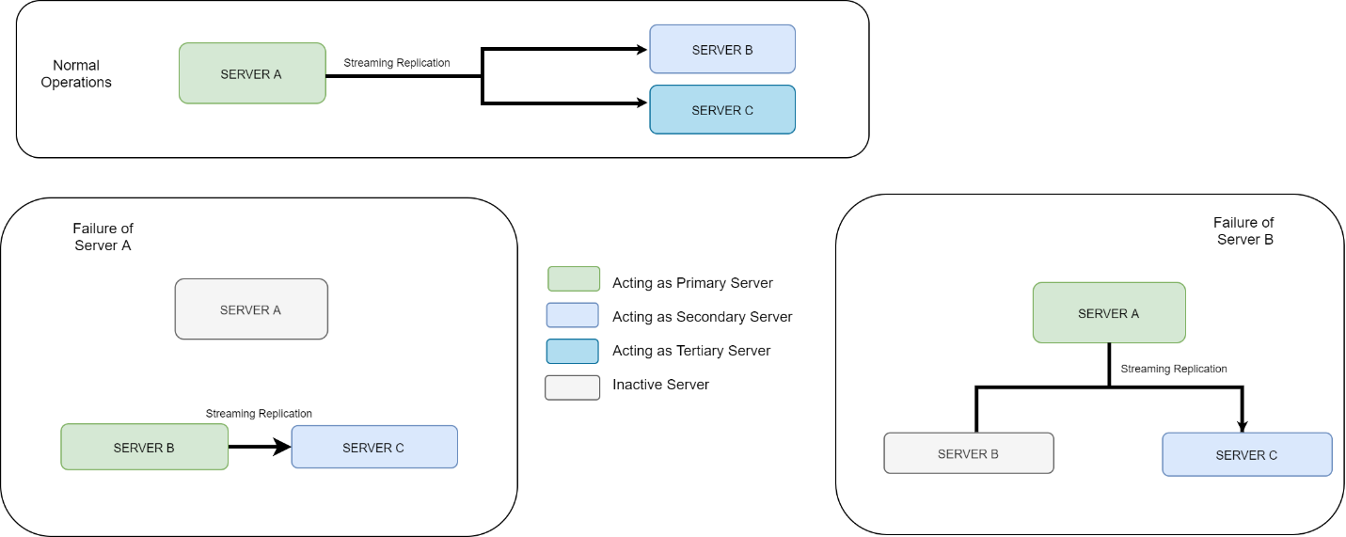The diagram below depicts the high-availability architecture:





All servers will have the exact same database and software setup.

The primary server (initially “SERVER A”) is set up with a “publication”. On server start up, the secondary server (initially “SERVER B”) checks that the publication is ready – if not, it will wait until the primary server is ready. When the publication is ready, the secondary and tertiary servers will “subscribe” to the publication and live replication will become active.

The diagram shown in **Appendix D** is a detailed flowchart of the high availability/automatic failover setup between only the primary server (“master” in the diagram) and secondary server (“replica” in the diagram). The failover logical flow is implemented using a Watch Dog process running independently of all other ITS Central processes (i.e., not sharing any code), removing all possibilities of bugs in the ITS Central code base affecting the Watch Dog process.

The Watch Dog in the secondary server monitors the following critical processes in the primary server:

* IP address – by pinging the primary server periodically
* Web service (GUI) – by polling the web interface
* PostgreSQL database – by pinging the primary server’s database

The Watch Dog on the secondary server will failover if:

* the primary server turns off due to power failure or other reasons;
* the primary server’s NIC have problems which will lead to failure in the primary and secondary servers; and/or
* the primary server experiences a database failure, which can result from “out of memory” or “out of disk space” conditions.

However, the failover will be put on hold if any of the following conditions is detected:

* The secondary server cannot reach the primary server, but can reach web GUI.
* The secondary server cannot reach the primary server nor reference the device on the network. This means there is a problem with the internal network.

Once failover is completed, the new primary server will send the Project Team an email. The project team will investigate the failure and take the appropriate actions to resolve the failure, such as replacing the failed server.